Contents

About 2

1  Regional spectrum 3

2  Core workforce spectrum 32

3  Homeownership market 49

4  Rental market 69

5  Current housing gaps 83

6  Projected housing gaps 91

Appendix A: Engagement 94

Appendix B: Data notes 97

*Cover image: Aerial view of Fredericksburg, Virginia © John Davis (stock.adobe.com)*

# About

This study is a regional housing gap analysis conducted by [HDAdvisors](https://www.hdadvisors.net) (HDA) for the [Fredericksburg Area Association of Realtors®](https://www.faarmembers.com/) (FAAR). The study has four objectives:

* Frame workforce housing needs within the context of the region’s full housing spectrum,
* Assess the housing affordability landscape for the workforce, with specific focus on workers whose homes and jobs are within the region,
* Determine what types, locations, and prices of homes best meet the needs of current and projected workers, and
* Present results at both the regional and local levels with fact sheets and other deliverables that can be easily disseminated and consumed by multiple audiences.

# 1  Regional spectrum

This report outlines the *housing spectrum* concept and its utility for understanding housing market dynamics. It includes assessments of households in the region by various demographic and socioeconomic characteristics, primarily by wages/income. Special analysis for the region’s core workforce (i.e. persons both living and working within the region) can be found in Chapter 2.

**How AMIs and the “region” are defined**

*The Area Median Income (AMI) categories in the regional housing spectrum are custom limits developed from the same methods used by the U.S. Department of Housing and Urban Development (HUD). Because HUD does not publish official limits for just the Fredericksburg region, new AMIs were calculated using the latest available microdata from the American Community Survey (ACS).*

*ACS microdata are available at the same geography served by the George Washington Regional Commission (GWRC), known officially as Planning District 16. The five localities in this area include:*

*- City of Fredericksburg*

*- Caroline County*

*- King George County*

*- Spotsylvania County*

*- Stafford County*

*Together, these jurisdictions are collectively referred to as “the region” throughout the report.*

## 1.1 Overview

With few exceptions, housing opportunities are primarily limited by how much money a household has available to buy or rent a home. To create a regional housing spectrum, we first need to group households according to their incomes. The categories used here, along with their respective plain-language descriptions, are shown below.

*Table 1.1: Housing spectrum income group categories*

| **Income group (AMI)** | **Description** |
| --- | --- |
| Above 120% AMI | *High-income* |
| 100-120% AMI | *Above-average income* |
| 80-100% AMI | *Moderate-income* |
| 50-80% AMI | *Low-income* |
| 30-50% AMI | *Very low-income* |
| Below 30% AMI | *Extremely low-income* |
| Zero or negative income | *No income* |

### Income

Based on 2018-2022 ACS 5-year estimates, there are approximately 385,000 persons living in 132,300 households across the region.[1] Over a third (36.1%) of these are high-income households. The next most common group are low-income households (18.4%). All other households with positive incomes are roughly divided even (at 10-13% each) among other income groups.

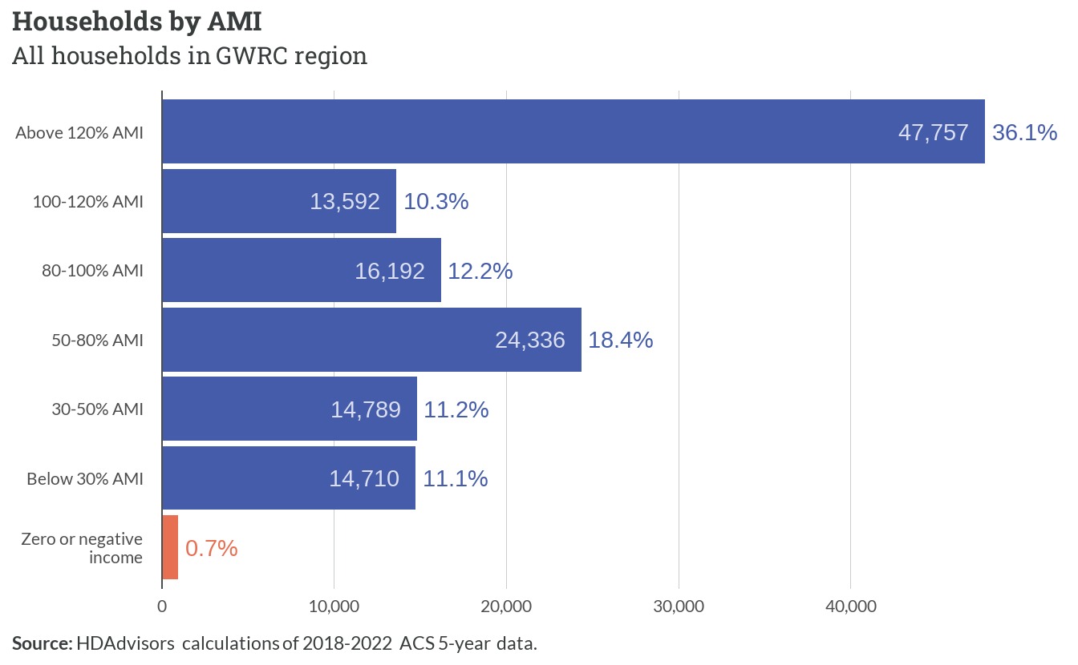

*Figure 1.1: Households by AMI*

Fewer than 1,000 households (<1%) did not have a net positive income for the 12 months prior to their survey response. While the housing needs of this small group represent an outsized component of the region’s housing challenges, the small sample of responses prevents reliable estimates from being calculated. As a result, these records are mostly excluded from the remainder of the report.

We can provide a clearer picture of actual household incomes within these AMI groups by plotting their distributions, as shown in the figure below. The overlapping curves demonstrate that while incomes generally increase with higher AMI percentages, there’s significant variation within each group due to the variety of household sizes represented.

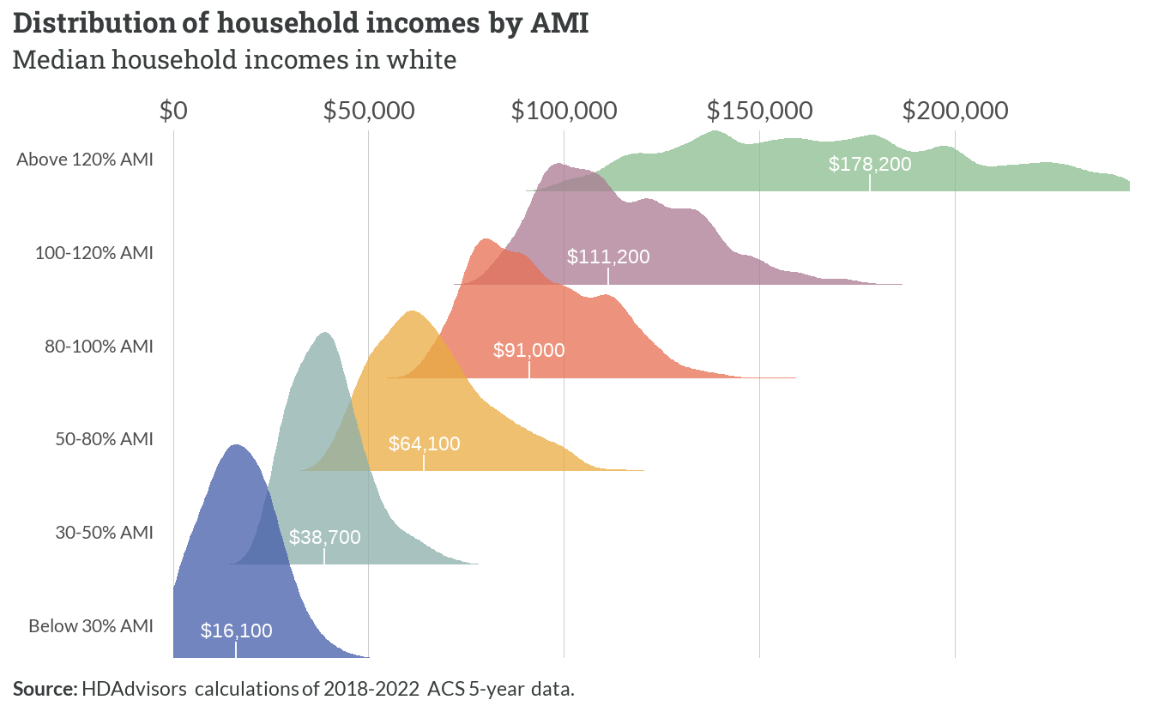

*Figure 1.2: Distribution of household incomes by AMI*

This table adds the typical range for each AMI group to its descriptions.[2] For example, we now know to associate *low-income* households with incomes between roughly $50,000 and $90,000.

*Table 1.2: Typical household income ranges by AMI*

| **Income group (AMI)** | **Description** | **Typical range** |
| --- | --- | --- |
| Above 120% AMI | *High-income* | $124,300 - $292,700 |
| 100-120% AMI | *Above-average income* | $93,000 - $140,000 |
| 80-100% AMI | *Moderate-income* | $75,000 - $116,000 |
| 50-80% AMI | *Low-income* | $49,000 - $88,000 |
| 30-50% AMI | *Very low-income* | $28,600 - $51,500 |
| Below 30% AMI | *Extremely low-income* | $3,500 - $28,000 |

### Tenure

For every 100 households in the region, 76 own their homes. Of these 76 homeowners, 58 are still making mortgage payments, while 18 have fully paid off their homes. The other 24 out of every 100 households are renters.

While homeownership becomes less common as we move down the income scale, homeowners still outnumber renters in every income group except for extremely low-income households. Of note are the slightly higher shares of homeowners below 50% AMI without mortgages—likely a reflection of seniors on fixed incomes who live in the same homes they purchased over 30 years ago.

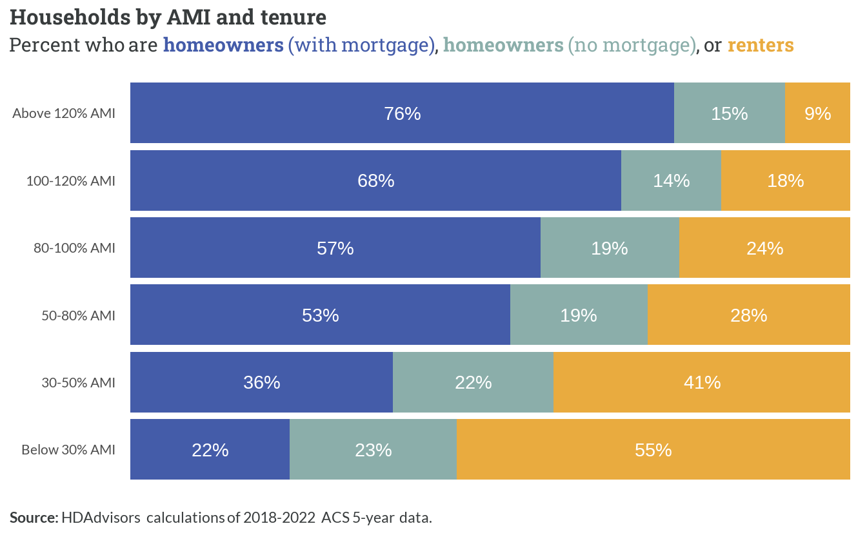

*Figure 1.3: Households by AMI and tenure*

### Household characteristics

The most common type of household in the region are those headed by a married (or unmarried) couple. Single persons living alone are the next most common, and make up larger shares of households with incomes below 50% AMI. Single parents with at least one child are also more prevalent among lower-income households.

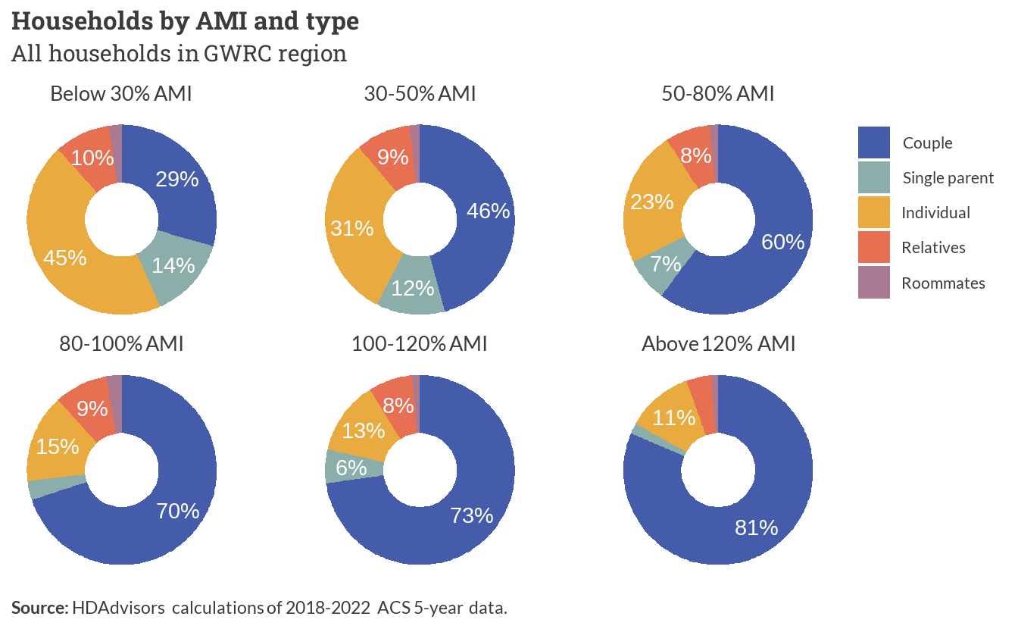

*Figure 1.4: Households by AMI and type*

Middle-aged households—where the average age of primary adults under one roof is between 35 and 64—are the most prevalent age group across every income level. Since these are the prime income-earning years for most adults, middle-aged households are a larger share of higher income households. Conversely, young households and senior/elderly households are more likely to have below-average incomes.

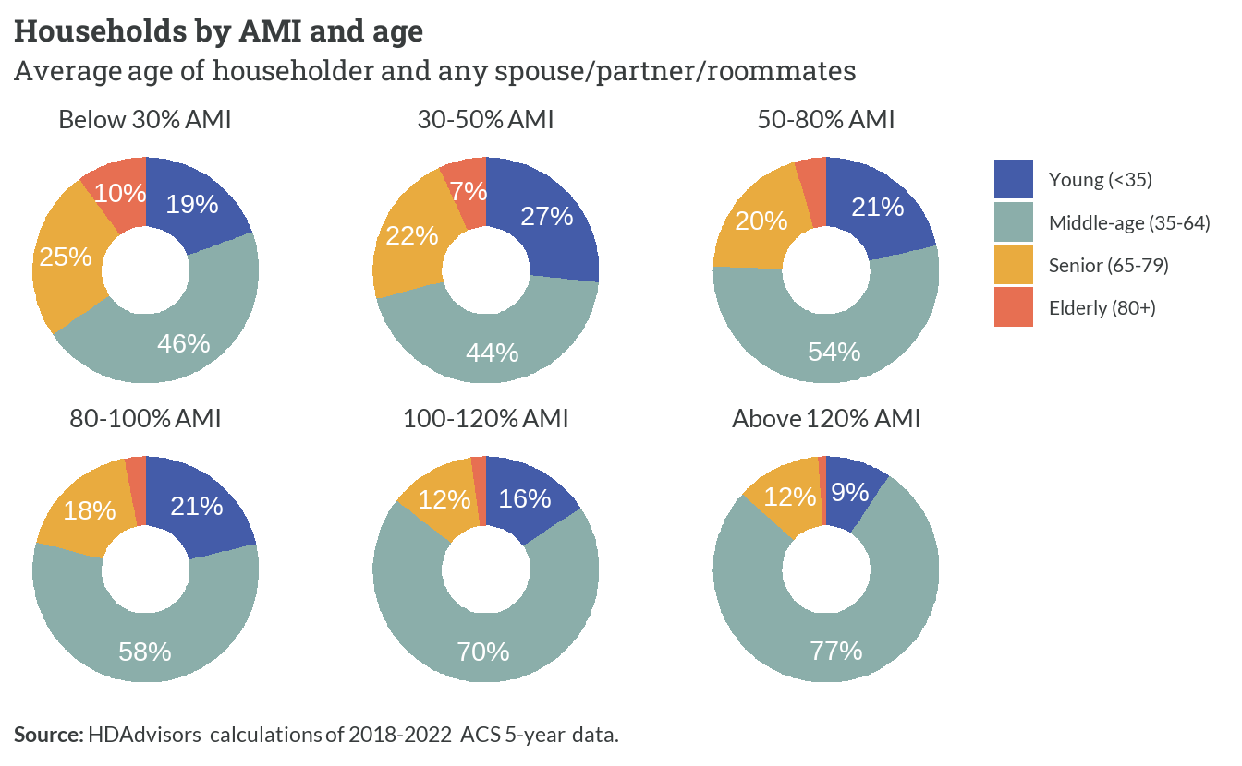

*Figure 1.5: Households by AMI and age*

Only a third of all households have at least one school-aged child under 18. While this share is fairly consistent across all income levels, households earning between 50% AMI and 120% AMI are slightly more likely to have children than households with the lowest and highest incomes.

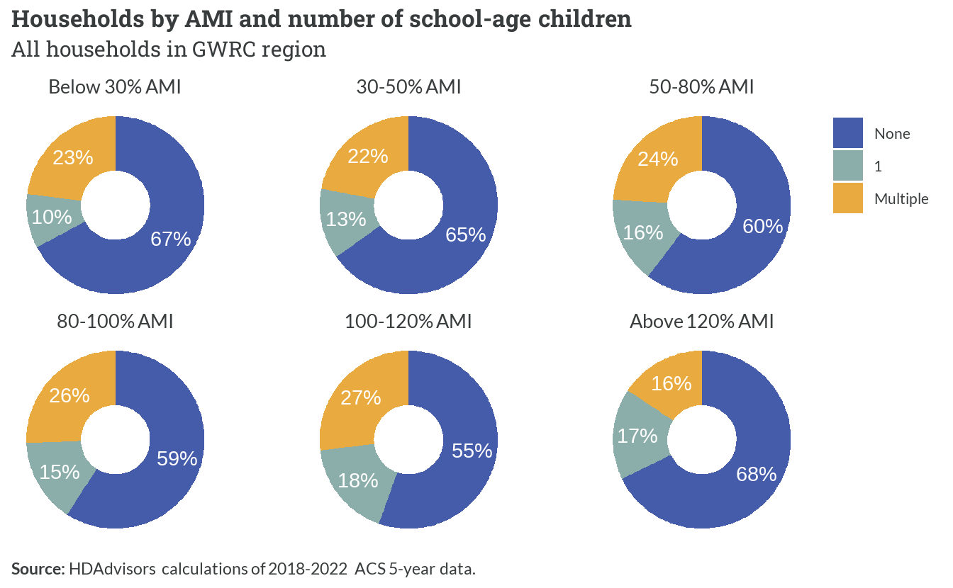

*Figure 1.6: Households by AMI and number of school-age children*

### Employment

The majority of adults in the region who are between 25 to 54, and who do not have a disability, are currently employed or looking for work. While another small share are active duty members of the military, any of those adults not actively working or seeking jobs are outside of the labor force. With very little or no income of their own, non-working individuals are much more likely to be part of households below 50% AMI.

Among persons in extremely and very low-income households who are not in the labor force and do not have a disability, many are probably *stay-at-home moms*. These individuals are mostly women (83%) who live with at least one earner (80%), and live with at least one child (80%).

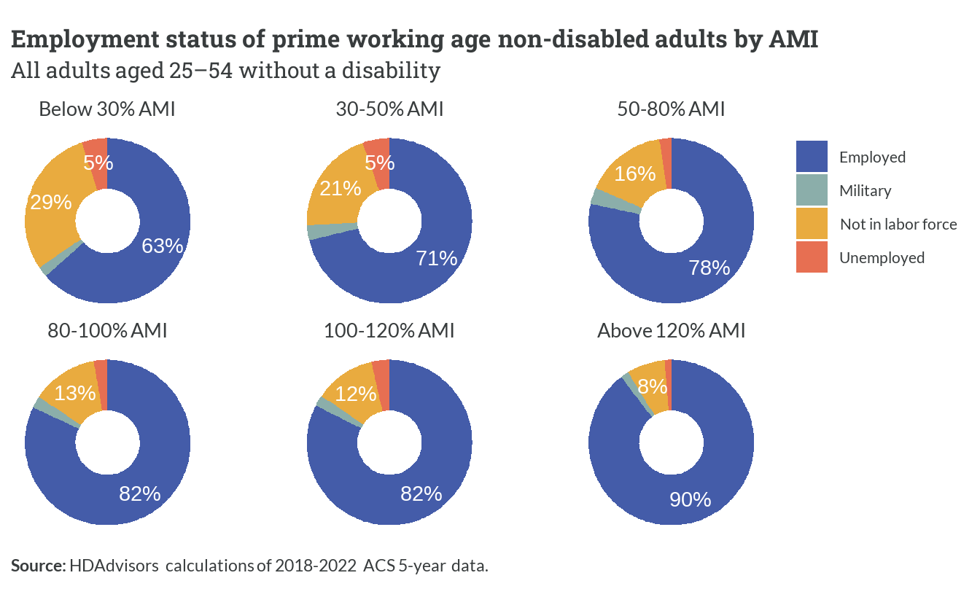

*Figure 1.7: Employment status of prime working age non-disabled adults by AMI*

Only 18% of all households in the region do not include someone earning income.[3] The majority of those are senior or elderly households (76%) with lower incomes. Households with incomes between 30% AMI and 80% AMI are more likely than average to have just a single earner, while double-earner households are increasingly prevalent as incomes go up.

Higher-income groups also have a noticeable share of households with three or more earners. Many of these multiple-earner households (68%) are families with at least one younger, working adult child still living with parents who have not retired.

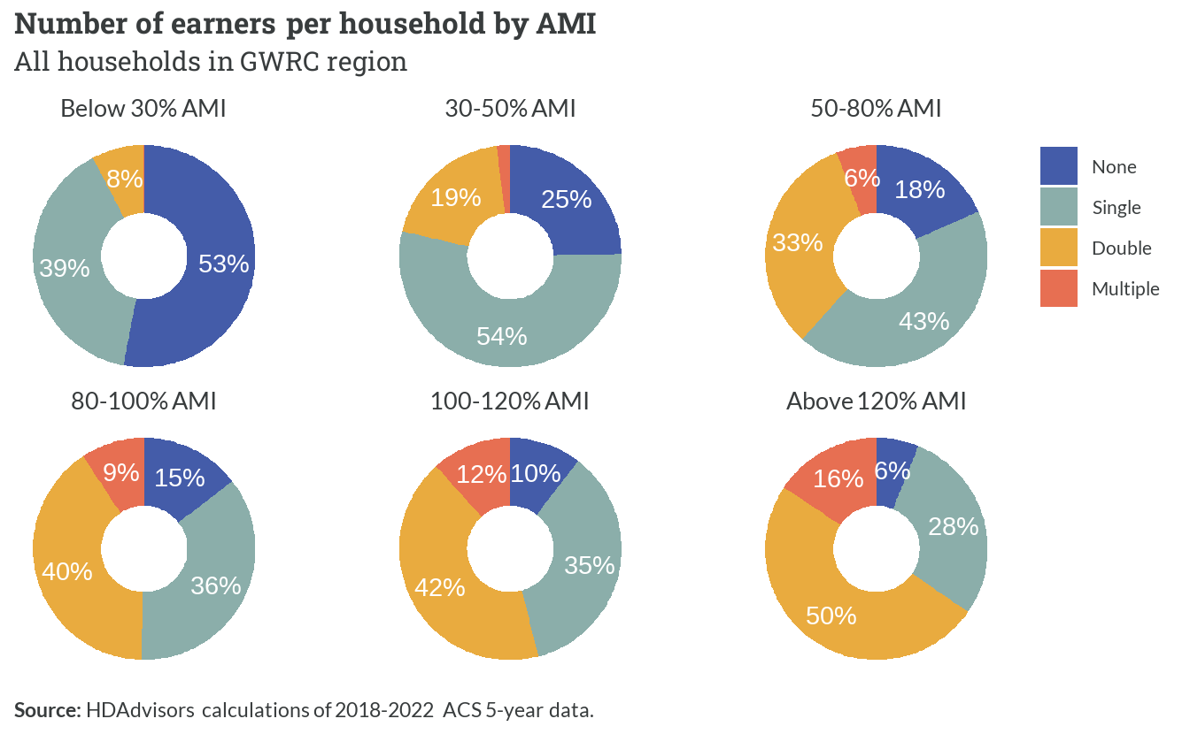

*Figure 1.8: Number of earners per household by AMI*

## 1.2 Below 30% AMI

*Table 1.3: Summary of households below 30% AMI*

| **Below 30% AMI** | **Summary** |
| --- | --- |
| Households | 14,710 |
| Persons | 34,864 |
| Average household size | 2.39 |
| Median household income | $16,100 |

Like other income groups, most extremely low-income households live in detached single-family homes or townhomes. Among renters, single-family homes are the most common type but are not the majority. A large portion of renters live in smaller apartment buildings, with slightly smaller shares in medium and large-sized buildings.

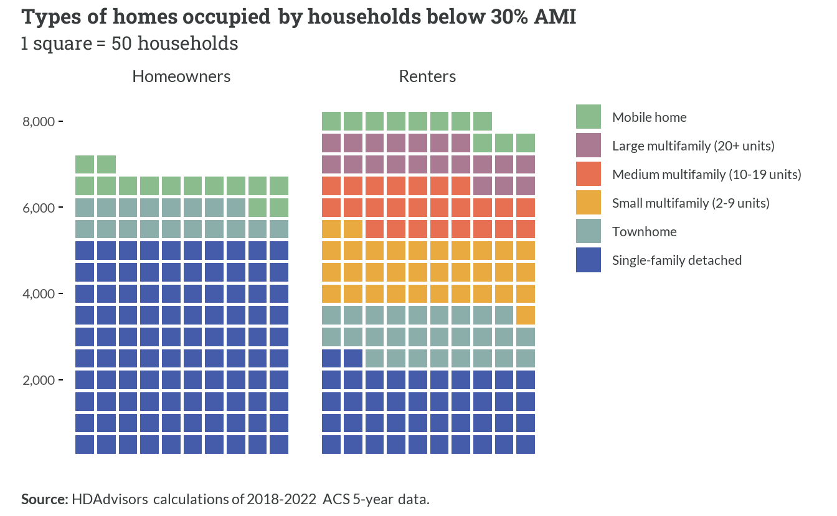

*Figure 1.9: Types of homes occupied by households below 30% AMI*

The majority of total aggregate income earned by extremely-low income households comes from wages earned from work. This share is larger (70%) for younger renter households who are more likely to be of working age. Among homeowners, nearly equal amounts come from both wages and Social Security, which reflect their higher average ages. Only a small fraction (about 5%) of income for these households comes from public assistance programs.[4]

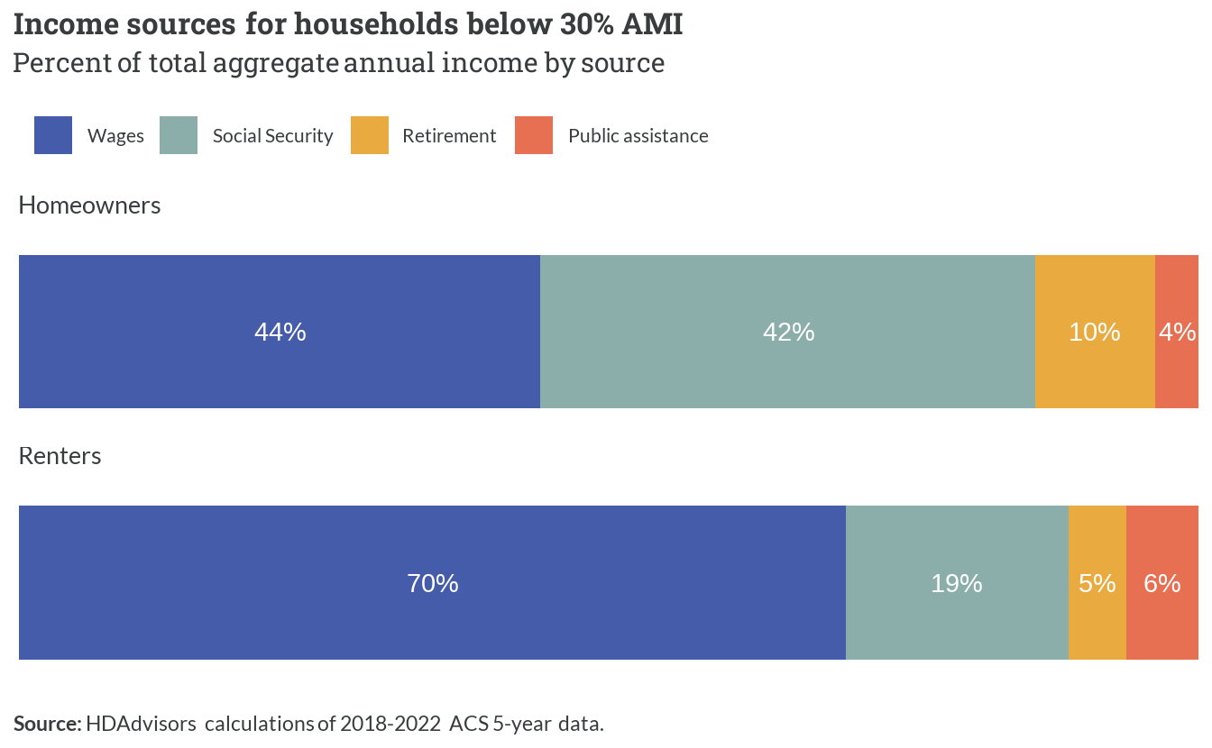

*Figure 1.10: Income sources for households below 30% AMI*

The amounts households below 30% AMI spend on housing each month highly depends on whether they own or rent. Average homeowner costs are less than $800—with many paying less than $500 monthly—likely due to many seniors who have paid off their mortgages, and now must only pay property taxes and insurance. The average renter, on the other hand, pays more than $1,100 for their apartment.

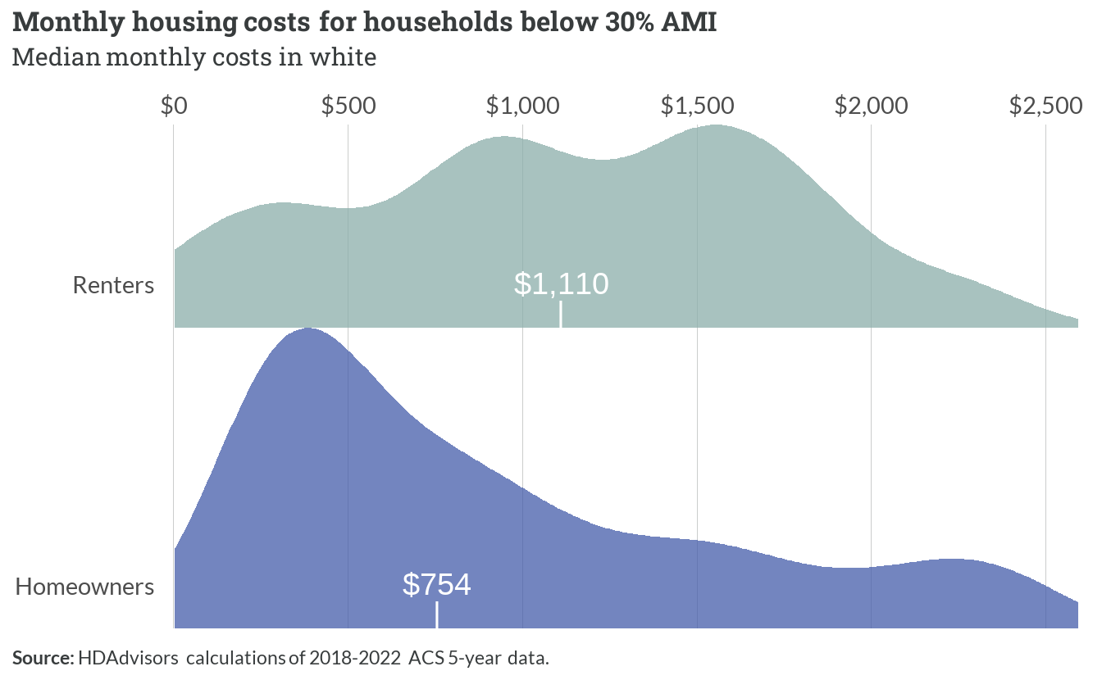

*Figure 1.11: Monthly housing costs for households below 30% AMI*

More than 2 in 3 extremely low-income households spend more than 30% of their gross income on basic housing costs. Worse, most of these households are severely cost-burdened—dedicating more than 50% of their income toward housing.

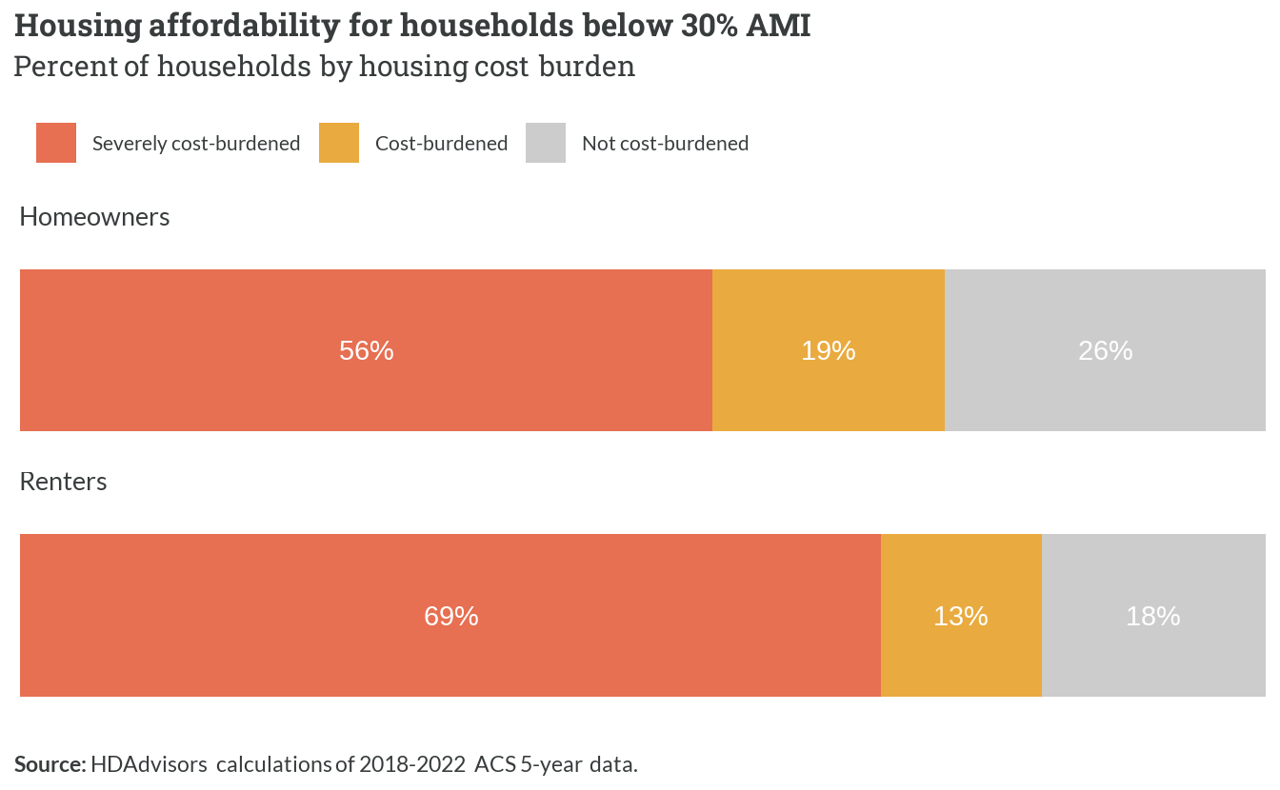

*Figure 1.12: Housing affordability for households below 30% AMI*

## 1.3 30-50% AMI

*Table 1.4: Summary of households between 30-50% AMI*

| **30-50% AMI** | **Summary** |
| --- | --- |
| Households | 14,789 |
| Persons | 38,156 |
| Average household size | 2.51 |
| Median household income | $38,700 |

Very low income households in the region make a median household income of $38,700 across almost 14,790 households.

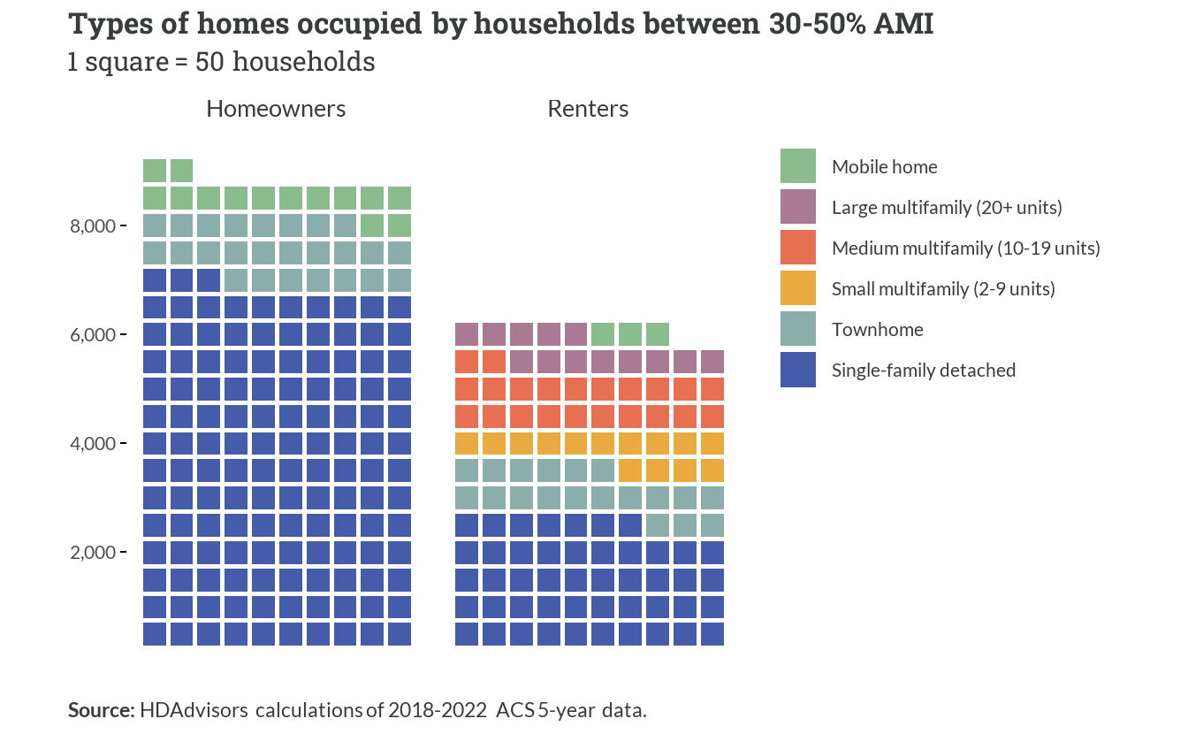

*Figure 1.13: Types of homes occupied by households between 30-50% AMI*

Very low income (VLI) homeowners, like ELI households, are also categorized by single family detached and townhomes. However, there are more households in this spectrum bracket that own than rent compared with ELI households. A little over half of VLI renting households live in single family and townhome units, with a much smaller share of these households in multifamily units.

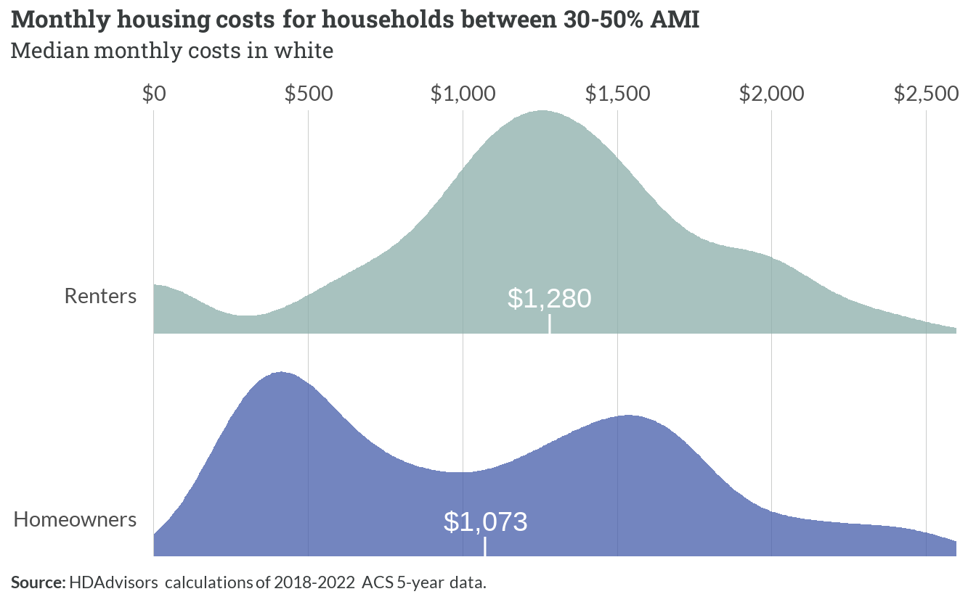

*Figure 1.14: Monthly housing costs for households between 30-50% AMI*

Even with a smaller proportion of households renting, VLI households are only paying a $200 difference between the median mortgage and median rent. Large shares of VLI homeowners pay less than $500 a month in housing costs, while the second greatest share of homeowners pay a little over $1500 a month. Renters, while likely cost burdened, pay a median $1280 towards their housing.

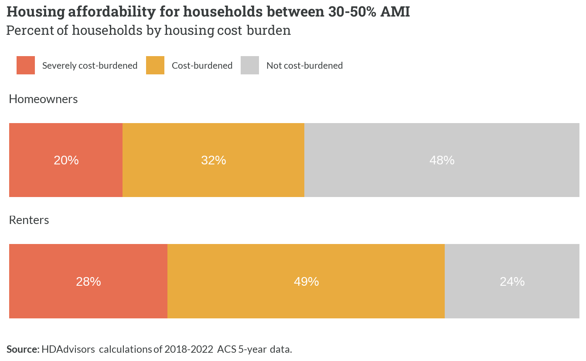

*Figure 1.15: Housing affordability for households between 30-50% AMI*

Almost 50% of VLI renters are cost burdened, or spending more than 30% in their income towards housing costs. With the 28% of VLI renting households that are extremely cost burdened, over three quarters of VLI renters are cost burdened households - leaving a smaller share of income available for life’s other expenses. Nearly the same amount of VLI homeowners are not cost burdened at all, demonstrating the benefits of affordable homeownership options when they are available.

## 1.4 50-80% AMI

*Table 1.5: Summary of households between 50-80% AMI*

| **50-80% AMI** | **Summary** |
| --- | --- |
| Households | 24,336 |
| Persons | 68,694 |
| Average household size | 2.83 |
| Median household income | $64,100 |

With median household incomes of $64,100, regional low income households represent nearly 68,700 people in the area. These 24,336 households have slightly bigger average sizes than ELI and VLI households.

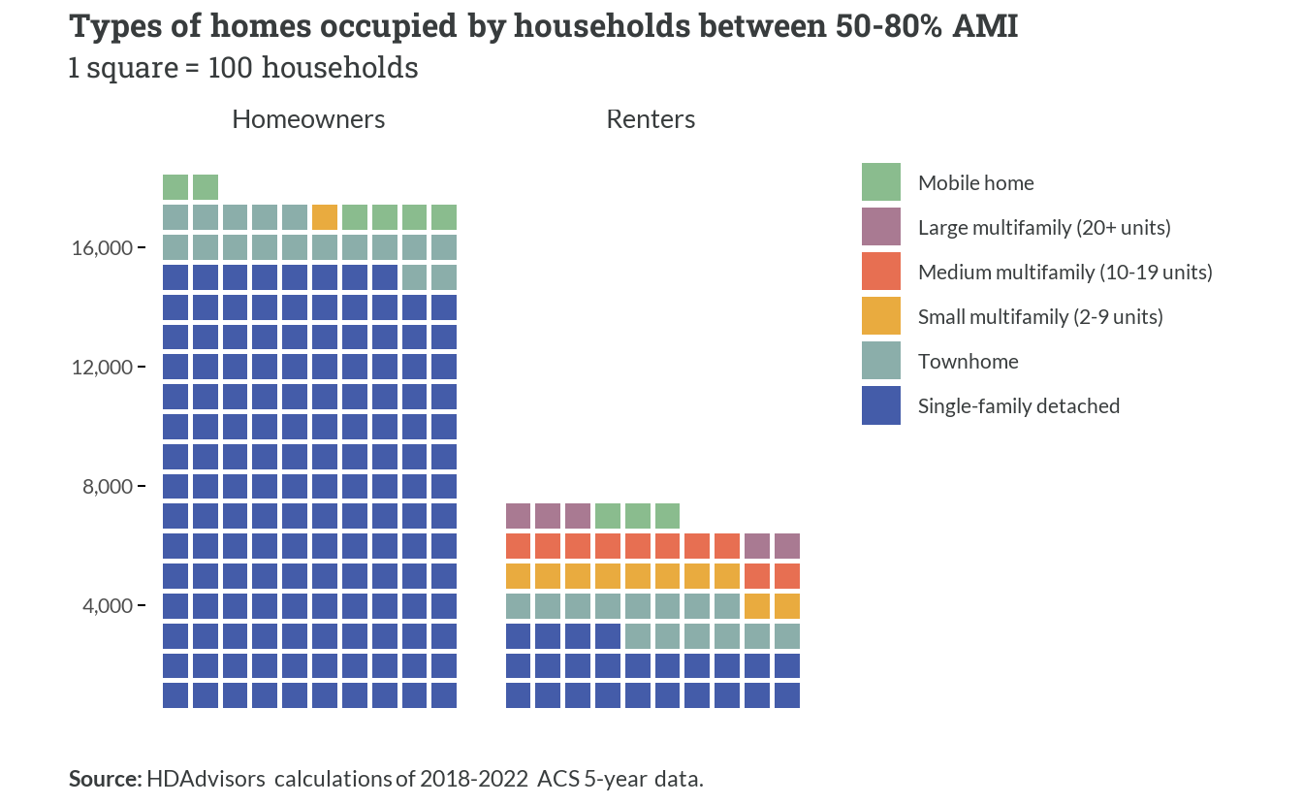

*Figure 1.16: Types of homes occupied by households between 50-80% AMI*

These low income households are overwhelmingly small family owners, with less than half of low income households renting.

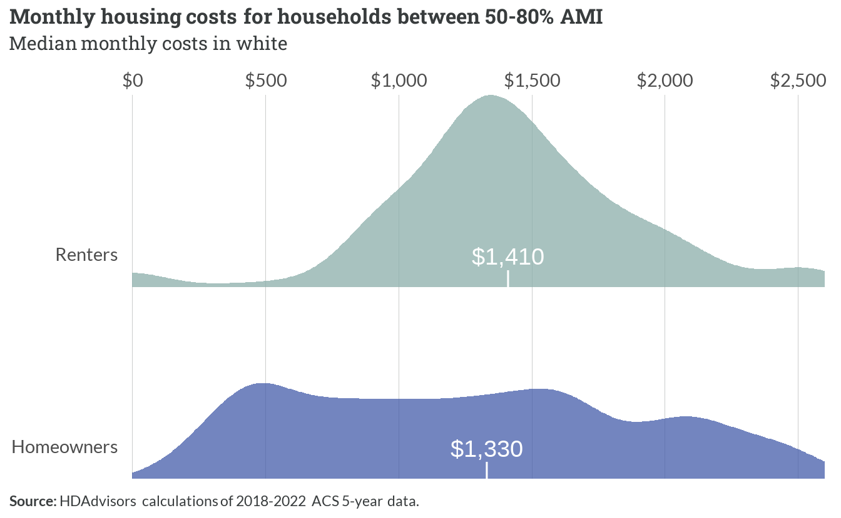

*Figure 1.17: Monthly housing costs for households between 50-80% AMI*

Low income renters in this bracket of the spectrum are generally not cost-burdened with many renters paying a median rent of $1410. Low income homeowners on the other hand see much greater and more even distribution of household housing costs across the board, with a median payment at $1330.

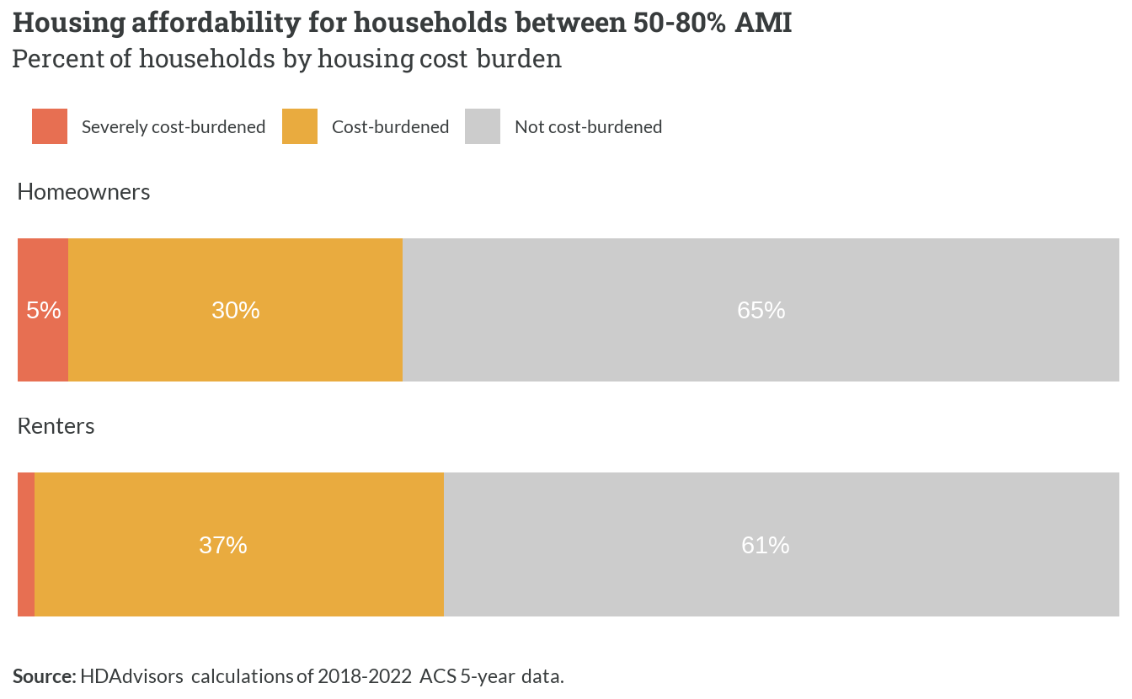

*Figure 1.18: Housing affordability for households between 50-80% AMI*

Additionally, low income homeowners and renters are not likely cost burdened with the majority in each tenure able to pay less than 30% of income towards housing costs. However, 30% and 5% of low income homeowners are cost-burdened and severely cost burdened respectively, with 37% and 1% of renters that are also cost burdened and severely cost burdened.

## 1.5 80-100% AMI

*Table 1.6: Summary of households between 80-100% AMI*

| **80-100% AMI** | **Summary** |
| --- | --- |
| Households | 16,192 |
| Persons | 49,933 |
| Average household size | 3.01 |
| Median household income | $91,000 |

Moderate income households in the region make a median household income at $91,000, representing almost 50,000 people with a little more than 3 people per household. At greater incomes, we are starting to see households grow in size.

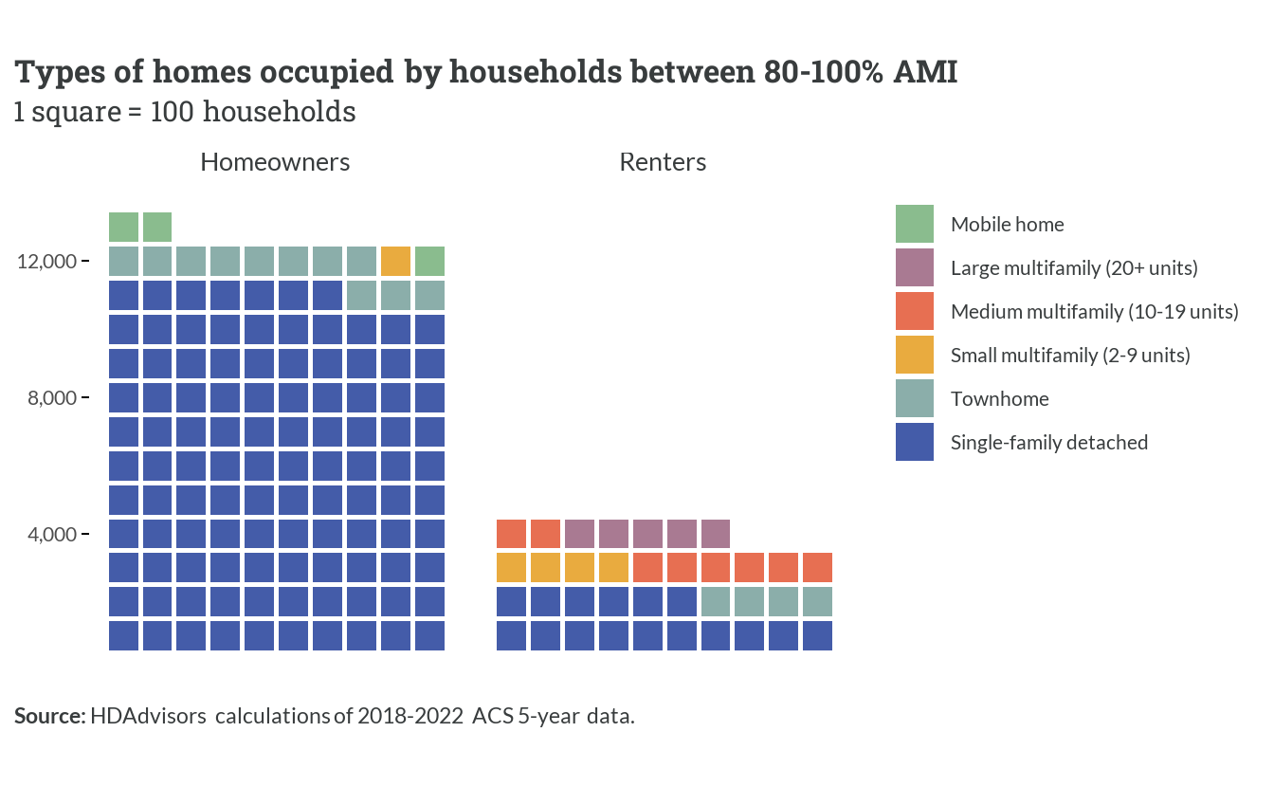

*Figure 1.19: Types of homes occupied by households between 80-100% AMI*

This translates to household types, as well, with the vast majority of ownership units (about 11,500) out of the 16,192 moderate income households in single family detached homes. Only about 3,700 moderate income households rent.

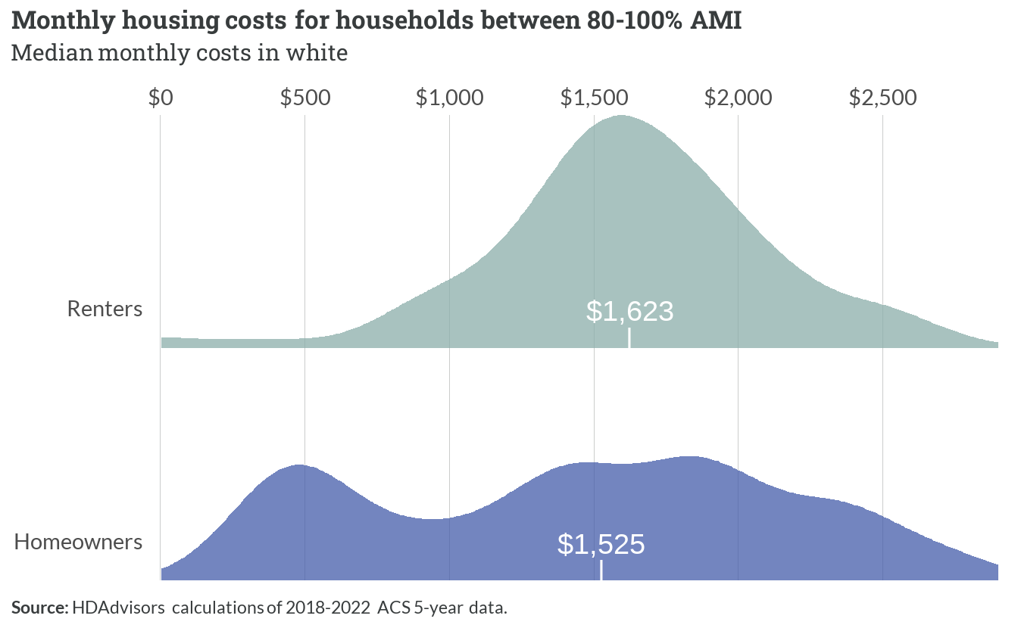

*Figure 1.20: Monthly housing costs for households between 80-100% AMI*

With greater diversity in the type of payment, the moderate income homeowners pay a median $1,525 towards housing costs, while the majority of the renting households pay a median $1,623.

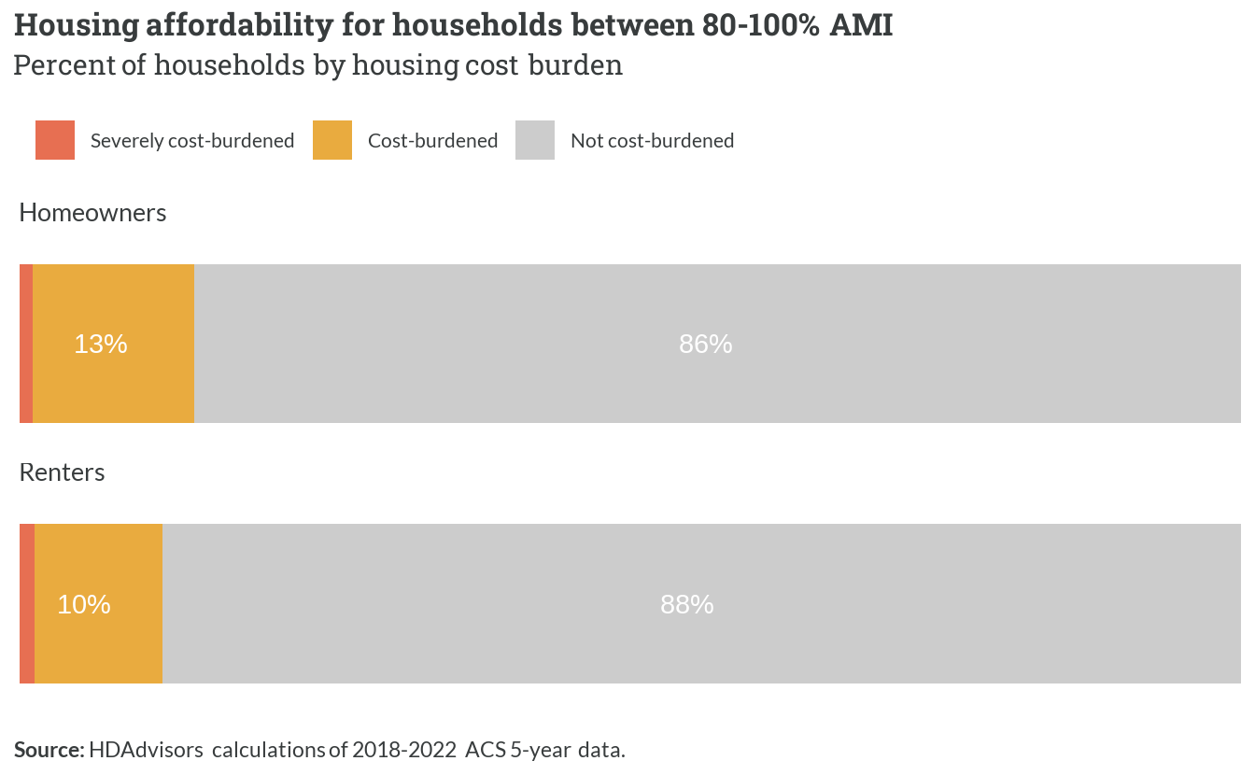

*Figure 1.21: Housing affordability for households between 80-100% AMI*

Similarly to low income households, regional moderate income households are less likely to be housing cost burdened. Eighty eight (88%) of renting households and 86% of owners are not disproportionately paying towards their housing costs.

## 1.6 100-120% AMI

*Table 1.7: Summary of households between 100-120% AMI*

| **100-120% AMI** | **Summary** |
| --- | --- |
| Households | 13,592 |
| Persons | 43,058 |
| Average household size | 3.05 |
| Median household income | $111,200 |

Households with above average income continue the trend of increased income, increasing household size, with a median household income of $111,200.

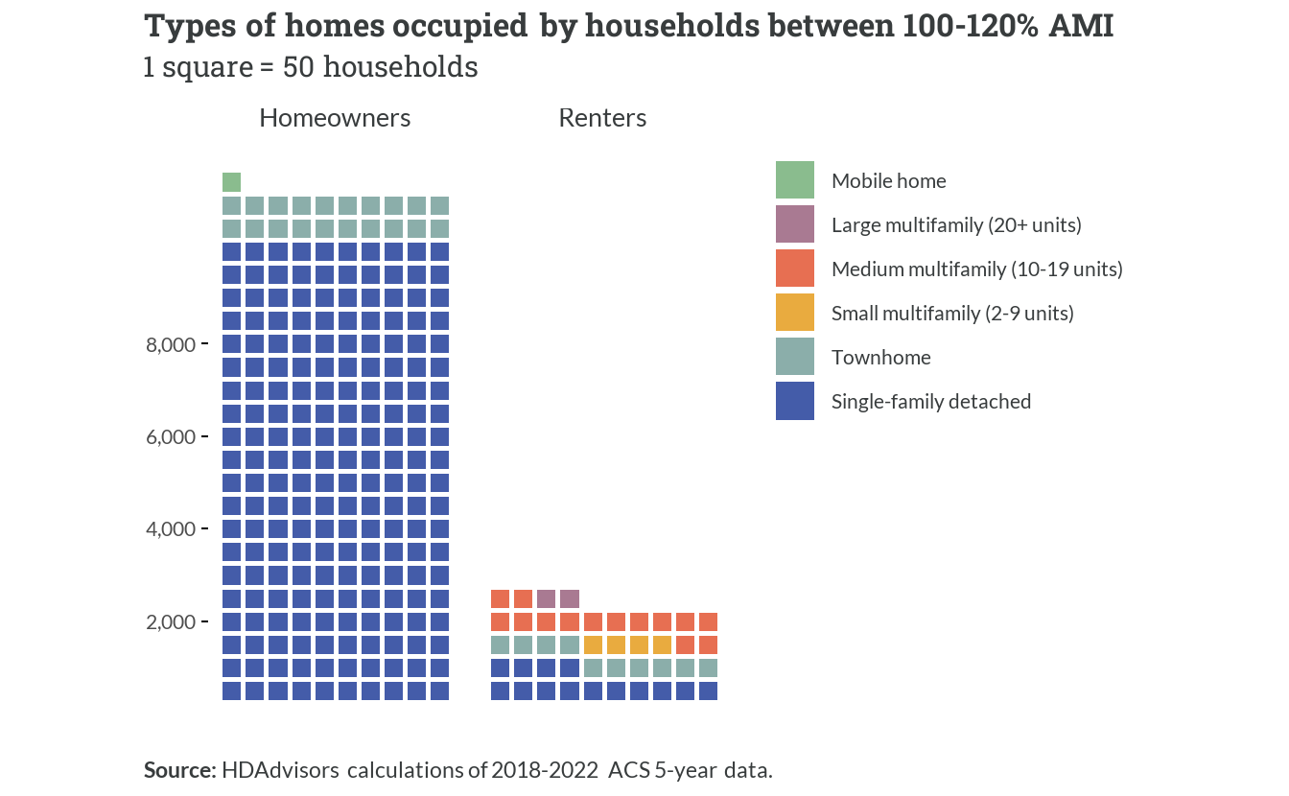

*Figure 1.22: Types of homes occupied by households between 100-120% AMI*

As with all other income brackets in the spectrum, single family homeownership is by far the most common housing type of these households.

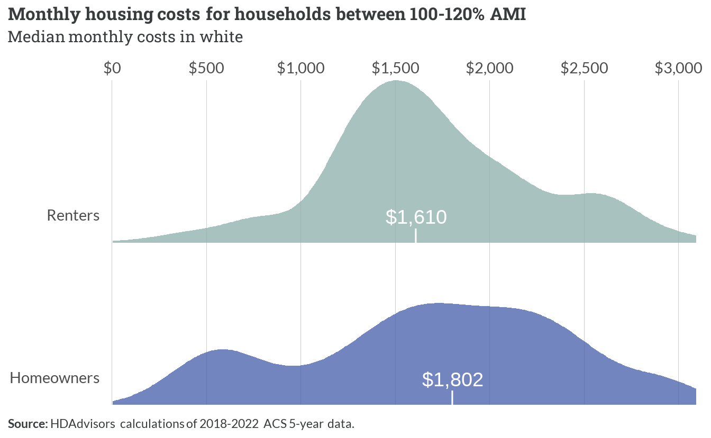

*Figure 1.23: Monthly housing costs for households between 100-120% AMI*

For the nearly 2,200 above-average income renting households, median housing costs are around $1,610. For homeowners, those costs are a little above $1,802 per month.

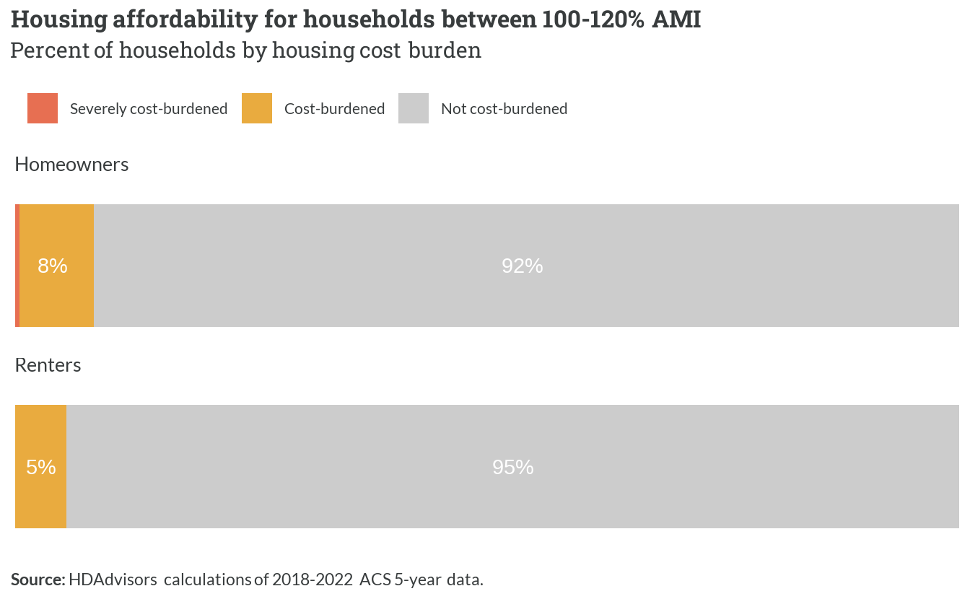

*Figure 1.24: Housing affordability for households between 100-120% AMI*

Only a very small share of above-average income households (both homeowners and renters) face cost burden.

## 1.7 Above 120% AMI

*Table 1.8: Summary of households above 120% AMI*

| **Above 120% AMI** | **Summary** |
| --- | --- |
| Households | 47,757 |
| Persons | 141,479 |
| Average household size | 2.84 |
| Median household income | $178,200 |

High-income households represent the greatest share of households on the regional housing spectrum. There are 47,757 high income households representing 141,479 people with median incomes at $178,200.

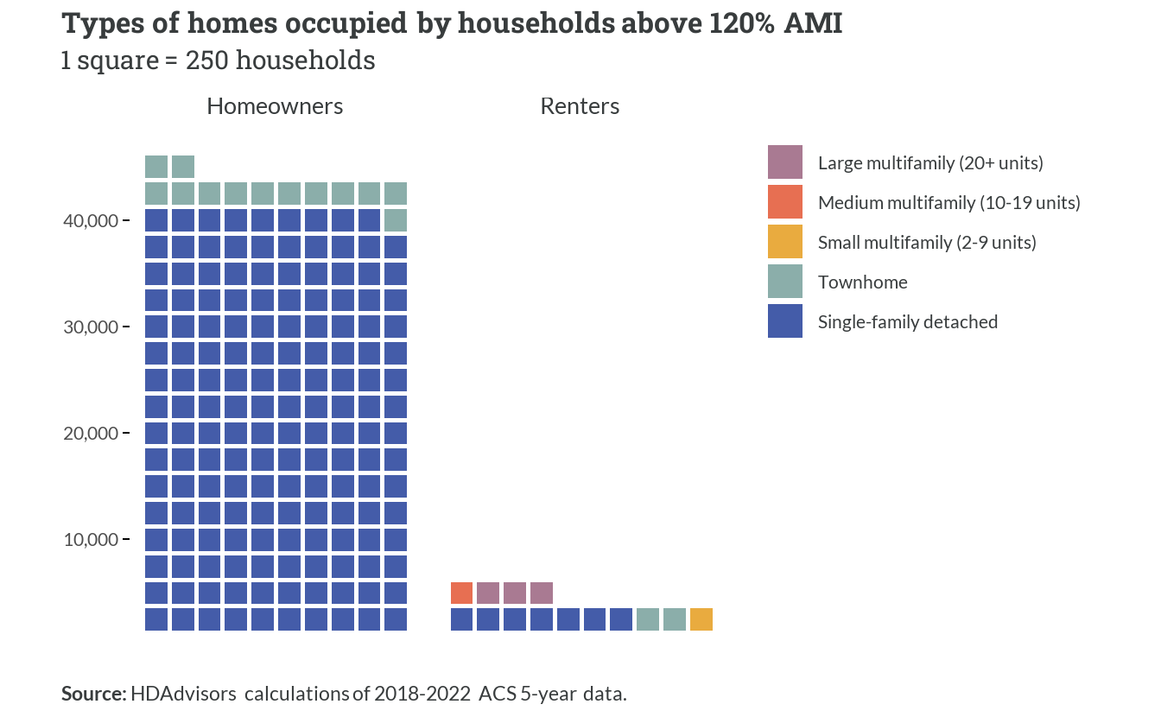

*Figure 1.25: Types of homes occupied by households above 120% AMI*

As can be expected, trending with increasing income, almost all households in this category own their homes. These are mostly single-family detached homes, with only a few thousand (out of more than 40,000) living in townhomes.

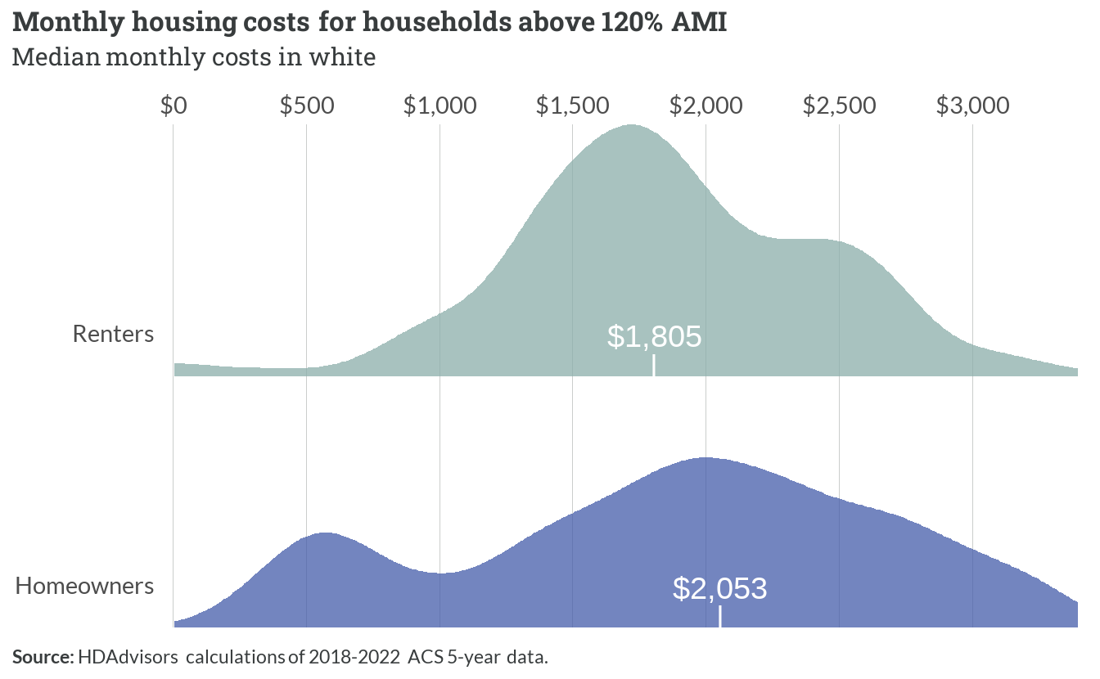

*Figure 1.26: Monthly housing costs for households above 120% AMI*

These homeowner households are paying greater amounts for their housing costs, at a median $2,053. Renter high-income households are paying a median $1,805 in costs, with a large share paying $2,000 in rent or more.

Cost burden rates among high-income households are negligible, and therefore not shown in a separate figure.

# 2  Core workforce spectrum

This chapter assesses the housing spectrum for the region’s *core workforce*. This includes all households where at least one member is employed at a job also located within the region.

**Defining the “core workforce”**

*For every record of an employed person, the Public Use Microdata Sample (PUMS) includes a variable for the place-of-work Public Use Microdata Area (“POWPUMA”). Households with at least one person who has worked in the last 12 months and whose POWPUMA values correspond to the Fredericksburg area (Planning District 16) were designated as members of the core workforce. Employed persons who work from home are included in this group.*

## 2.1 Overview

### Identifying the core workforce

Based on this definition, 125,312 workers are both employed and live in the region. This means that two-thirds of all workers who live in the region also work within Planning District 16, versus communities outside of the region.

Additionally, this data considers those who work remotely from their homes as commuting within the Fredericksburg region. Only 37,711 workers (20% of job holders) travel to Northern Virginia or Washington D.C. for work.

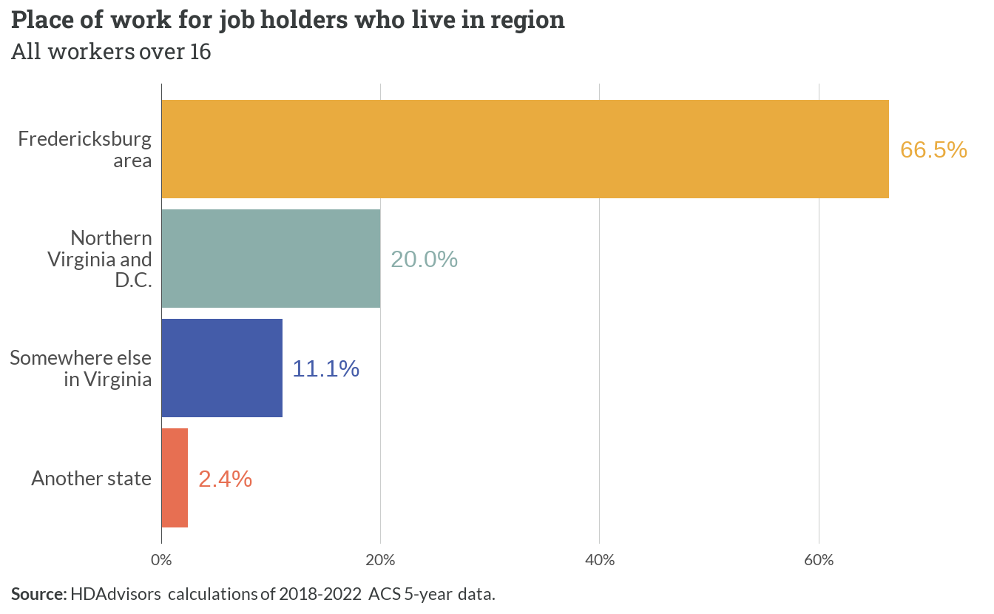

*Figure 2.1: Place of work for job holders who live in region*

When considering whole households, most are members in the region’s core workforce: 79,545 households (60.2%) have at least one earner who works around Fredericksburg. Only 23.2% of households in the region consist of both earners leaving for work outside Planning District 16. A smaller share (16.7%), composed mostly of retirees, have no active workers.

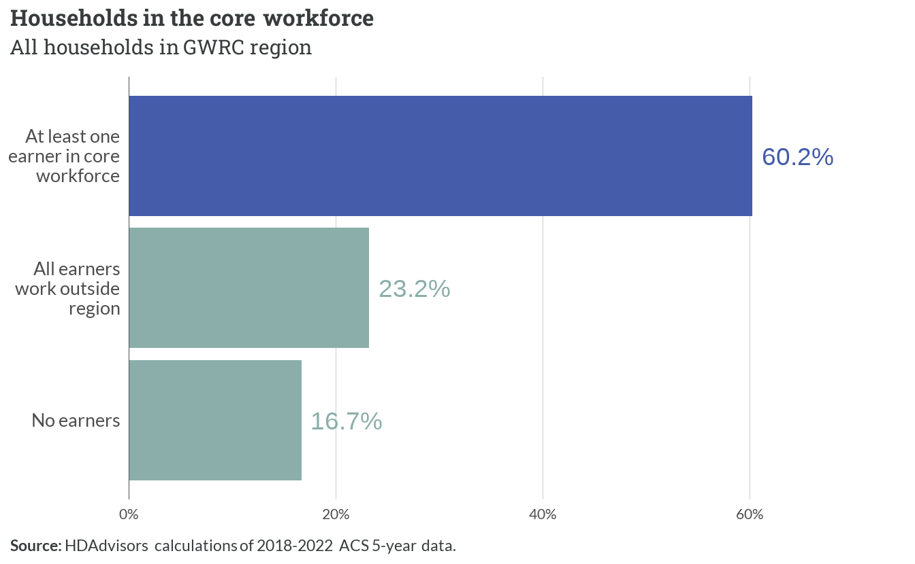

*Figure 2.2: Households in the core workforce*

### Common industries and occupations

This core workforce is also primarily represented by people who work at private, for-profit businesses in the region (59.3% of workers). Smaller shares of the core workforce work for government entities, are self employed, or work at non-profits.

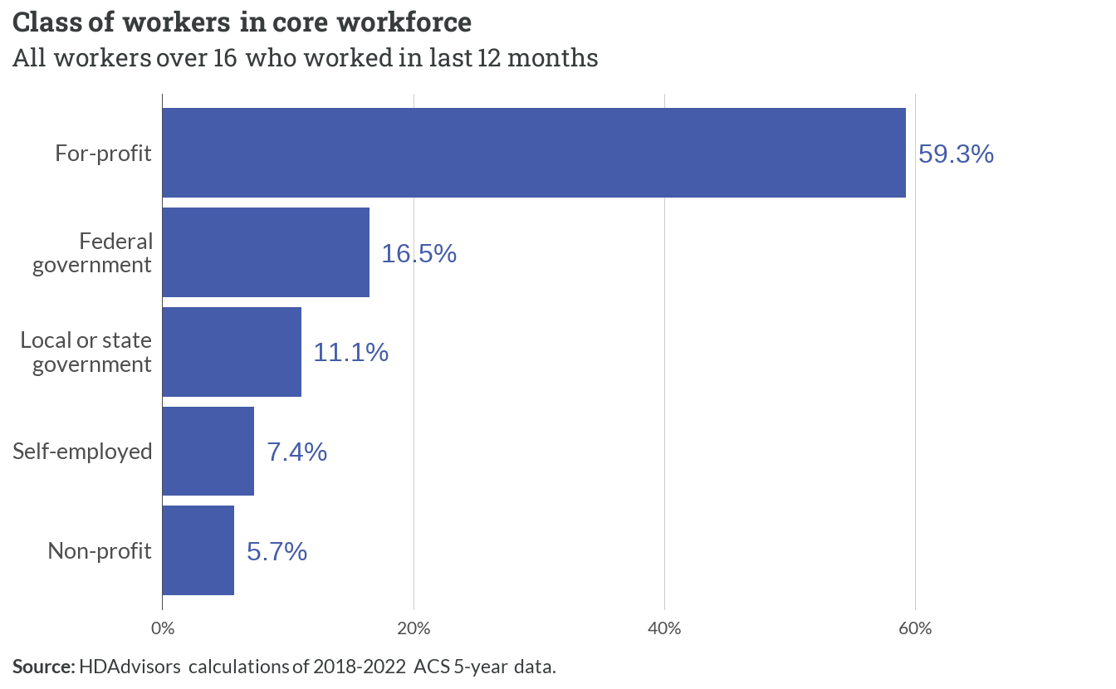

*Figure 2.3: Class of workers in core workforce*

Regionally, 36,834 workers are employed in the Retail and Wholesale (15%) and Professional Services (15%) industries. Healthcare and Social Assistance, as well as Public Administration and Military follow behind, and paint a picture for the kind of incomes the core workforce earns.

*Table 2.1: Top five most common core workforce industry groups*

| **Industry group** | **Workers** | **Percent** |
| --- | --- | --- |
| Retail and Wholesale | 18,481 | 15% |
| Professional Services | 18,353 | 15% |
| Healthcare and Social Assistance | 16,261 | 13% |
| Public Administration and Military | 15,594 | 12% |
| Education | 12,278 | 10% |

Across all industries, the most common professions include Administrative and Clerical Support work, along with Leadership and Management. Jobs in the region that involve sales, healthcare, and logistics are also commonly held by workers who live in the area.

*Table 2.2: Top five most common core workforce occupational groups*

| **Occupational group** | **Workers** | **Percent** |
| --- | --- | --- |
| Administrative and Clerical Support | 14,226 | 11% |
| Leadership and Management | 13,711 | 11% |
| Sales, Marketing, and Customer Service | 12,655 | 10% |
| Healthcare and Medical Services | 10,343 | 8% |
| Transportation and Logistics | 9,176 | 7% |

### Income

Core workforce households are slightly more likely to have higher incomes compared to households where all earners have jobs outside of the region. However, more than 13,000 core workforce households (17%) have incomes below 50% AMI. A slightly larger share (18%) have low incomes between 50% and 80% AMI.

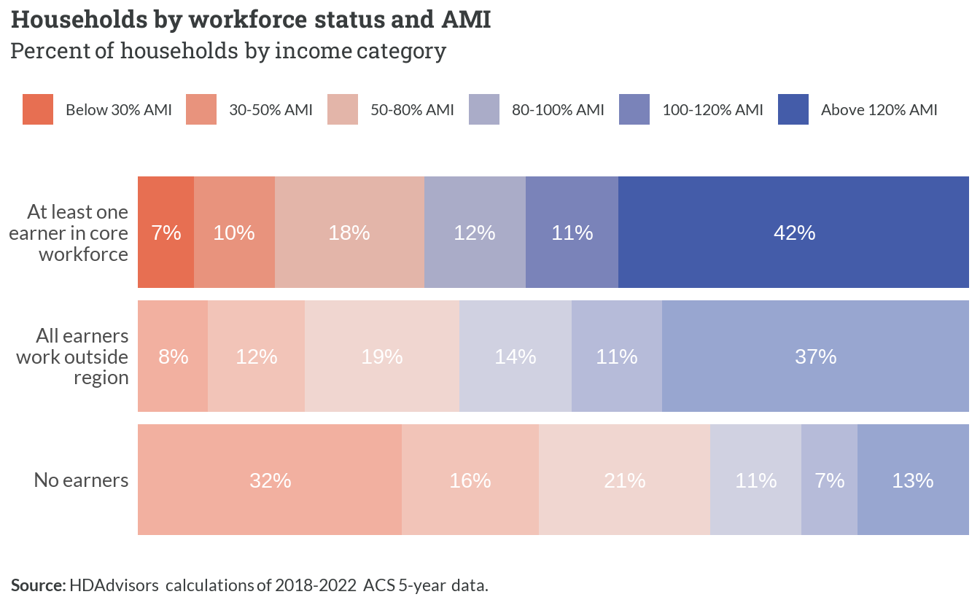

*Figure 2.4: Households by workforce status and AMI*

### Household characteristics

Core workforce households have similar rates of homeownership compared to non-core workforce households.

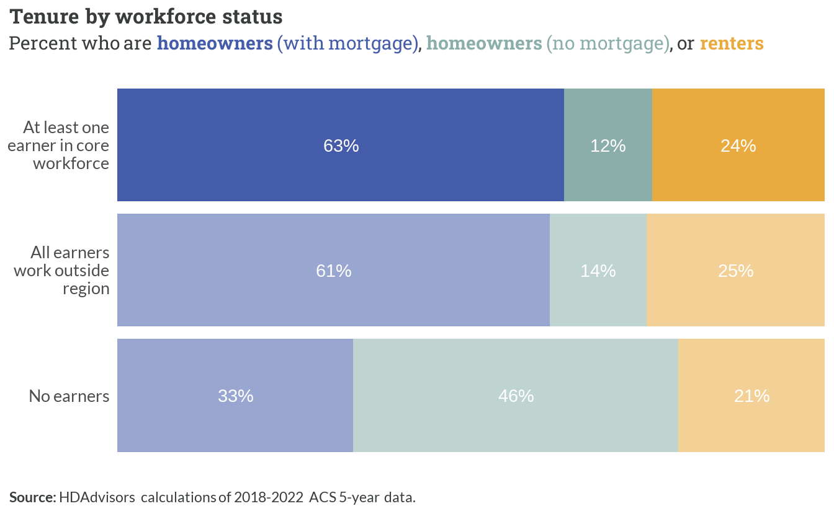

*Figure 2.5: Tenure by workforce status*

Almost half of all core workforce households are headed by couples who both hold jobs in the region. A large share of those (and 20% of all core workforce households) do not have children under 18. These “Dual-Income No Kids” households (DINKs) often have strong purchasing power in the housing market.

Single workers who live on their own account for 12% of households in the core workforce. Single-earner couples with and without children are also common. Working single parents, however, are just under 5% of the core workforce.

*Table 2.3: Five most common core workforce household types*

| **Household type** | **Children** | **Earners** | **Percent** |
| --- | --- | --- | --- |
| Couple | Yes | Two | 23% |
| Couple | No | Two | 20% |
| Individual | No | One | 12% |
| Couple | Yes | One | 8% |
| Couple | No | One | 8% |

Households in the core workforce have lived in their current homes for similar periods as the non-core workforce, with just under half moving within the last four years. Many non-earner households have lived in their homes for much longer, which corresponds to a significant share of those being older retirees.

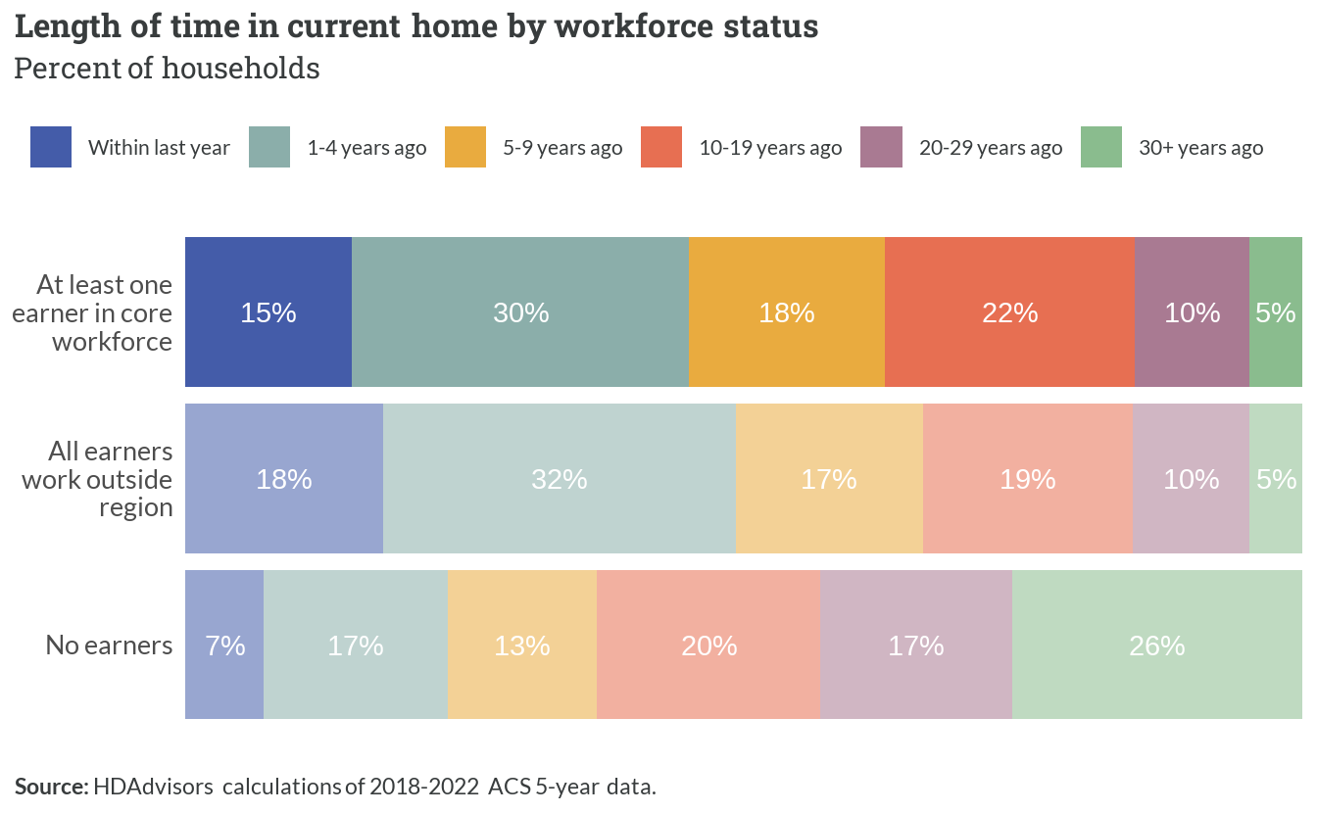

*Figure 2.6: Length of time in current home by workforce status*

### Affordability

The chart below shows the range of typical housing costs for the core workforce compared to other households. Dots represent median values, and lines cover half of all values centered on the median.

For incomes above 100% AMI, core workforce households spend similar amounts on housing compared to the non-core workforce. At most incomes below 100% AMI, the core workforce spends slightly *less* on housing than the non-core workforce.

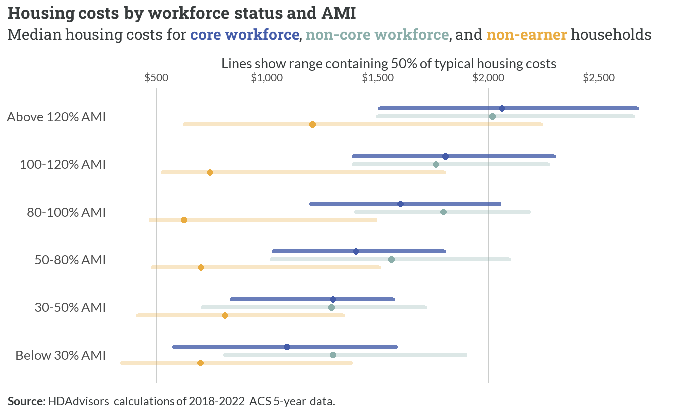

*Figure 2.7: Housing costs by workforce status and AMI*

The core workforce experiences housing cost burden in a pattern similar to the regional averages for each income level. High rents paid by households under 50% AMI are the primary driver of this challenge.

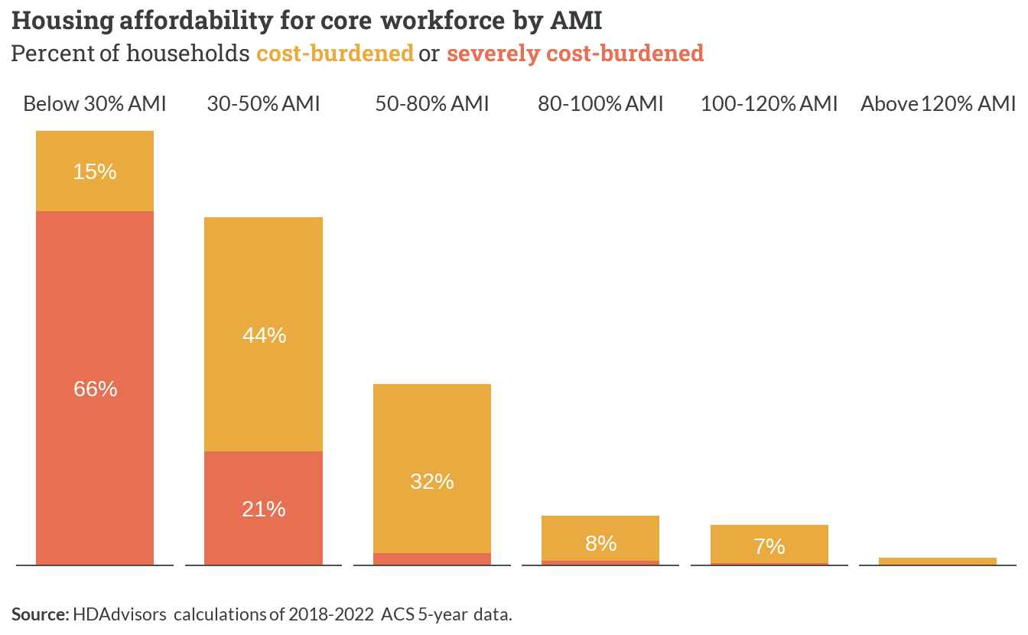

*Figure 2.8: Housing affordability for core workforce by AMI*

## 2.2 Below 30% AMI

Most core workforce households living at 30% of AMI spectrum are individual earners with no children. Next is single parents households and then couples with children households with two earners at this income bracket. Overall, 7% of households with at least one earner are ELI households.

*Table 2.4: Three most common core workforce household types below 30% AMI*

| **Household type** | **Children** | **Earners** | **Percent** |
| --- | --- | --- | --- |
| Individual | No | One | 21% |
| Single parent | Yes | One | 17% |
| Couple | Yes | One | 17% |

Extremely low income earners are the folks that keep the Fredericksburg running: laborers, cashiers, cooks, retail workers, etc. Additionally, it’s important to note that these households almost always have one earner.

*Table 2.5: Ten most common core workforce occupations below 30% AMI*

| **Ten Most Common Occupations** |  |
| --- | --- |
| 1. Customer Service Representatives | 6. Nursing Assistants |
| 2. Cooks | 7. Maids And Housekeeping Cleaners |
| 3. Cashiers | 8. Laborers And Freight, Stock, And Material Movers, Hand |
| 4. First-Line Supervisors Of Retail Sales Workers | 9. Sales And Related Workers, All Other |
| 5. Driver/Sales Workers And Truck Drivers | 10. Retail Salespersons |

## 2.3 30-50% AMI

Very low income households in the core workforce are also primarily represented by individual earners without children. Fifteen percent (15%) of VLI earner households are couples with children, then single parent households (13%). Of the core workforce spectrum brackets, VLI core workers hold the greatest share of single parents and the top three most common workforce household types are also households with only one earner.

*Table 2.6: Three most common core workforce household types between 30-50% AMI*

| **Household type** | **Children** | **Earners** | **Percent** |
| --- | --- | --- | --- |
| Individual | No | One | 19% |
| Couple | Yes | One | 15% |
| Single parent | Yes | One | 13% |

VLI households hold similar occupations to the ELI core workforce.

*Table 2.7: Ten most common core workforce occupations between 30-50% AMI*

| **Ten Most Common Occupations** |  |
| --- | --- |
| 1. Construction Laborers | 6. Retail Salespersons |
| 2. Cooks | 7. First-Line Supervisors Of Retail Sales Workers |
| 3. Driver/Sales Workers And Truck Drivers | 8. Stockers And Order Fillers |
| 4. Cashiers | 9. Other Managers |
| 5. Janitors And Building Cleaners | 10. Receptionists And Information Clerks |

## 2.4 50-80% AMI

Low-income earners in the core workforce are primarily represented by households with two earners and children, followed by individuals and couples without kids. The low-income spectrum is where we start to see two earners in the households represented in the most common workforce types (39%), compared with VLI and ELI households.

*Table 2.8: Three most common core workforce household types between 50-80% AMI*

| **Household type** | **Children** | **Earners** | **Percent** |
| --- | --- | --- | --- |
| Couple | Yes | Two | 25% |
| Individual | No | One | 16% |
| Couple | No | Two | 14% |

Low-income worker occupations overlap some with ELI and VLI households, but also see representation by educational and healthcare occupations like teachers and nurses. Education and Health Services are some of the most common industries in the entire core workforce.

*Table 2.9: Ten most common core workforce occupations between 50-80% AMI*

| **Ten Most Common Occupations** |  |
| --- | --- |
| 1. Driver/Sales Workers And Truck Drivers | 6. Stockers And Order Fillers |
| 2. Cashiers | 7. Registered Nurses |
| 3. Retail Salespersons | 8. Maids And Housekeeping Cleaners |
| 4. First-Line Supervisors Of Retail Sales Workers | 9. Laborers And Freight, Stock, And Material Movers, Hand |
| 5. Elementary And Middle School Teachers | 10. Customer Service Representatives |

## 2.5 80-100% AMI

Moderate income core workers are often couples with one or two earners in the household. Most of these households are couples with children (38%).

*Table 2.10: Three most common core workforce household types between 80-100% AMI*

| **Household type** | **Children** | **Earners** | **Percent** |
| --- | --- | --- | --- |
| Couple | Yes | Two | 28% |
| Couple | No | Two | 18% |
| Couple | Yes | One | 10% |

Moderate income earners see greater representation from education industries, with elementary and middle school teachers with the most common occupation in this spectrum bracket. The occupations represented for households in this 80-100% AMI bracket appear to be professions with greater educational attainment.

*Table 2.11: Ten most common core workforce occupations between 80-100% AMI*

| **Ten Most Common Occupations** |  | |
| --- | --- | --- |
| 1. Elementary And Middle School Teachers | | 6. Waiters And Waitresses |
| 2. Retail Salespersons | | 7. Secretaries And Administrative Assistants, Except Legal, Medical, And Executive |
| 3. Software Developers | | 8. First-Line Supervisors Of Retail Sales Workers |
| 4. Customer Service Representatives | | 9. Insurance Sales Agents |
| 5. Other Managers | | 10. Landscaping And Groundskeeping Workers |

## 2.6 100-120% AMI

Many above-average income households are couples with two earners (37%), with a large share of those having children.

*Table 2.12: Three most common core workforce household types between 100-120% AMI*

| **Household type** | **Children** | **Earners** | **Percent** |
| --- | --- | --- | --- |
| Couple | Yes | Two | 27% |
| Couple | No | Two | 18% |
| Individual | No | One | 9% |

Interestingly, Cashiers are the most common occupation for those with above moderate income in the core workforce. As described below, as the highest share of these households contain two earners, it’s likely that cashiers and retail supervisors live with other high earners, increasing the overall income of the household. Occupations in this category appear less correlated to positions that require higher educational attainment.

*Table 2.13: Ten most common core workforce occupations between 100-120% AMI*

| **Ten Most Common Occupations** |  |
| --- | --- |
| 1. Cashiers | 6. Other Managers |
| 2. First-Line Supervisors Of Retail Sales Workers | 7. Retail Salespersons |
| 3. Driver/Sales Workers And Truck Drivers | 8. Software Developers |
| 4. Laborers And Freight, Stock, And Material Movers, Hand | 9. Postal Service Mail Carriers |
| 5. Elementary And Middle School Teachers | 10. Teaching Assistants |

## 2.7 Above 120% AMI

Working couples are the most represented household type for high income earners in the core workforce (more than 60%). Couples with no children but multiple earners would include adult-age working children living with their parents.

*Table 2.14: Three most common core workforce household types above 120% AMI*

| **Household type** | **Children** | **Earners** | **Percent** |
| --- | --- | --- | --- |
| Couple | No | Two | 30% |
| Couple | Yes | Two | 25% |
| Couple | No | Multiple | 11% |

Much like above moderate income households, the inclusion of some typically lower-wage jobs here (e.g. cashiers) implies that many live with a second earner who brings in relatively more income.

*Table 2.15: Ten most common core workforce occupations above 120% AMI*

| **Ten Most Common Occupations** |  | |
| --- | --- | --- |
| 1. Other Managers | | 6. Retail Salespersons |
| 2. Elementary And Middle School Teachers | | 7. Secretaries And Administrative Assistants, Except Legal, Medical, And Executive |
| 3. Software Developers | | 8. Cashiers |
| 4. First-Line Supervisors Of Retail Sales Workers | | 9. Financial Managers |
| 5. Registered Nurses | | 10. Driver/Sales Workers And Truck Drivers |

# 3  Homeownership market

## 3.1 Existing supply

There are slightly more than 111,200 households across the region who own their homes. Two-thirds (66%) have a single primary mortgage, and another 8% have an additional second mortgage and/or home equity loan. Just over 25% do not have a mortgage; nearly all of these homeowners have no debt at all.

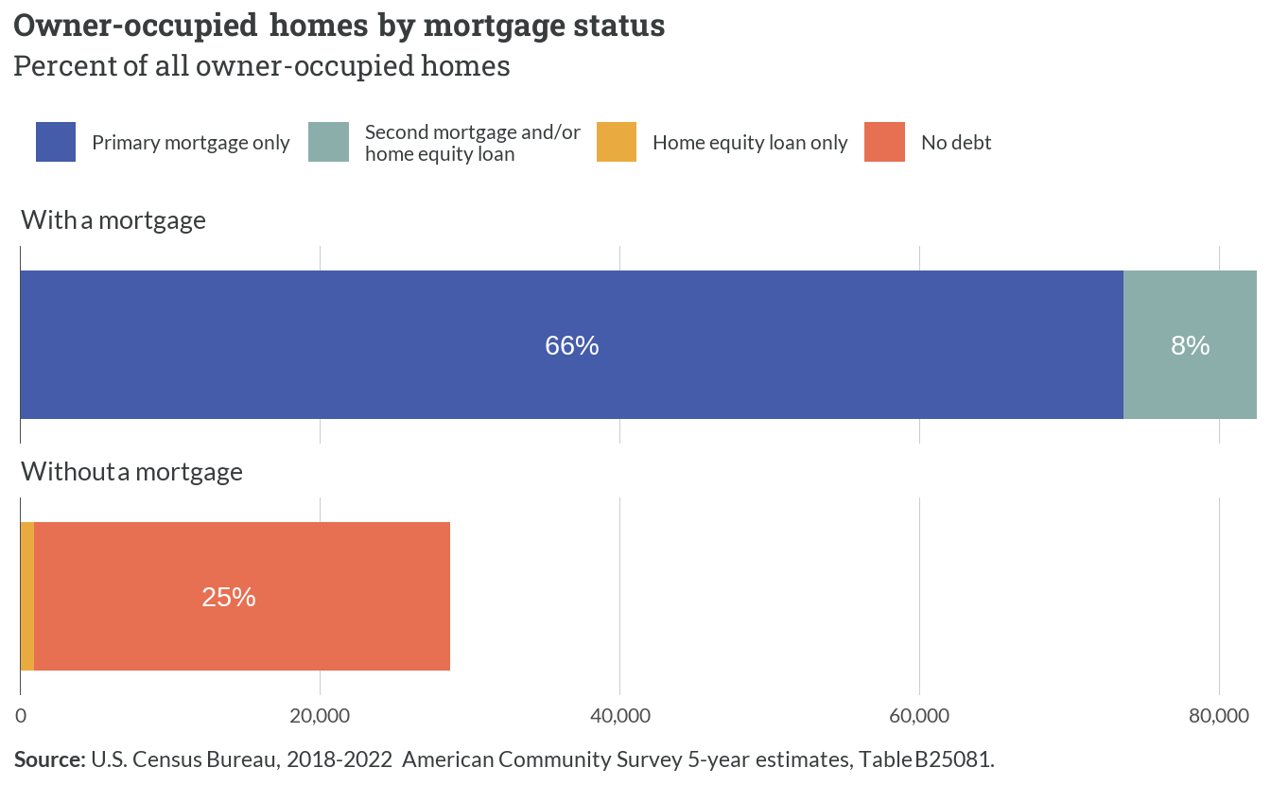

*Figure 3.1: Owner-occupied homes by mortgage status*

Most homes in the existing supply are single family units with three to four bedrooms, units that could easily accommodate households with upwards of four people and more. Nearly 16,000 units in the region have five bedrooms or more, and fewer than 10,000 homes in the region are sized for families of two people or fewer.

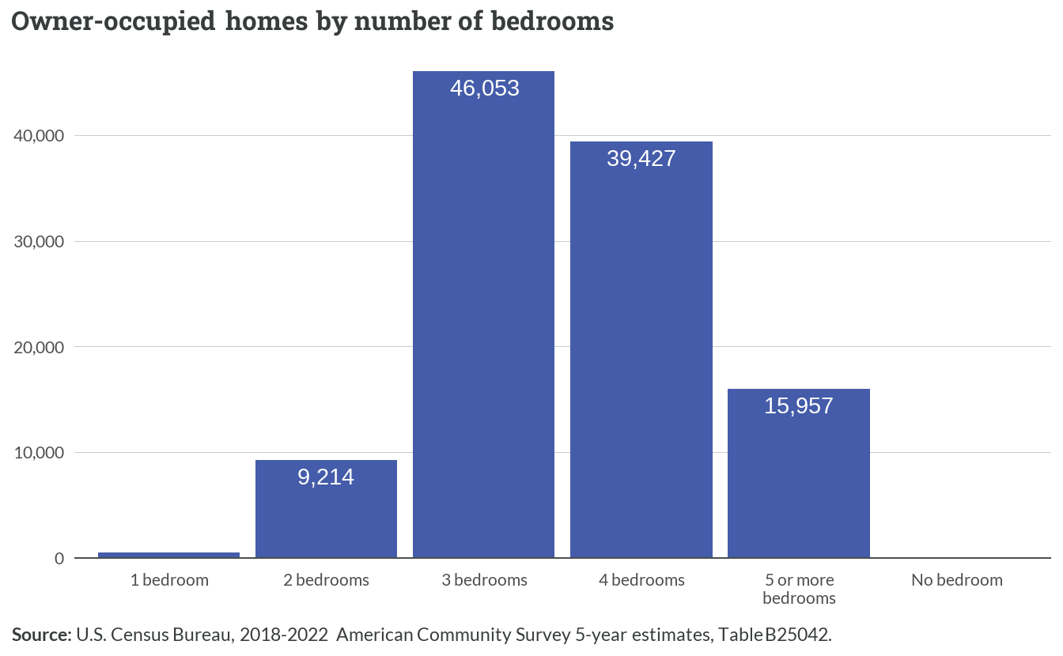

*Figure 3.2: Owner-occupied homes by number of bedrooms*

The housing stock in the region is predominantly composed of single-family detached homes, which account for about 88% (97,661) of all owner-occupied units. Single-family attached homes represent the second most common structure type with 9,309 units. The remaining housing types — including 2-4 unit buildings, larger multifamily structures, manufactured homes, and other configurations — collectively comprise less than 4% of owner-occupied housing stock.

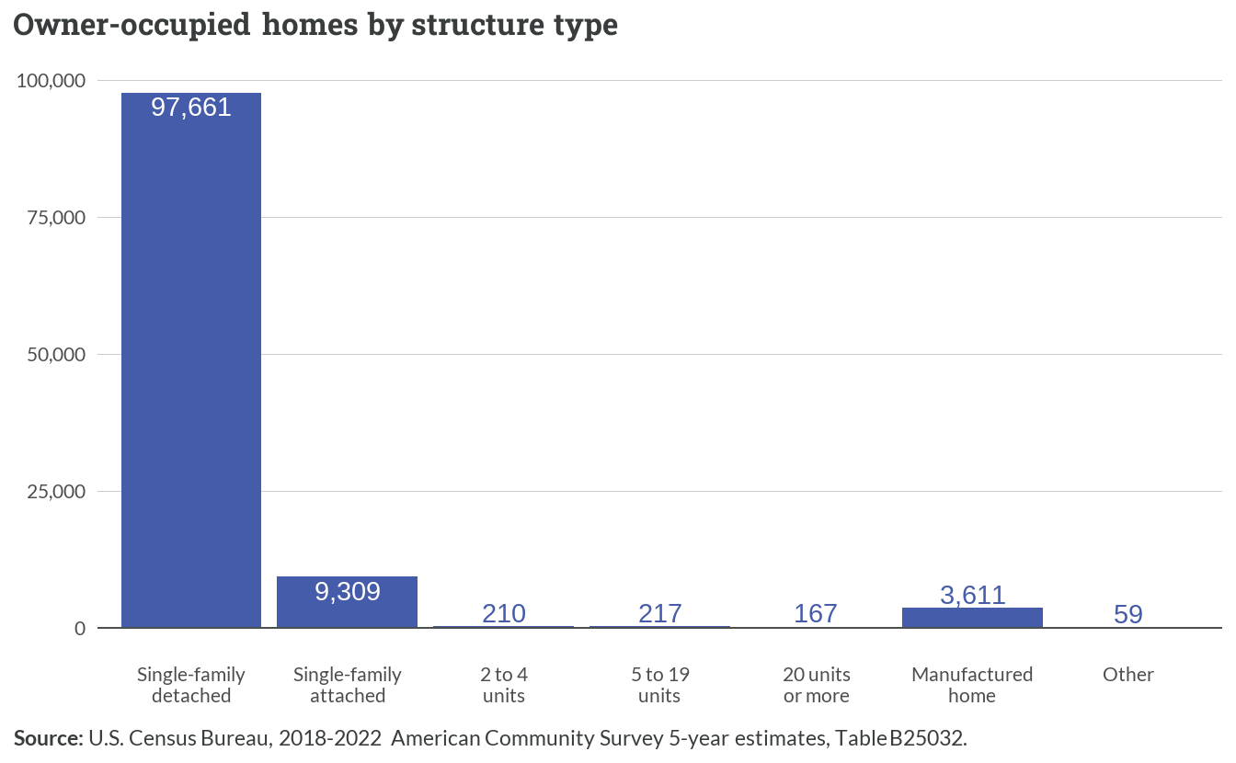

*Figure 3.3: Owner-occupied homes by structure type*

Home values in the region show a clear concentration in the middle price ranges, with the $300,000-$499,999 bracket containing the largest share of owner-occupied homes. This price segment shows roughly equal distribution between mortgaged and non-mortgaged properties. Higher-value properties ($750,000 and above) represent a relatively small portion of the market, while homes valued under $200,000 account for approximately 15% of the owner-occupied stock.

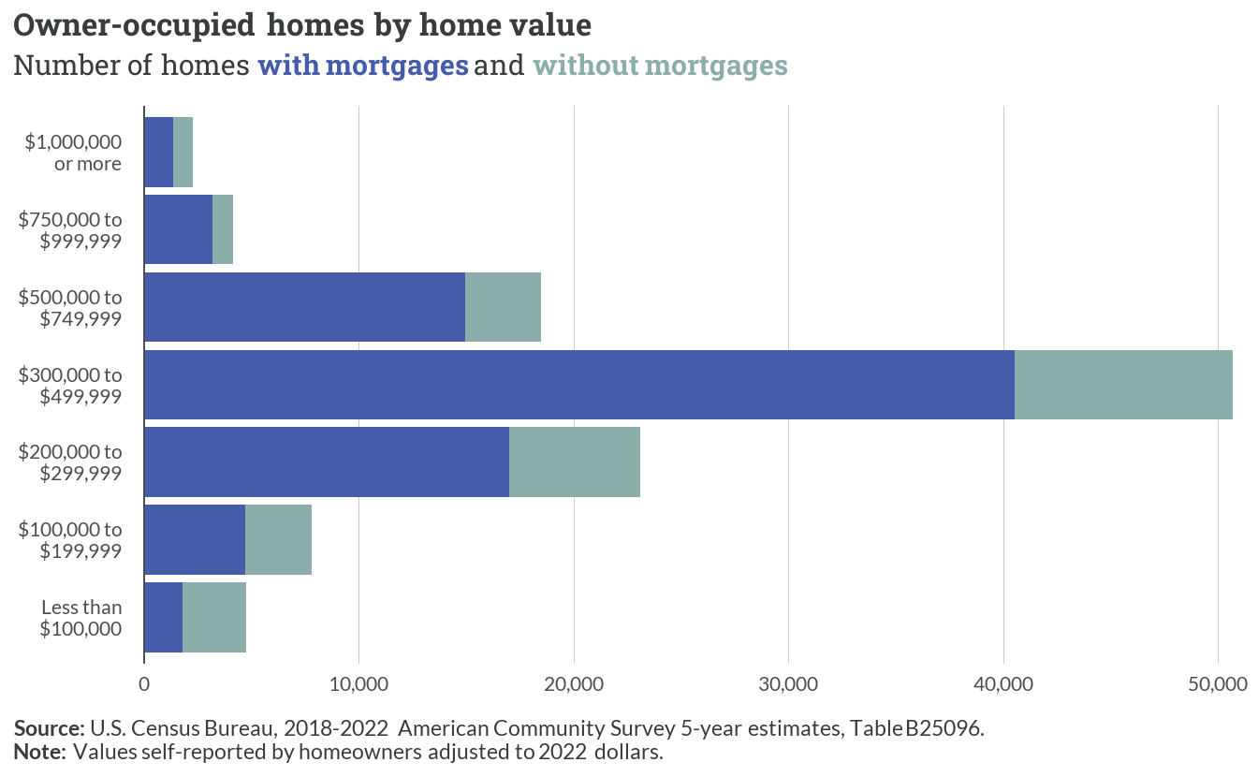

*Figure 3.4: Owner-occupied homes by home value*

Monthly housing costs for owner-occupied homes in the region exhibit notable variation, with the largest segment (43,668 households) paying more than $2,000 per month for housing-related expenses. About 26,489 households (26%) have relatively lower monthly costs under $1,000, while the middle cost ranges ($1,000-$1,999) account for approximately 30,918 households. This distribution suggests significant disparities in housing cost burdens across the region’s homeowners.

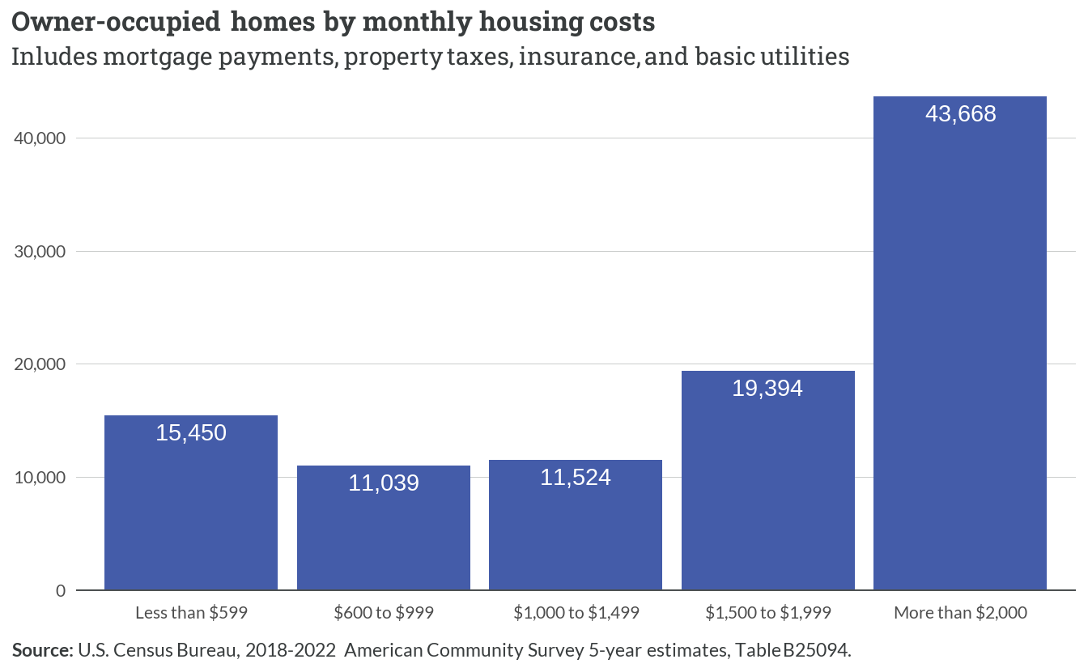

*Figure 3.5: Owner-occupied homes by monthly housing costs*

## 3.2 Building trends

Single-unit permits dominated the construction landscape since 2000, peaking around 2004 at approximately 5,000 permits before declining sharply to stabilize between 1,500-2,000 permits annually after 2008. Multifamily construction (5+ units) showed modest but consistent activity, while 2-4 unit structures remained minimal throughout the period. The vast majority of new homes produced in the region were built to be sold.

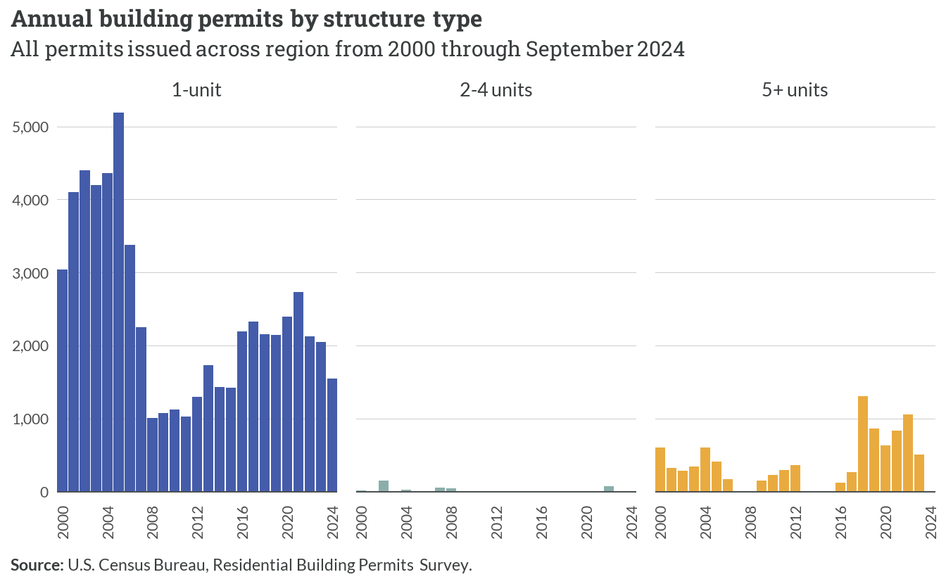

*Figure 3.6: Annual building permits by structure type*

Among localities, Stafford and Spotsylvania demonstrated the strongest growth trajectories, reaching approximately 22,000 and 19,000 cumulative permits respectively. The remaining localities — Orange, Caroline, King George, and Fredericksburg — showed more modest growth, each accumulating between 2,000 and 6,000 permits over the period.

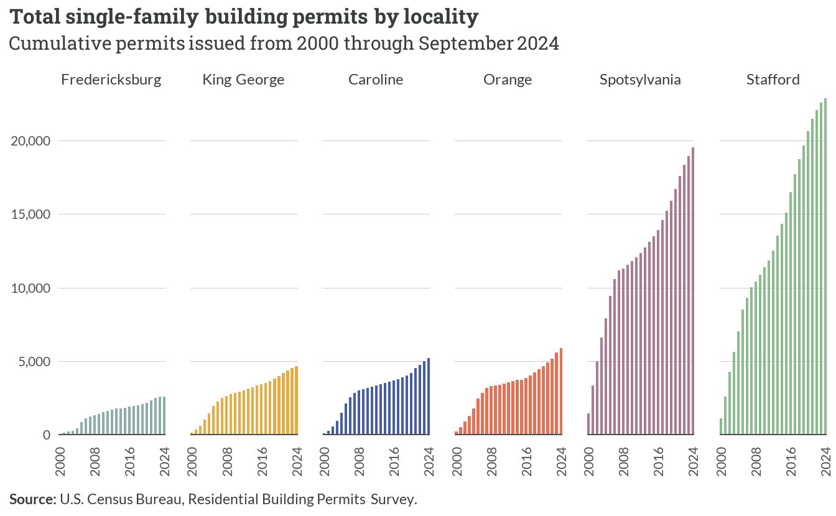

*Figure 3.7: Total single-family building permits by locality*

The chart below depicts relative changes in single-family building permit activity, indexed to 2000 levels. Caroline County and Fredericksburg showed the highest relative volatility, reaching peaks significantly above their baselines in the mid 2000s. Following declines during and after the Great Recession, most localities have seen stronger production levels in recent years. While Stafford and Spotsylvania account for most of the raw production totals, their rates of residential development today are well below the pace they set in the 2000s.

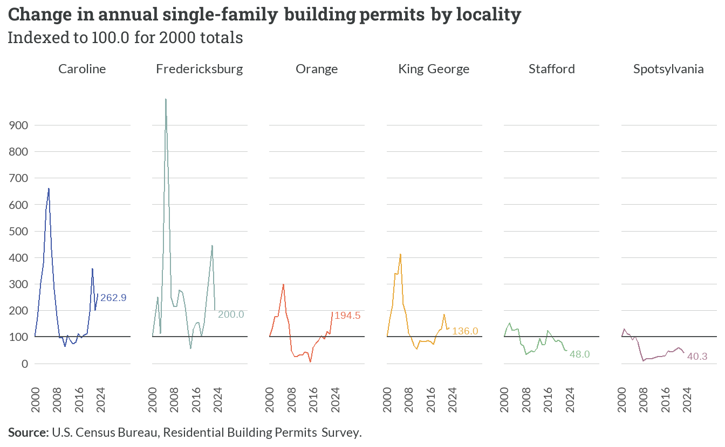

*Figure 3.8: Change in annual single-family building permits by locality*

New single-family construction has been spread throughout the region, but several concentrated areas are noticeable on the map below. These include larger subdivisions around the following places:

* Ladysmith and Bowling Green (Caroline County)
* Hop Yard Landing (King George County)
* New Post and Harrison Village (Spotsylvania County)
* Southern Gateway, Embrey Mill, and Shelton Woods (Stafford County)
* Lake of the Woods (Orange County)

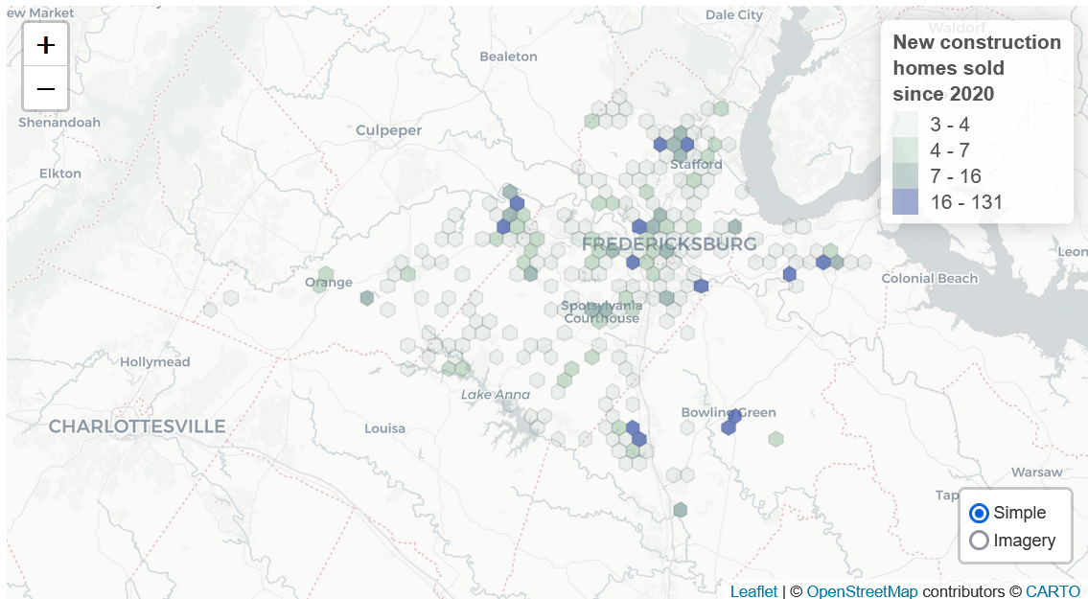

*Figure 3.9: New construction home sales activity*

Four-bedroom homes consistently represent the largest segment of new construction, peaking at approximately 350 new units sold in 2022. Smaller three-bedroom homes maintained steady construction levels around 250 units annually, while five-bedroom homes showed relative stability at about 100 units annually.

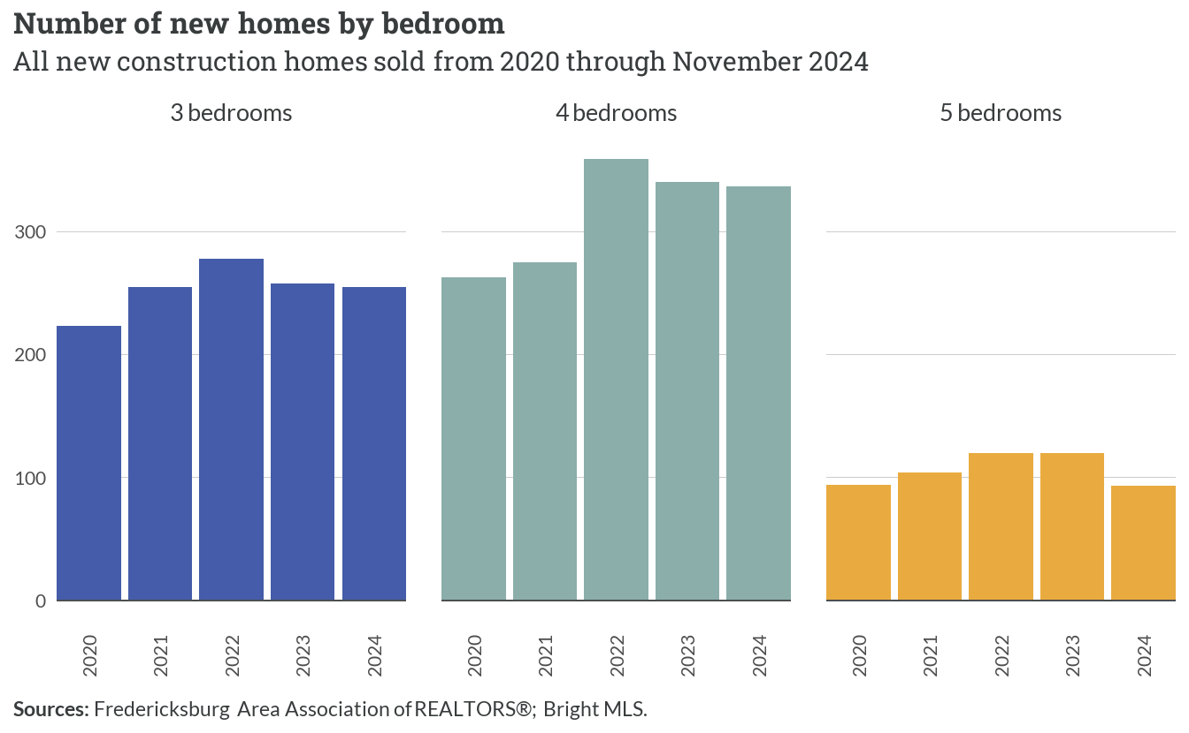

*Figure 3.10: Number of new homes by bedrooms*

Five-bedroom homes showed consistent size reduction from approximately 3,500 to 2,800 square feet. Four-bedroom homes maintained relative stability around 2,700 square feet, while three-bedroom homes remained steady at roughly 1,800 square feet throughout the period.

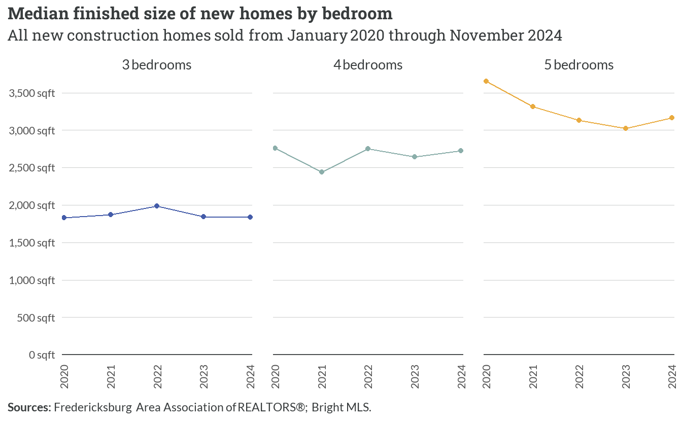

*Figure 3.11: Median finished size of new homes by bedroom*

## 3.3 Market trends

### Regional market

The total volume of home sales in the Fredericksburg region shows distinct seasonal patterns overlaid with broader market trends. Peak activity consistently occurs in late spring/early summer, with notable spikes reaching approximately 1,000 monthly sales in 2020 and 2021. However, the market has experienced a gradual decline in overall volume since 2021, with recent months showing sales levels around 500 units — roughly half the volume seen during the market’s peak periods.

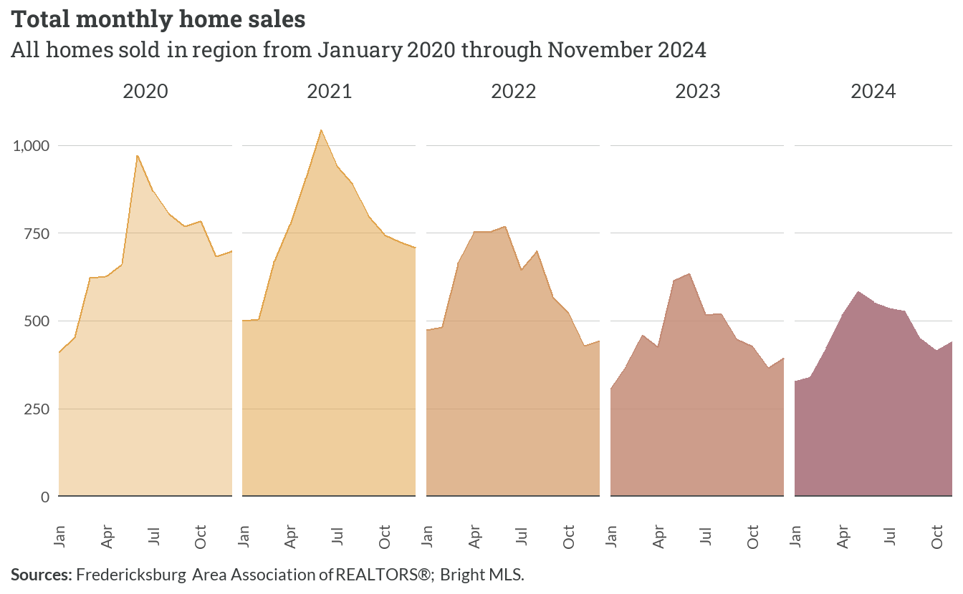

*Figure 3.12: Total monthly home sales*

The median time homes spend on the market reveals significant market evolution over the study period. Early 2020 saw homes taking about 30 days to sell, followed by a sharp decline to 5-10 days during the pandemic-driven market acceleration. Since 2022, average days on market in the off seasons has partially returned to pre-pandemic levels, but most homes in the spring of 2024 still sold in fewer than 10 days.

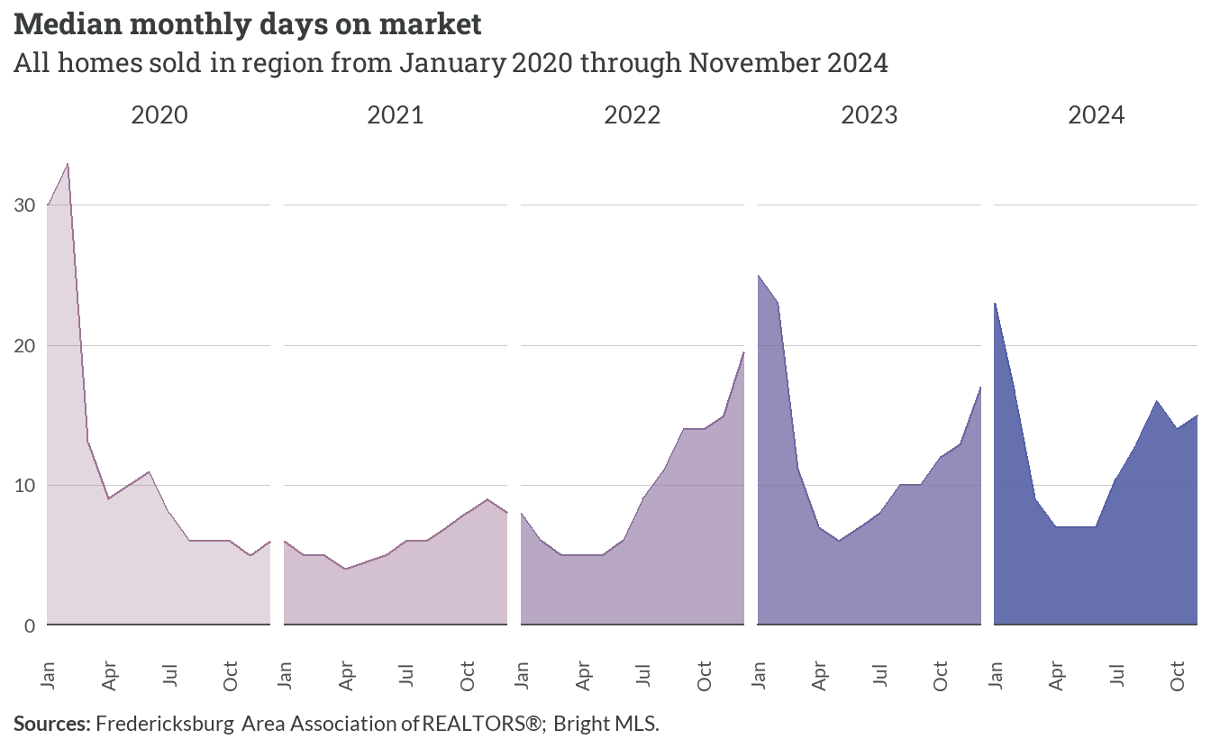

*Figure 3.13: Monthly median days on market*

Median home sale prices demonstrate consistent upward momentum throughout the period. Starting from approximately $300,000 in early 2020, prices have risen steadily, with particularly sharp increases during 2021 and 2022. Current median prices (as of November 2024) hover around $470,000, representing a roughly 55% increase over the four-year period, though the rate of appreciation appears to have moderated in recent months.

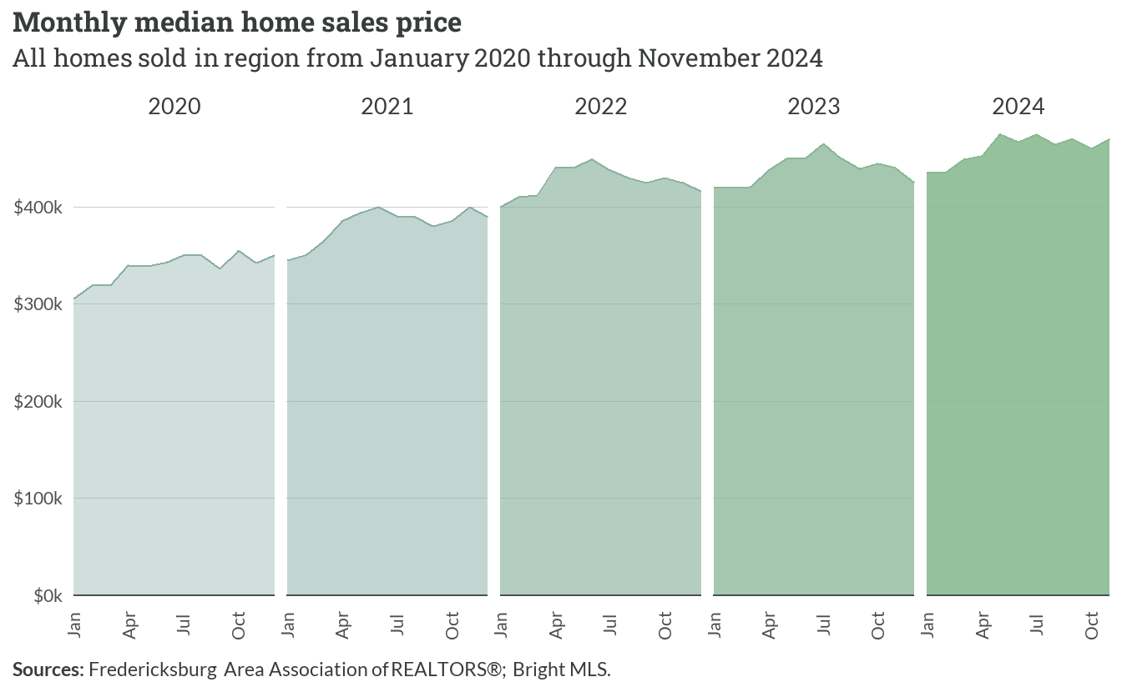

*Figure 3.14: Monthly median sales price*

The distribution of closing prices across different price segments highlights the market’s structural transformation. In early 2020, about 45% of sales occurred below $300,000, while only 5% exceeded $500,000. By late 2024, this distribution has shifted dramatically — only 8% of sales fall below $300,000, while approximately 51% of transactions occur above $500,000, reflecting both home price appreciation and changes in the composition of sales activity.

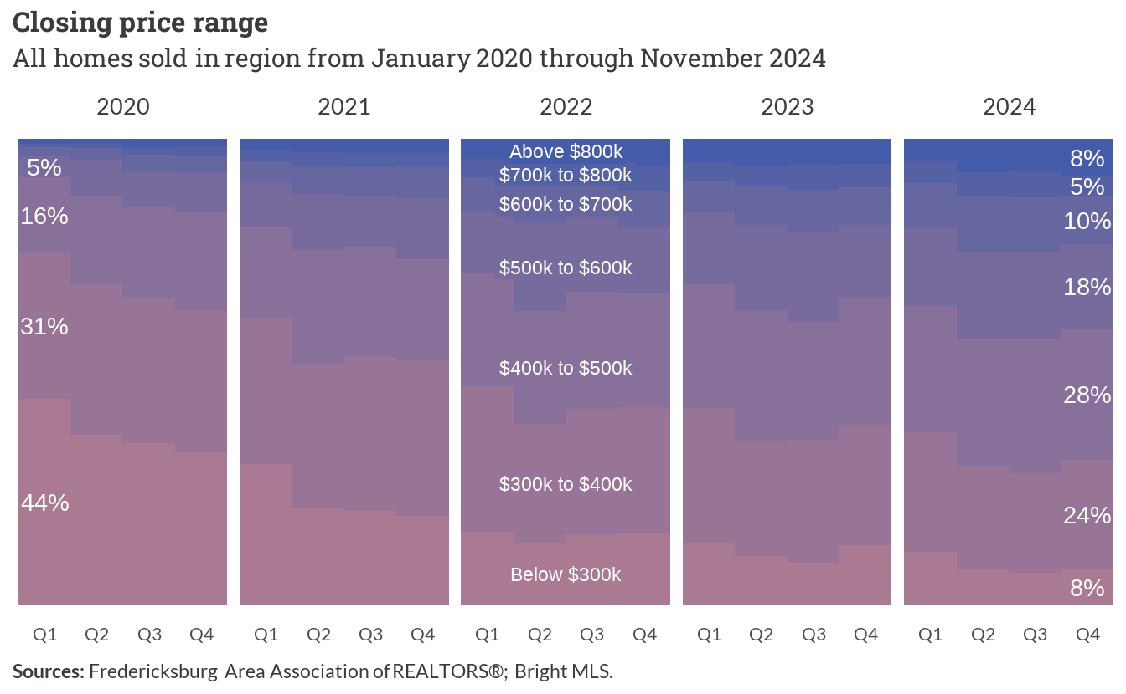

*Figure 3.15: Closing price range*

### Local markets

The distribution of home sales volume across localities reveals stark differences in market size and trajectory. Stafford and Spotsylvania dominate the regional market, each recording over 3,000 annual sales at their peak in 2021. However, both jurisdictions have experienced substantial declines, with current volumes approximately 60% below their peaks. The region’s smaller markets, including Orange, Caroline, King George, and Fredericksburg, demonstrate more modest but still significant reductions, with current annual sales volumes ranging from about 100 to 600 units.

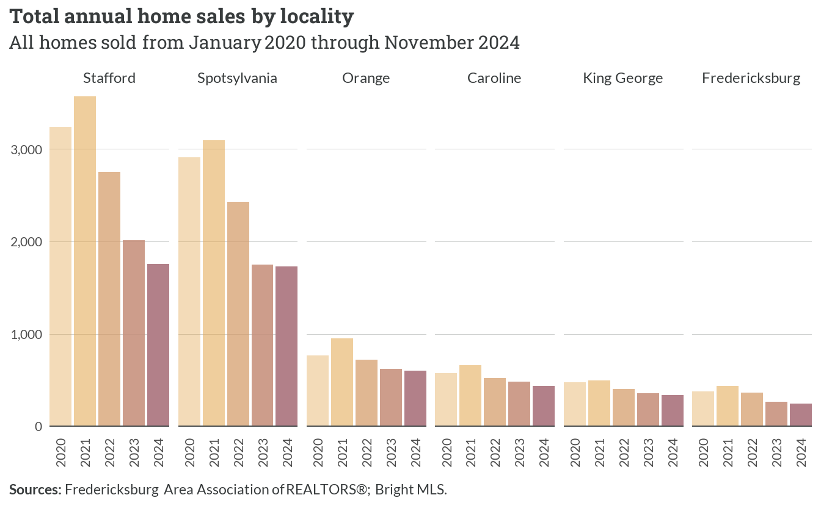

*Figure 3.16: Total annual home sales by locality*

Market velocity, measured by median days on market, shows increasing differentiation between localities over time. While all jurisdictions experienced extremely rapid sales during 2021-2022 with median marketing periods of 5-10 days, recent trends reveal growing disparity. Stafford, Spotsylvania, and Fredericksburg maintain relatively quick sales at 8-10 days, while Orange and Caroline have seen marketing times extend closer to 20 days. King George occupies the middle ground with typical marketing periods just under 15 days.

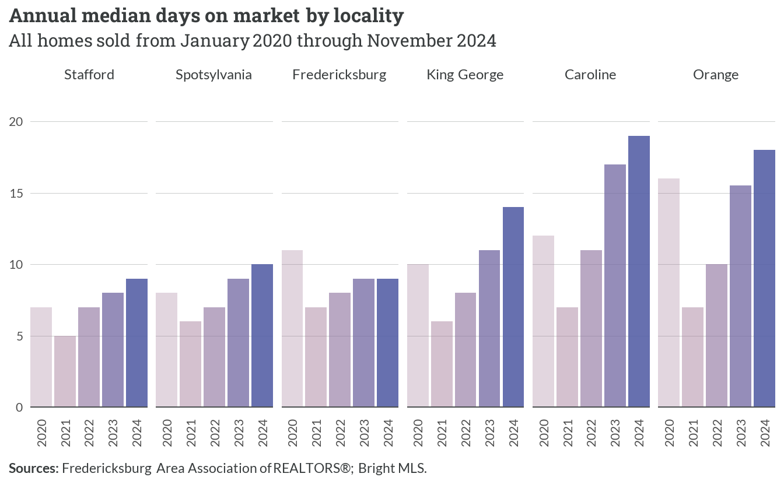

*Figure 3.17: Annual median days on market by locality*

Price appreciation patterns demonstrate both the region’s overall growth and persistent jurisdictional differences. Stafford leads the market with median prices now exceeding $500,000, representing about 35% appreciation since 2020. The remaining jurisdictions cluster between $350,000 and $450,000, with King George, Fredericksburg, and Spotsylvania showing similar trajectories. Orange and Caroline, while experiencing steady growth, maintain lower price points with current medians near $410,000 and $365,000 respectively.

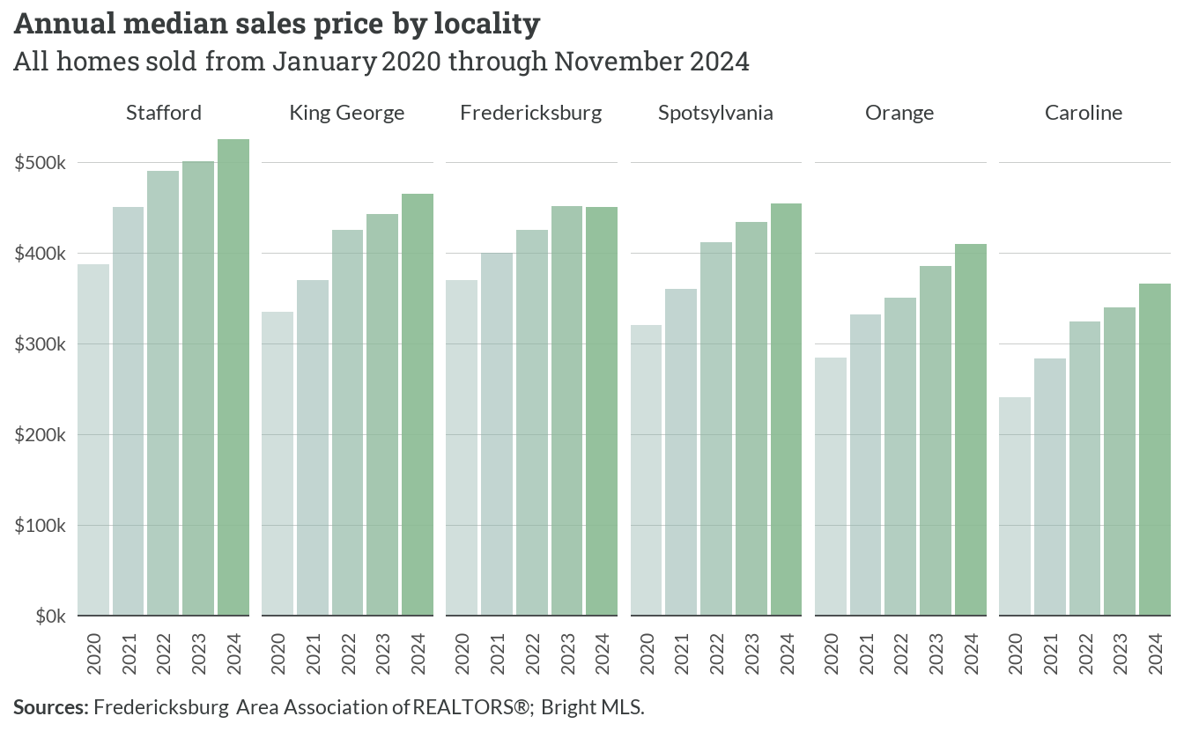

*Figure 3.18: Annual median sales price by locality*

**Market segments**

The market dynamics between detached homes and townhomes reveal divergent volume trends but similar price trajectories. Annual sales of detached homes peaked near 8,000 units in 2021 before declining sharply to about 4,000 units by late 2024. Townhome sales, while more modest in volume, maintained relatively stable levels around 1,000-1,200 units annually until 2023. Both segments have experienced steady price appreciation, with detached homes rising from about $360,000 to $485,000 and townhomes increasing from $270,000 to $390,000. Marketing times show growing differences, as detached homes now typically require 12 days to sell compared to 6-7 days for townhomes.

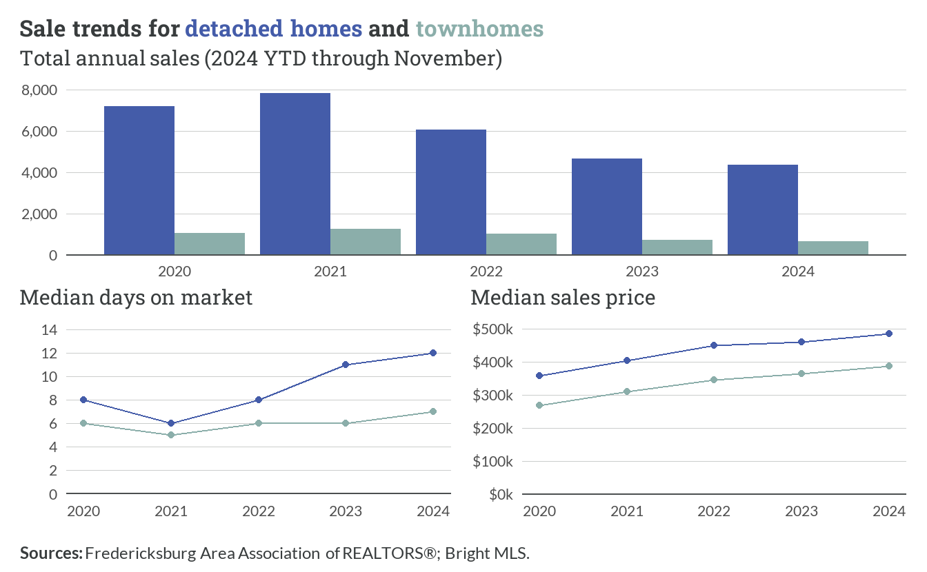

*Figure 3.19: Sale trends for detached homes and townhomes*

The comparison between resale and new construction markets highlights distinct patterns in both volume and buyer behavior. Resale transactions dominated the market with peak volumes exceeding 8,500 units in 2021, while new construction maintained consistent but much lower volumes around 800-1,000 units annually. Marketing periods for new homes have increased dramatically from 10 days in 2021 to nearly 40 days in 2024, while resale properties stabilized at about 10 days. Price trends show new construction commanding a significant premium, with current median prices near $500,000 compared to about $450,000 for resales, though both segments have experienced similar appreciation rates of roughly 30% since 2020.

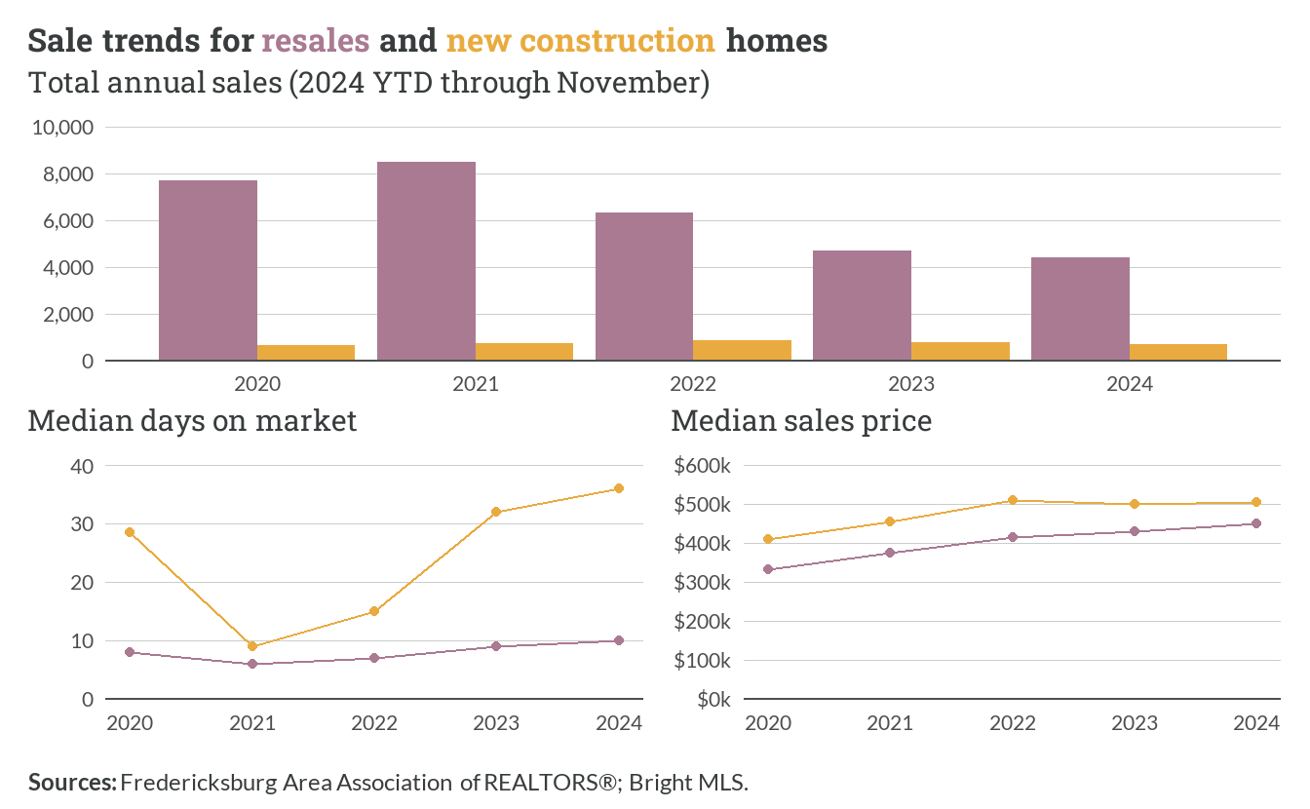

*Figure 3.20: Sale trends for resales new construction homes*

# 4  Rental market

## 4.1 Existing supply

Most of the approximate 35,240 rental homes in the Fredericksburg region have 2 or 3 bedrooms, with these sizes accounting for nearly 73% of all rental units. One-bedroom units make up about 14% of rentals, while larger homes with 4 or more bedrooms represent approximately 14% of the rental stock. A small number of rental units (778) have no bedrooms, typically representing studio apartments.

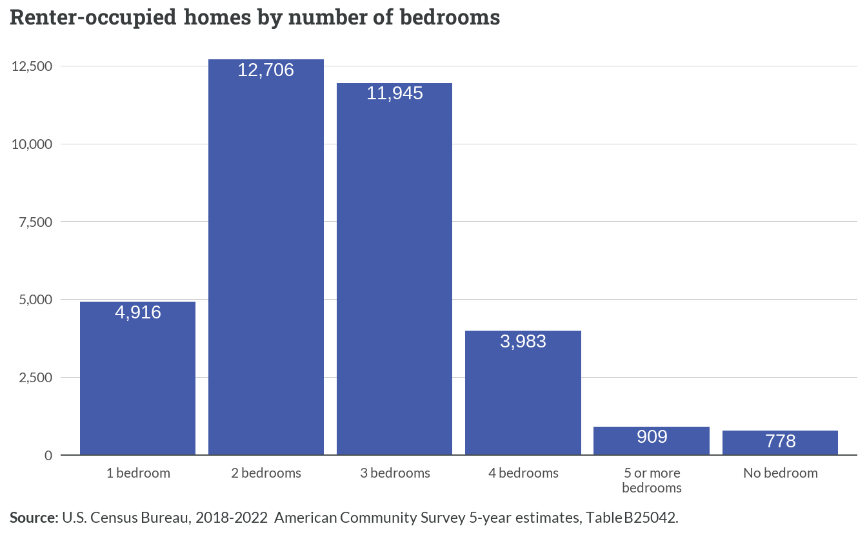

*Figure 4.1: Renter-occupied homes by number of bedrooms*

Single-family homes comprise the majority of rental properties in the region, with detached houses accounting for about 37% of units and attached homes making up another 16%. Multi-unit properties of varying sizes constitute about 45% of rentals, split between smaller properties with 2-4 units (6%), mid-sized buildings with 5-19 units (27%), and larger complexes with 20 or more units (12%). Manufactured homes account for 4% of rental properties.

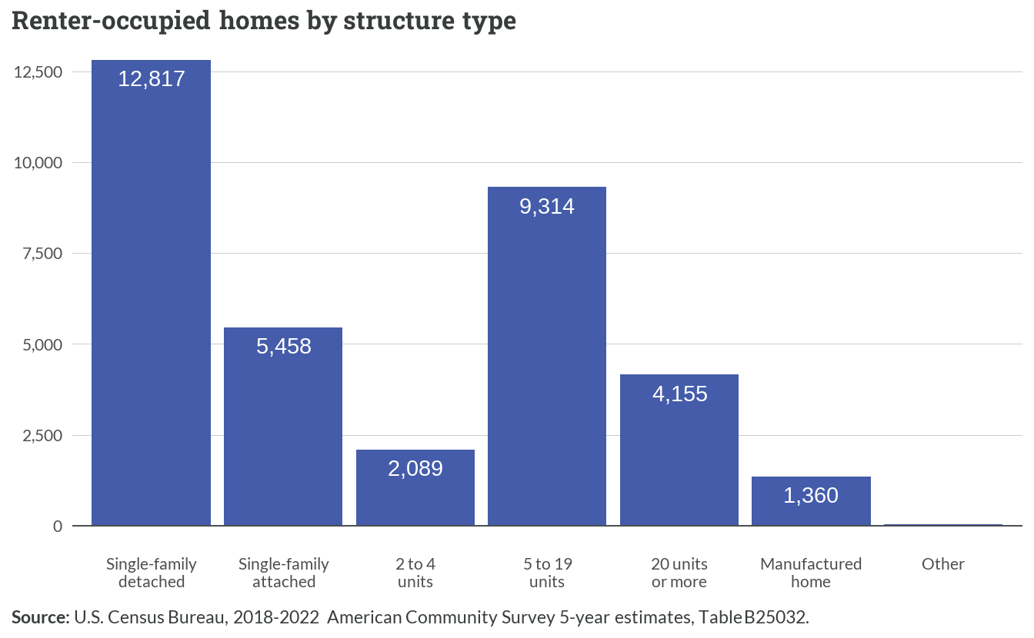

*Figure 4.2: Renter-occupied homes by structure type*

The most common rent range in the region is $1,500 to $1,999 per month, representing nearly 31% of all rental units. Another 27% of rentals fall between $1,000 and $1,499 monthly. Lower-cost units with rents under $1,000 make up about 15% of the market, while higher-end rentals above $2,000 represent approximately 22%. About 5% of rental units report no cash rent, typically indicating housing provided as part of employment or family arrangements.

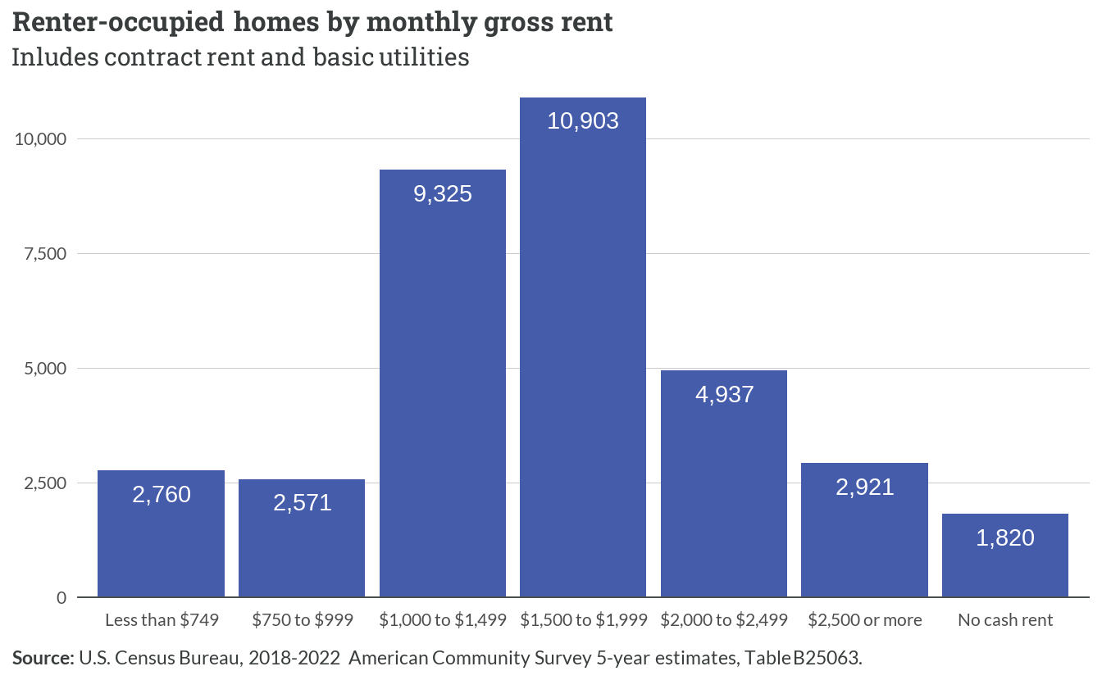

*Figure 4.3 Renter-occupied homes by monthly gross rent*

## 4.2 Building trends

Since the Census Building Permit Survey is unable to disaggregate building permits by tenure, this analysis assumes all multi-unit permits are for rental development. New multifamily building permits across the region show distinct patterns by structure type. The vast majority of permits have been issued for larger buildings with 5 or more units, with significant spikes in permitting activity occurring in the early 2000s and again in recent years. Meanwhile, permits for smaller multifamily structures, including 2-unit and 3-4 unit buildings, have remained consistently low throughout the period.

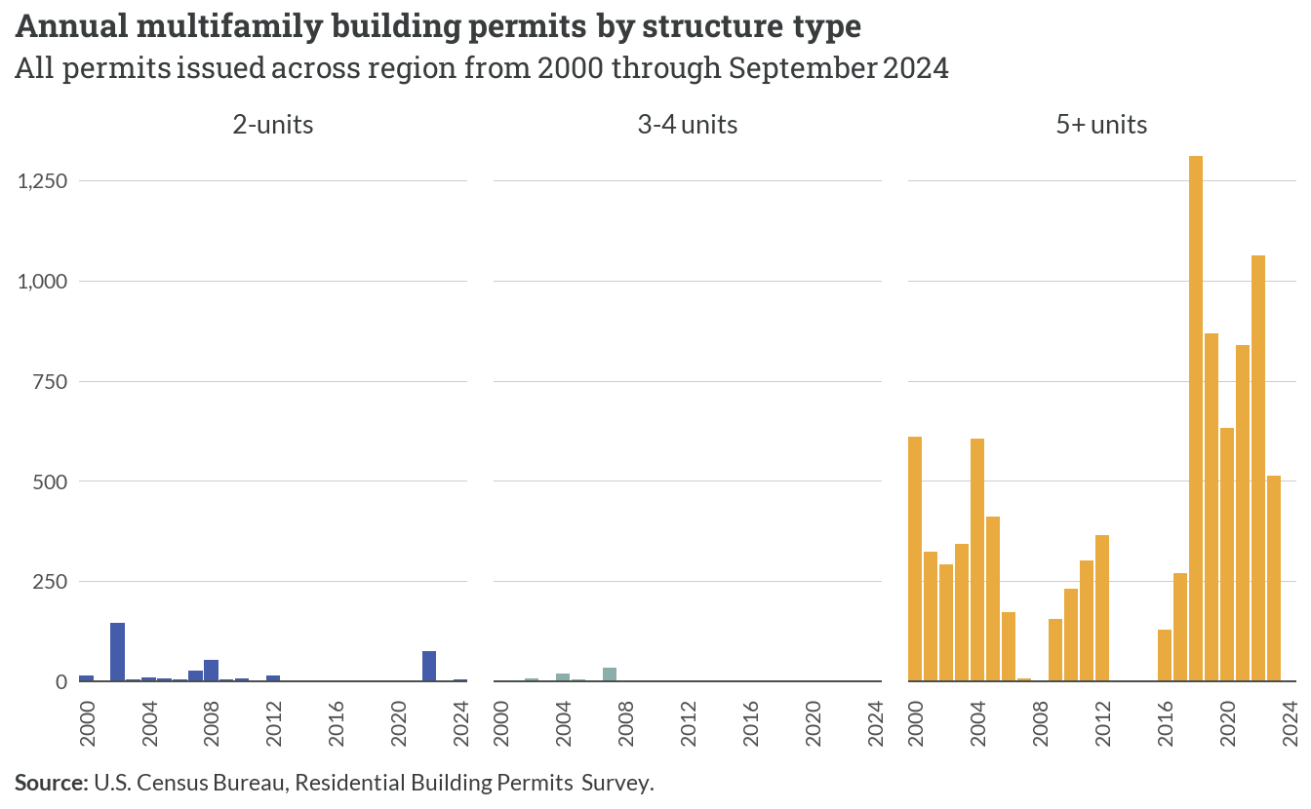

*Figure 4.4: Annual multifamily building permits by structure type*

The cumulative total of multifamily permits issued since 2000 varies dramatically by locality. Spotsylvania County has seen the most substantial growth in multifamily permits, with a sharp acceleration starting around 2016. Stafford County shows steady but more moderate growth over the period, while Fredericksburg demonstrates consistent incremental increases. The remaining localities — Caroline, King George, and Orange — show minimal multifamily permitting activity over the past two decades.

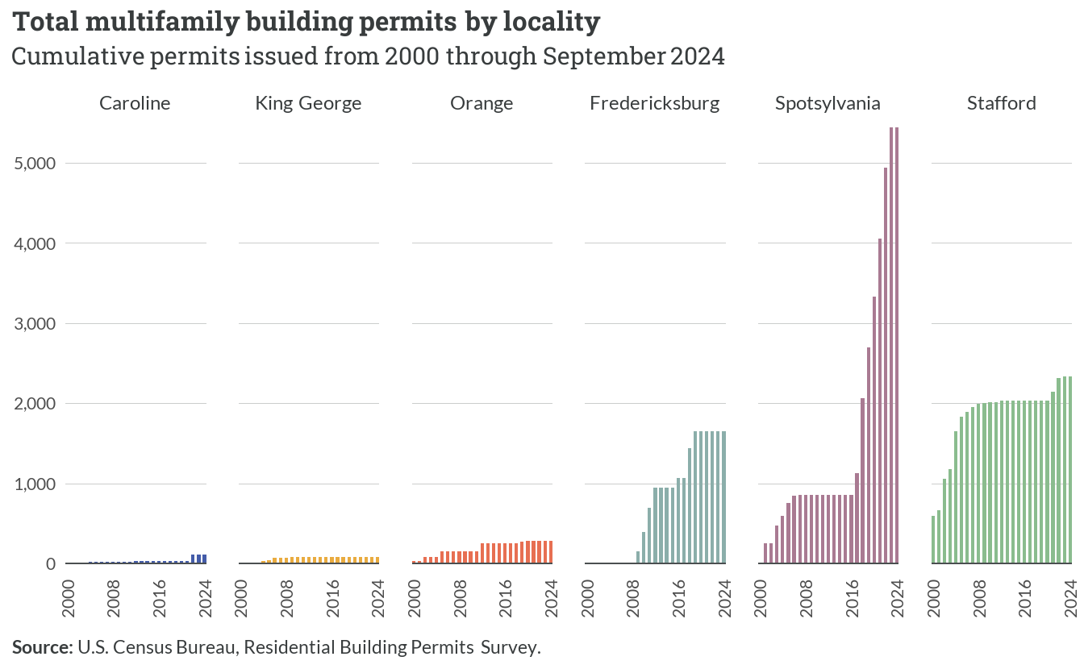

*Figure 4.5: Annual multifamily building permits by locality*

Based on CoStar data, construction activity for larger multifamily developments has fluctuated considerably since 2015. The number of units under construction peaked in early 2016 at over 1,700 units, followed by another significant surge in early 2019 reaching approximately 1,600 units. Recent quarters show a general downward trend in construction activity, with levels in 2023 falling below 600 units — some of the lowest observed in the time period.

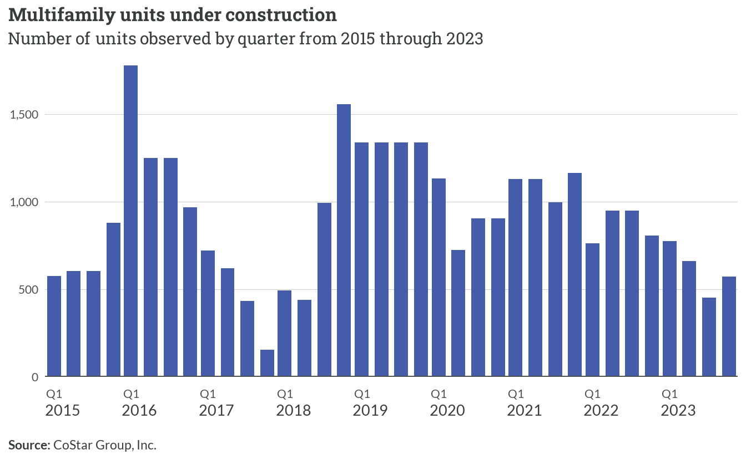

*Figure 4.6: Multifamily units under construction*

## 4.3 Market trends

The average asking rent in Fredericksburg has shown distinct patterns between nominal and inflation-adjusted values since 2015. While nominal rents steadily increased from around $1,200 to nearly $1,700 per unit, inflation-adjusted rents remained relatively stable between $1,700 and $1,800 until 2020. A notable spike occurred in 2021-2022, pushing inflation-adjusted rents above $1,900, before declining through 2023 and stabilizing near $1,750 in early 2024.

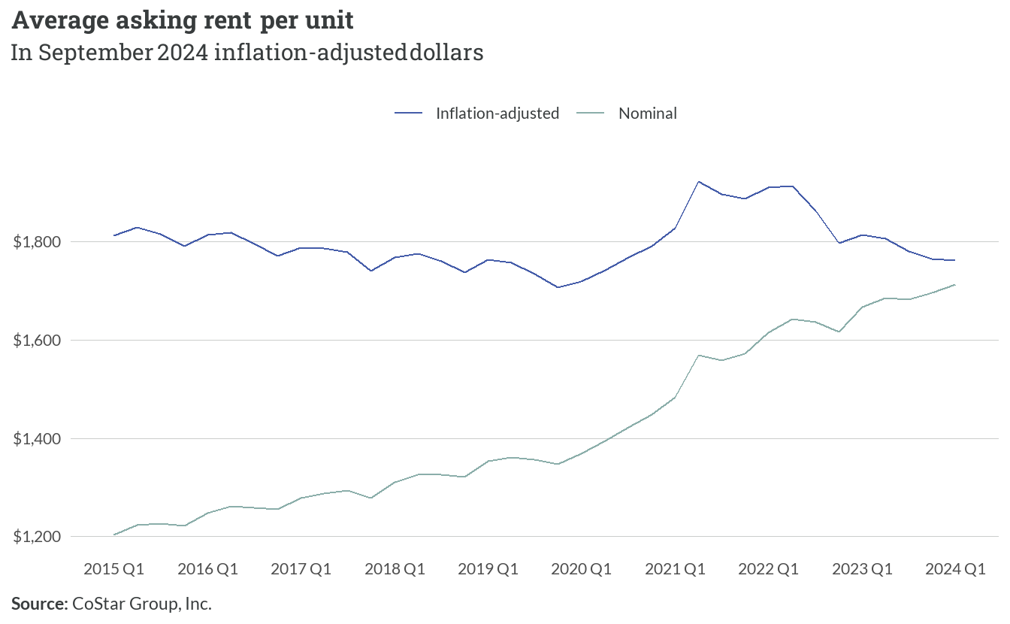

*Figure 4.7: Average asking rent*

This cycle of average asking rents changing roughly $150 from 2021 to 2023 perhaps reflects the influence of COVID-era rental support systems and eviction prevention measures that were available in Virginia. These programs were largely phased out by 2023, with following years showing increased eviction rates and market rents rising.

The reduction in rent from 2021 to 2023 could also be attributed to population migration and the rise of remote work in the pandemic era. Many households doubled up, with singles finding roommates or living with family, or households moving from urban areas to rural communities where they can still work remotely and afford rent. As demand reduced for rentals from 2021 to 2023 as a result, increased vacancy rates and reduced competition for units would drive down rents accordingly.

Quarter-over-quarter changes in average asking rent reveal significant volatility in the market since 2015. The most dramatic increase occurred in mid-2021, when rents jumped by approximately $85 in a single quarter. More recent trends show moderating changes, with quarterly adjustments typically ranging between $10-50 since 2023, suggesting a gradual return to historical patterns of incremental changes.

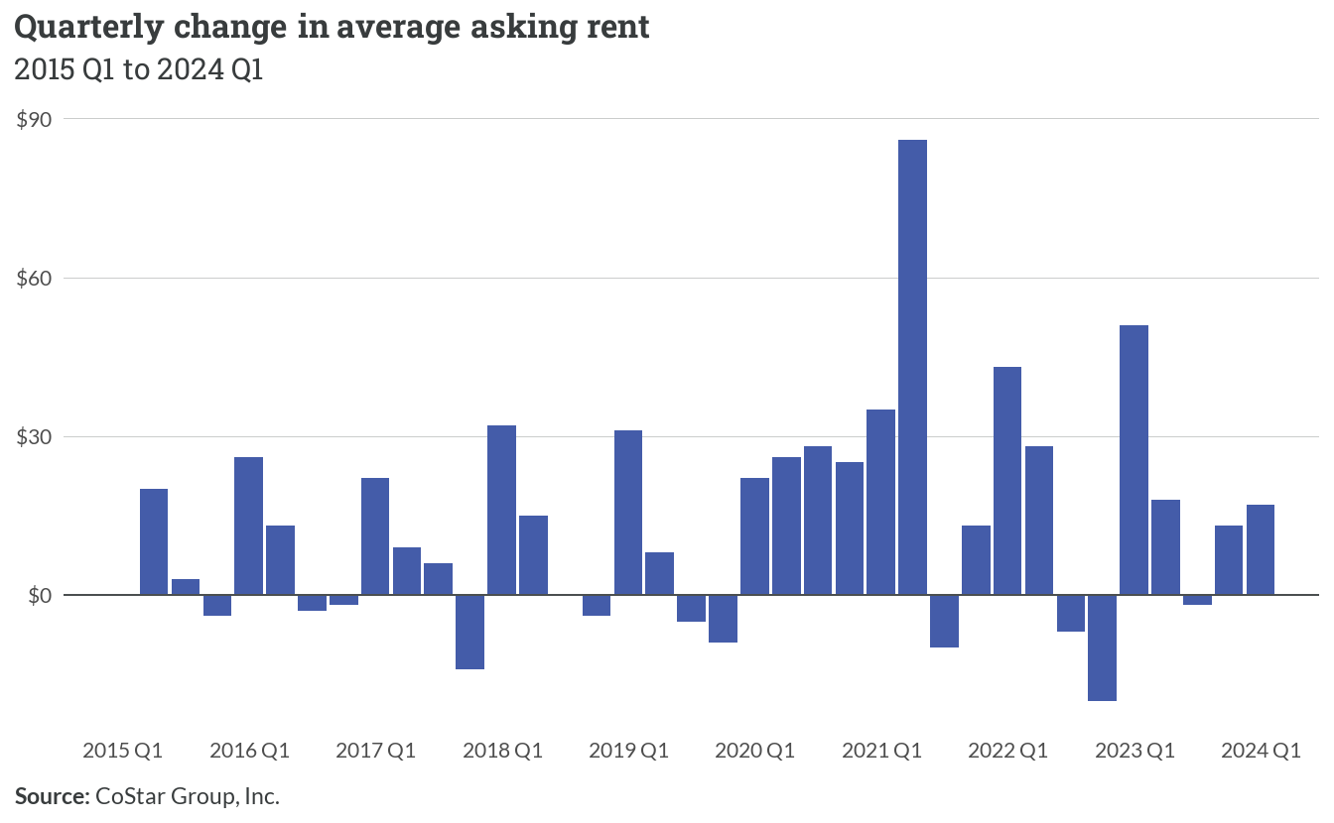

*Figure 4.8: Quarterly change in average asking rent*

Vacancy rates give information about the rental market’s supply-demand balance and the general health of the rental market. Low rental vacancy rates constrain the rental market, making it more difficult for low-income tenants to compete for homes as there are net fewer apartments available. Declining vacancy rates have significant consequences for home affordability, and can highlight supply and demand mismatches.

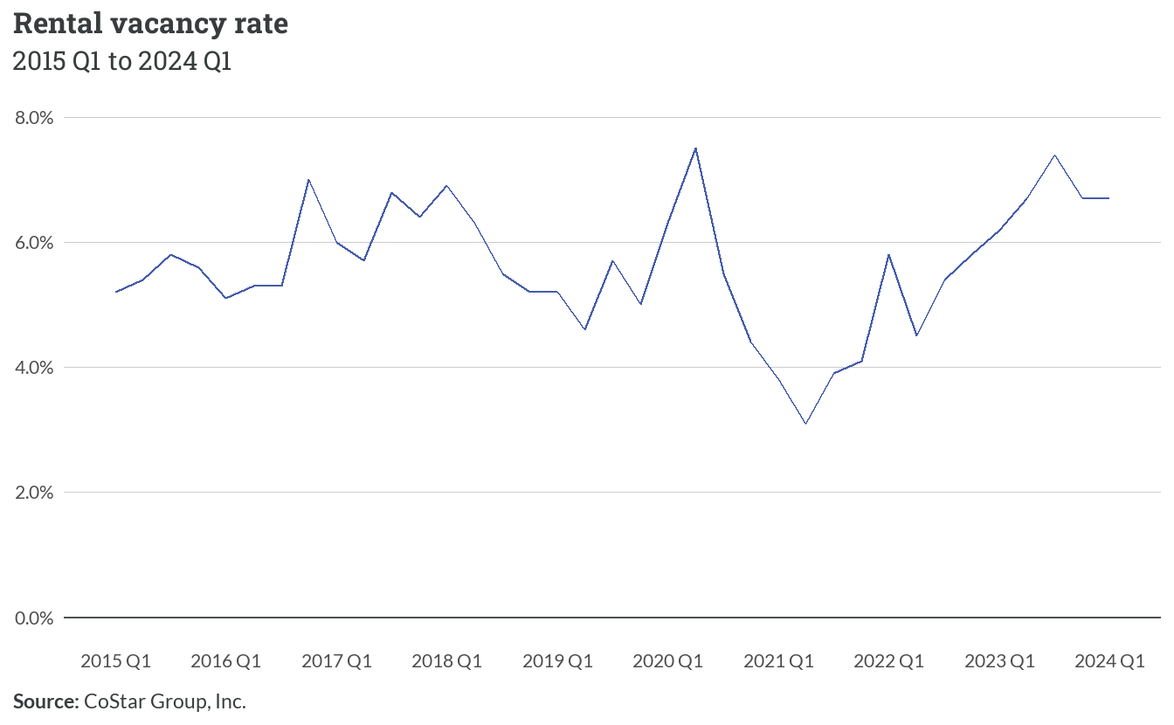

*Figure 4.9: Rental vacancy rate*

Through the COVID-19 pandemic era, rental vacancy rates across the country, including the Fredericksburg region, reached historic lows. The region has hovered around 6% vacancy rate since the pandemic, showing its position within the state as a rural-small market blend among the counties and growing exurbs.

A deeper examination at the year-to-year percent fluctuations reveals that, while the rental market loosened marginally in 2022 and 2023, with greater availability of rentals at decreasing prices. The most recent signs indicate the market tightening again, with the rental vacancy rate trending downward in 2024 with an estimated percent change in vacancy rate at -0.5%.

With the rental vacancy rate sitting near 6% currently, but a decreasing trend in the last four quarters, the region is likely seeing increasing monthly rental costs, as well as decreasing availability of units. This is also a factor that drives up rental prices.

## 4.4 Dedicated affordable rental housing

An array of federal housing assistance programs help low-income residents across the region with rental housing opportunities. Today, there are approximately 6,700 dedicated affordable rental homes found across 78 properties.

Stafford County leads the region with approximately 2,000 federally assisted housing units, followed closely by Fredericksburg City. Spotsylvania maintains a substantial presence with about 1,600 units, while Orange and King George counties have notably smaller inventories of roughly 400 and 350 units respectively. Caroline County has the smallest allocation with 145 units.

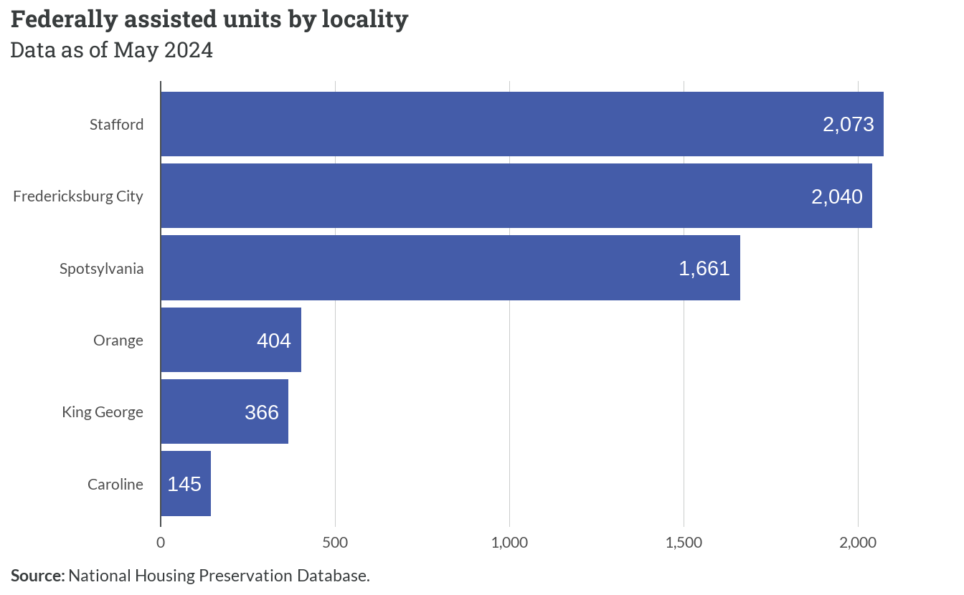

*Figure 4.10: Federally assisted units by locality*

The Low Income Housing Tax Credit (LIHTC) program dominates the region’s subsidized housing landscape, accounting for over three-quarters of all units. Section 8 and HUD-insured properties each represent approximately 8-10% of the total inventory. USDA Rural Housing Service (RHS) 515 and HOME programs constitute smaller shares at 4% and 1.4% respectively.

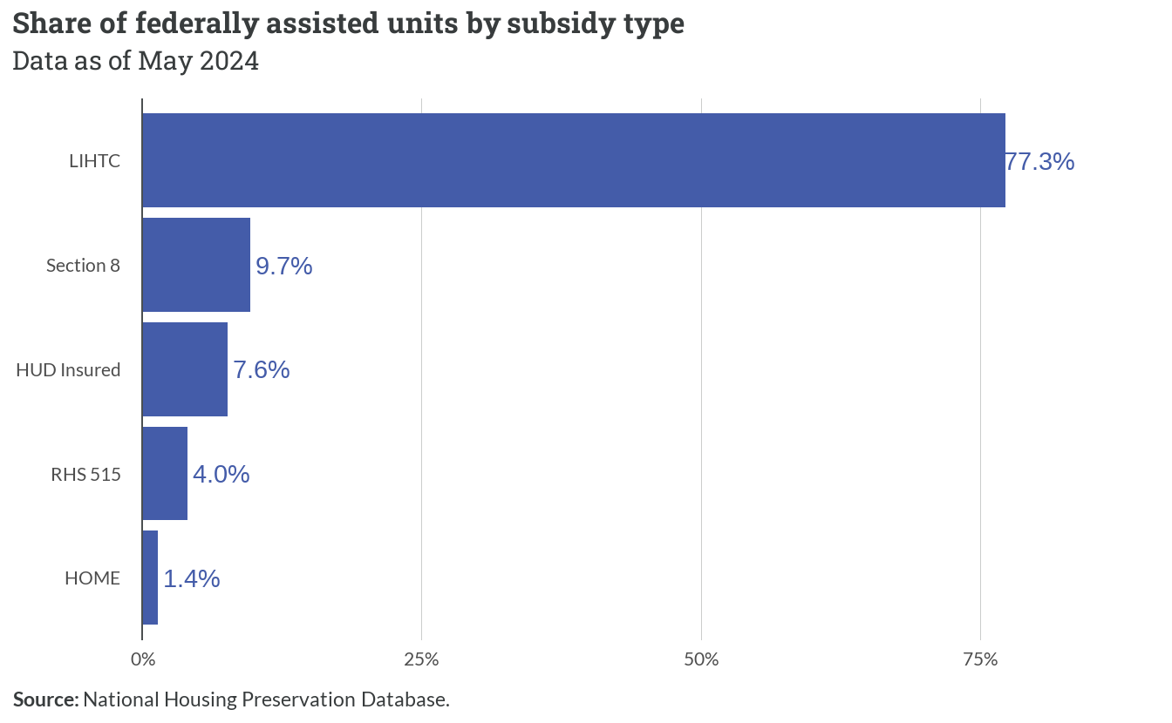

*Figure 4.11: Share of federally assisted units by subsidy type*

**Important**

*It is important to note that Section 8 described above is not the same as Section 8 Housing Choice Vouchers. Section 8 subsidies in the NHPD refer to HUD project-based rental assistance — meaning that they are rental assistance that is tied to a specific development, whereas Section 8 Housing Choice Vouchers are tenant-based subsidies that a recipient can take wherever they can find housing.*

In addition to those federally-assisted units, there are about 1,500 active Housing Choice Vouchers serving families throughout the region. In some cases, HCVs may be used at LIHTC properties to further lower tenants’ rents. Data is not readily available to determine how many units may have overlap.

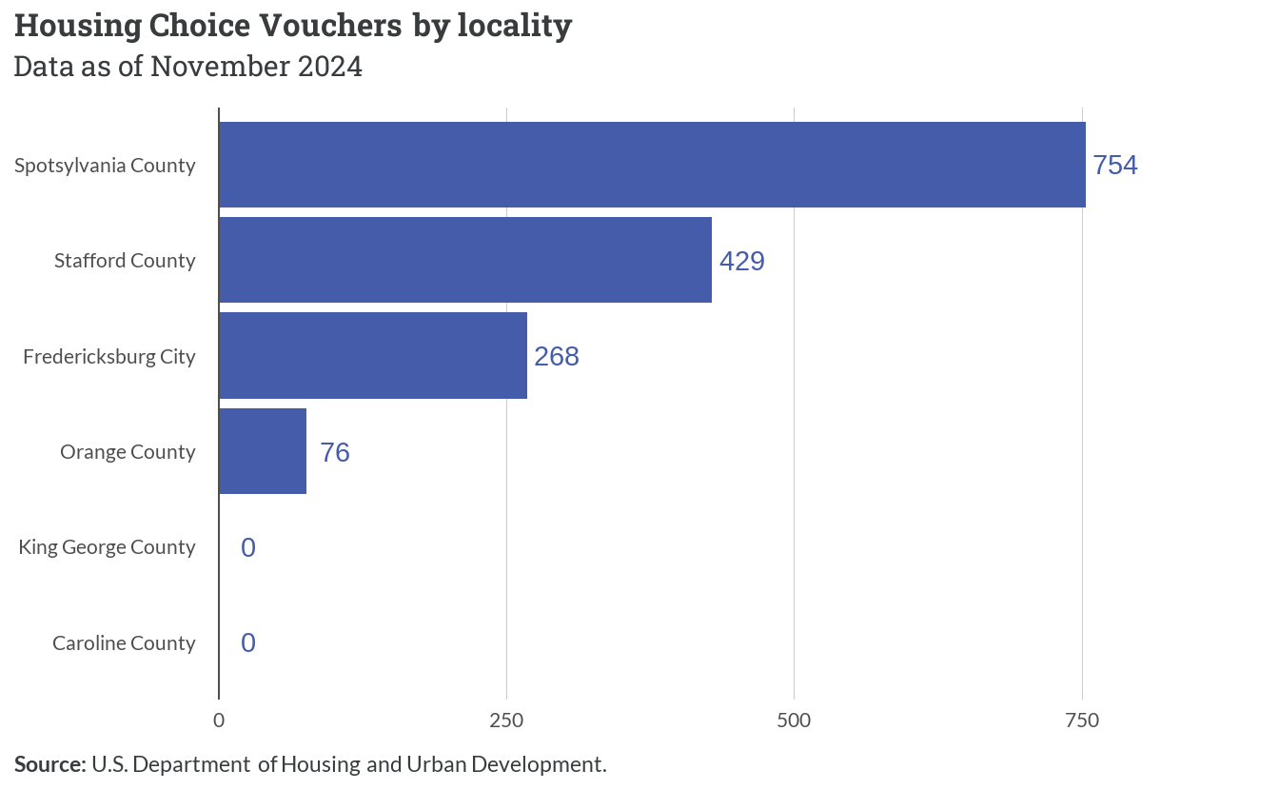

*Figure 4.12: Housing Choice Vouchers by locality*

The region faces important timing considerations regarding subsidy preservation, with 57% of federally assisted units having subsidies expiring within the next 9 years. Approximately one-quarter of units will reach expiration within 5 years, while an additional third face expiration in the 5-9 year timeframe. Only about 11% of units have subsidies extending beyond 20 years.

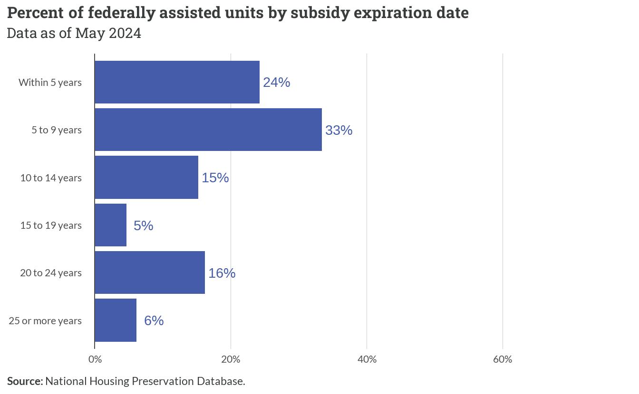

*Figure 4.13: Percent of federally assisted units by subsidy expiration date*

# 5  Current housing gaps

## 5.1 Overview

Monthly housing costs show substantial variation across income bands in the Fredericksburg region. Maximum affordable housing costs scale proportionally with Area Median Income (AMI), ranging from about $1,000 monthly for households below 30% AMI to over $4,000 for those above 120% AMI.

However, actual current housing costs demonstrate a compressed range between approximately $1,500 and $2,500 monthly across all income bands, creating particular affordability challenges for lower-income households.

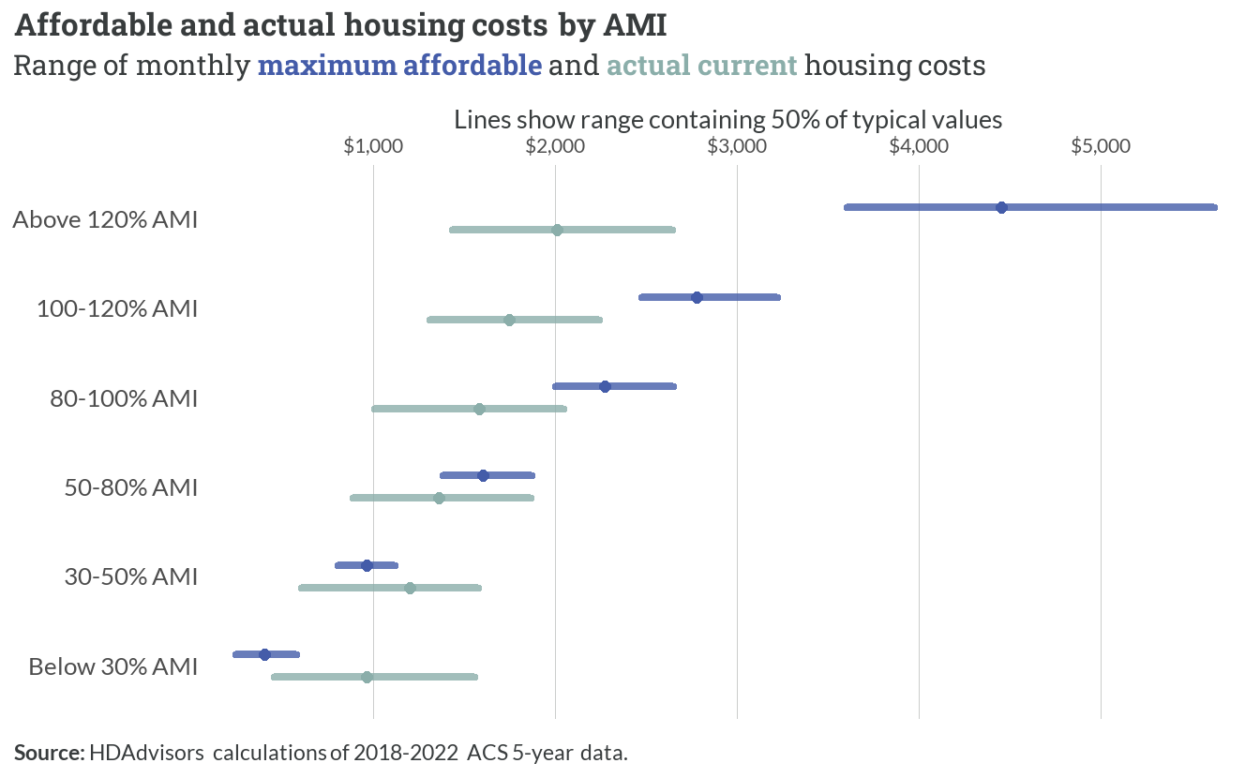

*Figure 5.1: Affordable and actual housing costs by AMI*

As a result of this mismatch, housing cost burdens reveal stark disparities between income groups, with similar patterns varying between core workforce and other households. Among core workforce households, severe cost burdens affect about two-thirds of those below 30% AMI, while an additional 44% of households between 30-50% AMI face moderate cost burdens.

The burden decreases significantly for higher income brackets, with only 7-8% of households above 80% AMI experiencing any cost burden. Similar patterns emerge for non-core workforce households, though with notably higher cost burdens in the 80-100% AMI range at 19% compared to 8% for core workforce households.

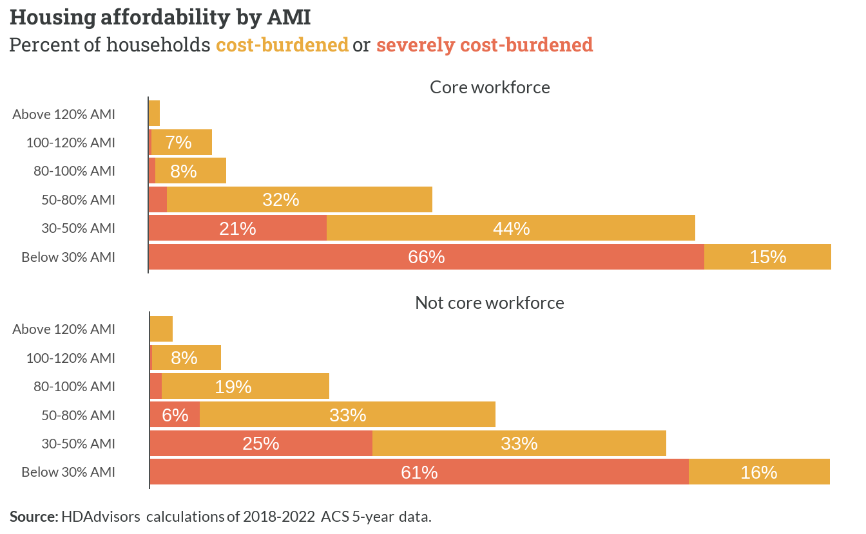

*Figure 5.2: Housing affordability by AMI*

## 5.2 Rental housing gap

Wage and rent growth patterns across the Fredericksburg region from 2015 to 2024 reveal a concerning dynamic of persistent unaffordability. While both metrics demonstrate parallel upward trajectories, with cumulative increases ranging from 30-50% across localities, this synchronization effectively absorbed most household income gains into housing costs.

This pattern is particularly evident in Fredericksburg proper, where the close tracking between wage and rent growth meant that households earning the average annual wage saw minimal improvement in their discretionary income after accounting for housing expenses.

The parallel growth trajectories effectively locked in existing affordability challenges, as wage increases that might have provided relief from housing cost burdens were instead captured by proportional rent increases. This dynamic appears most pronounced in urban centers like Fredericksburg and Stafford, where the close coupling between wage and rent growth perpetuated, rather than alleviated, existing patterns of housing stress for cost-burdened households.

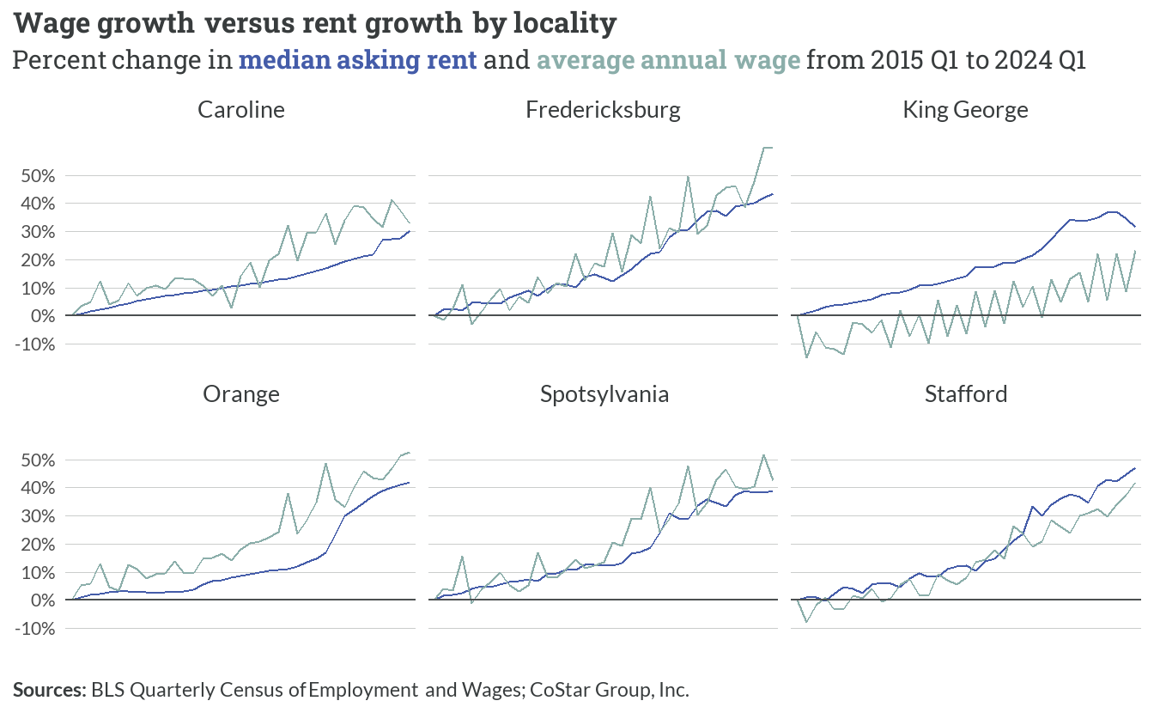

*Figure 5.3: Wage growth versus rent growth by locality*

The Fredericksburg region faces significant rental housing gaps at both ends of the income spectrum. Nearly 4,000 extremely low-income households (earning below 30% AMI) lack access to affordable rental units, while a similar deficit exists for households earning above 120% AMI.

The middle market shows substantial surpluses, particularly for households earning between 50-80% AMI where there are almost 8,000 more units than households. This suggests many higher-income renters are likely occupying units that would be affordable to lower-income households, while the lowest-income renters face severe challenges finding affordable housing.

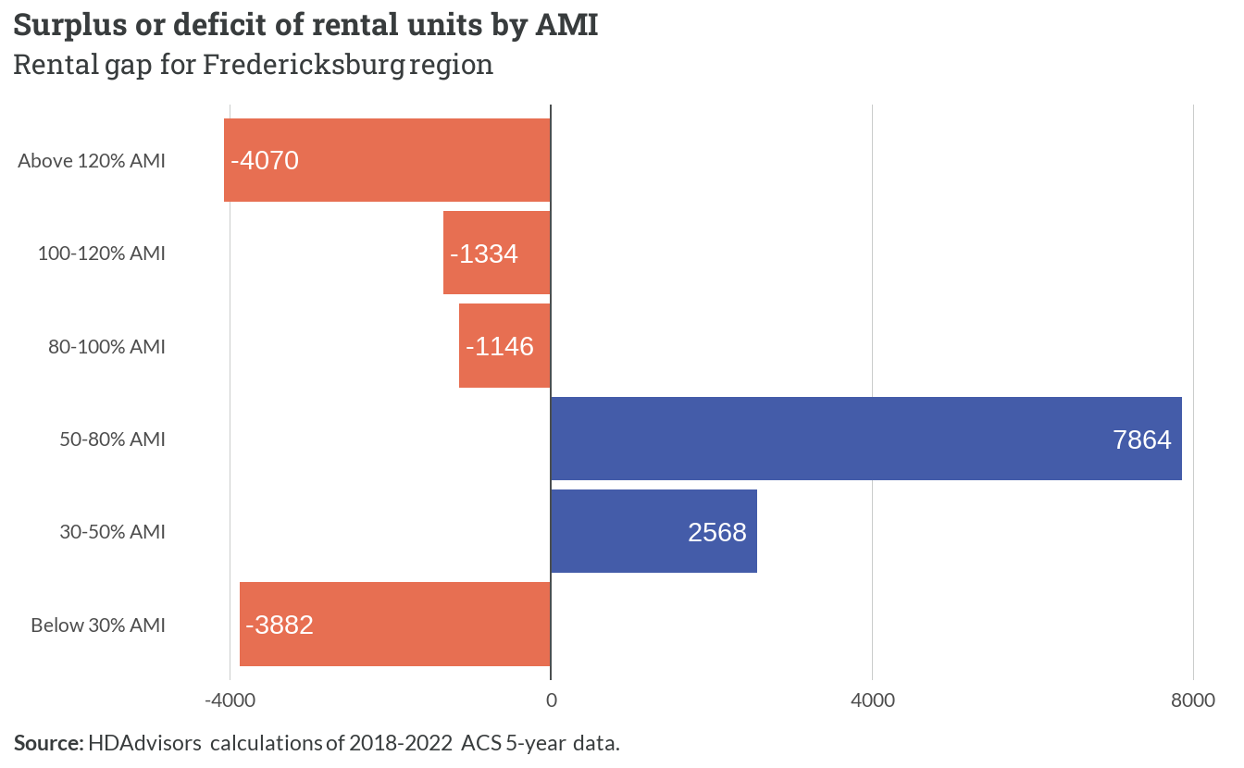

*Figure 5.4: Surplus or deficit of rental units by AMI*

### Core workforce rental affordability

Public sector workers in King George can afford the highest monthly rent at $1,620, followed by Caroline at $1,556 and Spotsylvania at $1,509. Police, fire, and teaching professionals in Fredericksburg and Stafford face somewhat tighter rental budgets, with affordable limits of $1,423 and $1,333 respectively. Orange has the lowest affordable rent threshold at $1,249.

For context, the average one-bedroom unit in the region rents for $1,620, while two-bedroom units average $1,812.

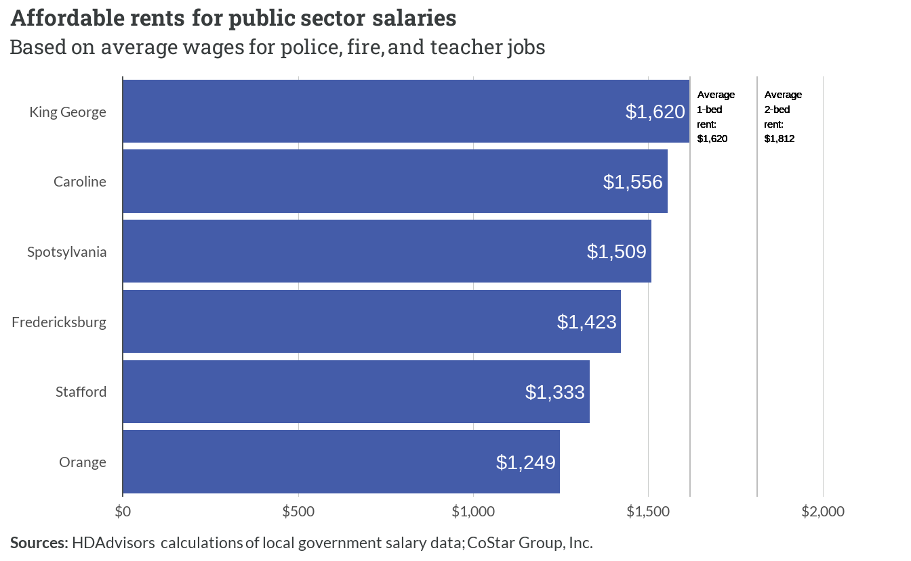

*Figure 5.5: Affordable rents for public sector salaries*

## 5.3 Homeownership gap

Most modestly-sized homes – let alone larger ones — are out of reach for typical renters. The median renter income of $55,500 falls $33,026 short of affording even a three-bedroom home. This gap expands dramatically for larger homes, with four and five-plus bedroom homes requiring more than double the typical renter’s income.

This disparity effectively locks many renters out of homeownership entirely, as the income requirements for every home size far exceed their earning capacity. The situation suggests a significant portion of the region’s renters may remain unable to build wealth through homeownership unless there are major changes in either home prices, interest rates, or wage growth.

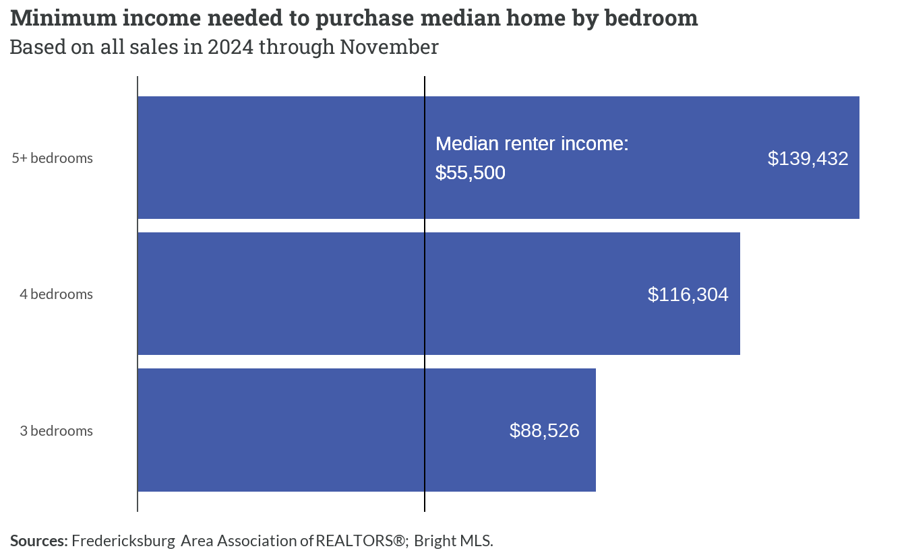

*Figure 5.6: Affordable home purchase prices for public sector salaries*

**Assumptions for calculations of minimum incomes**

Loan terms = 30-year fixed rate mortgage at 6.50% Down payment = 20% of purchase price

Taxes and insurance = 25% of monthly loan payment Debt-to-income ratio = 0.28

|  |
| --- |
|  |
|  |  |

Among households with 1-2 persons, approximately 4,000 current renters could theoretically afford a 3-bedroom home based on their income. However, the market dynamics become more complex for larger households.

For 3-person households, about 1,200 renters could afford homes split between 3 and 4 bedrooms, while 4-person households show a similar pattern with roughly 1,000 qualified buyers. The most constrained segment appears to be households with 5+ persons, where only about 500 renters could afford homes sized appropriately for their needs (4+ bedrooms).

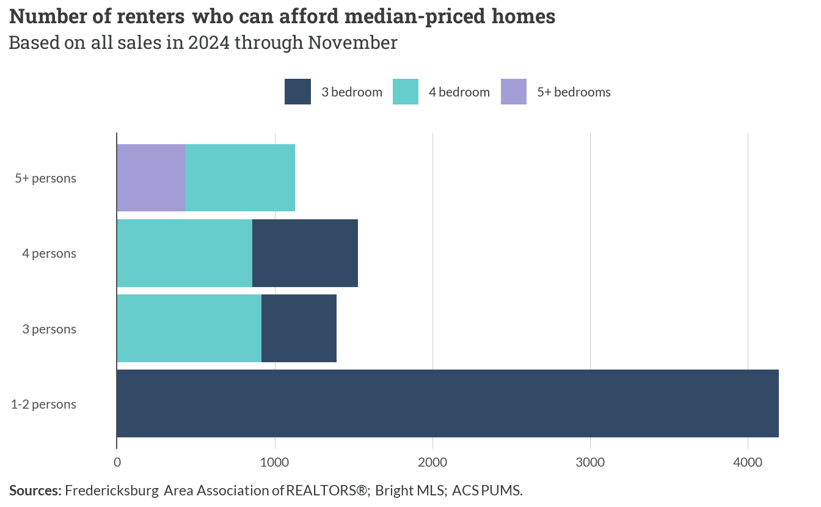

*Figure 5.7: Number of renters who can afford median-priced homes*

**Note**

This analysis suggests a substantial pool of qualified buyers across all household sizes who remain in the rental market, likely due to supply constraints rather than financial limitations.

### Core workforce homeownership affordability

The data reveals a significant affordability gap for public sector workers in the region. While their salaries support maximum home purchases ranging from $144,439 in Orange to $187,385 in King George, the actual median home prices are substantially higher.

Stafford shows the starkest contrast — while public sector workers can afford homes up to $154,160, the median sales price has climbed above $500,000 by 2024. Similar gaps exist in all localities, with median prices typically ranging from $350,000 to $450,000, far exceeding what police officers, firefighters, and teachers can afford on their salaries.

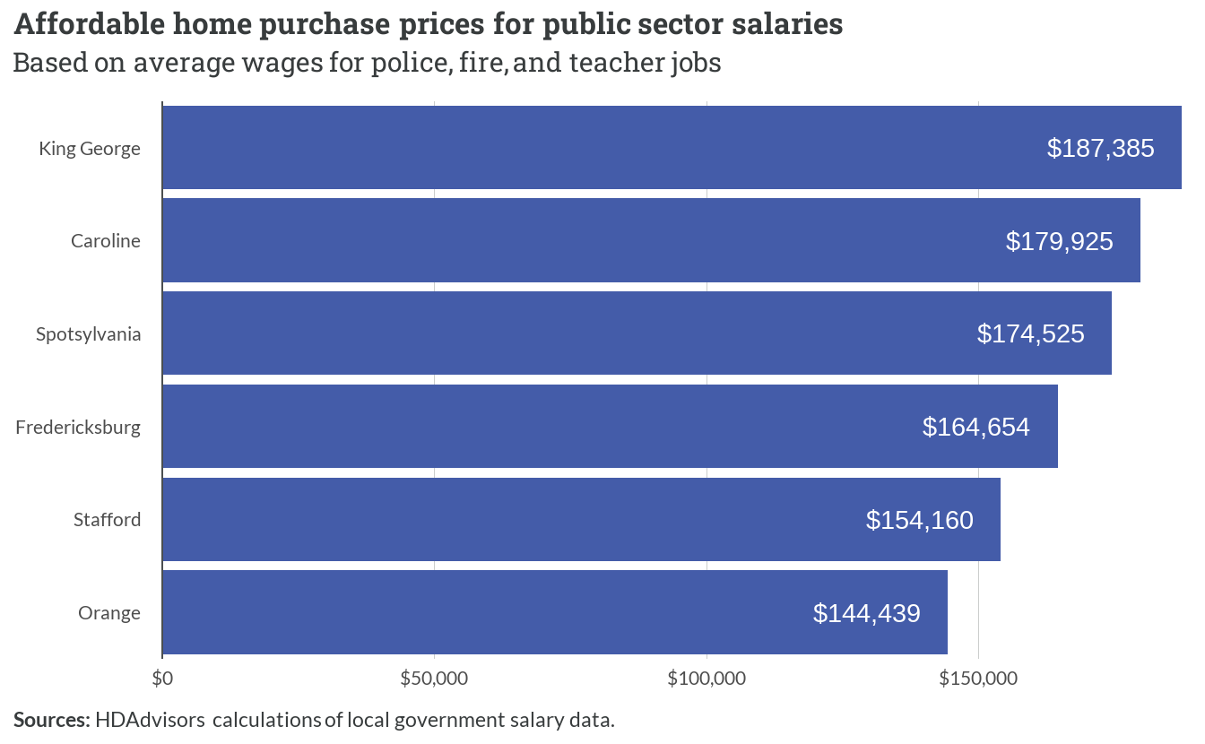

*Figure 5.8: Affordable home purchase prices for public sector salaries*

# 6  Projected housing gaps

## 6.1 Overview

This section uses population projections from the Weldon Cooper Center for Public Service at UVa to estimate new households that will be added to the region between now and 2050. As the chart below shows, the region can expect significant population growth over the coming decades.

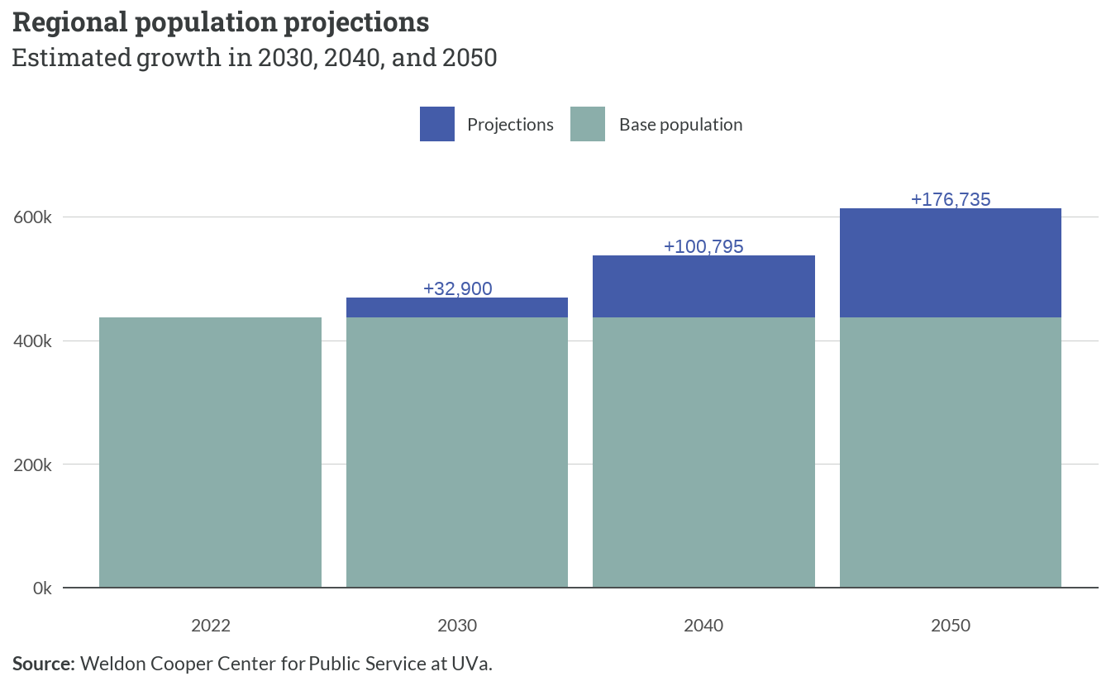

*Figure 6.1: Regional population projections*

The Fredericksburg region’s population is projected to grow substantially, with increasingly larger increments each decade. Starting from 2022, the region will add approximately 32,900 residents by 2030, followed by an additional 67,895 residents from 2030 to 2040.

The most significant growth is expected between 2040 and 2050, with 75,940 new residents. This accelerating growth pattern suggests the region will need to plan for a cumulative increase of more than 176,000 residents over the next three decades.

## 6.2 Household projections

Household projections indicate a steady upward trajectory in new household formation across the region. The data shows an initial addition of 11,527 households by 2030, followed by 23,790 new households between 2030 and 2040. The final decade sees the largest increment with 26,609 new households formed between 2040 and 2050. In total, the region is expected to accommodate approximately 61,926 new households by 2050, suggesting a significant need for housing expansion.

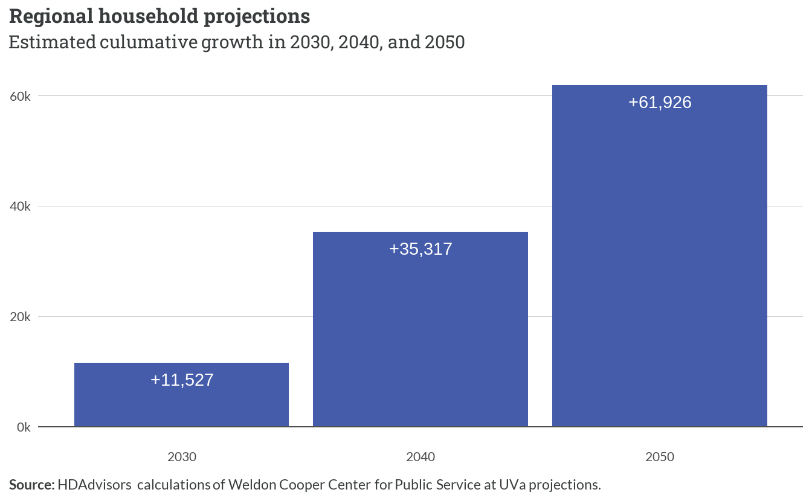

*Figure 6.2: Regional household projections*

At that rate, the region will need to house roughly **2,400 new households** each year between now and 2050.

### Local projections

The household growth projections reveal stark differences in distribution across localities. Stafford County leads with the highest projected growth of 28,094 households by 2050, followed by Spotsylvania with 19,516 new households.

The remaining localities show more modest growth patterns, with Caroline, Fredericksburg, King George, and Orange each projected to add between 3,100 and 3,900 households by 2050. This uneven distribution suggests housing demand and development pressures will be particularly concentrated in the region’s northern jurisdictions.

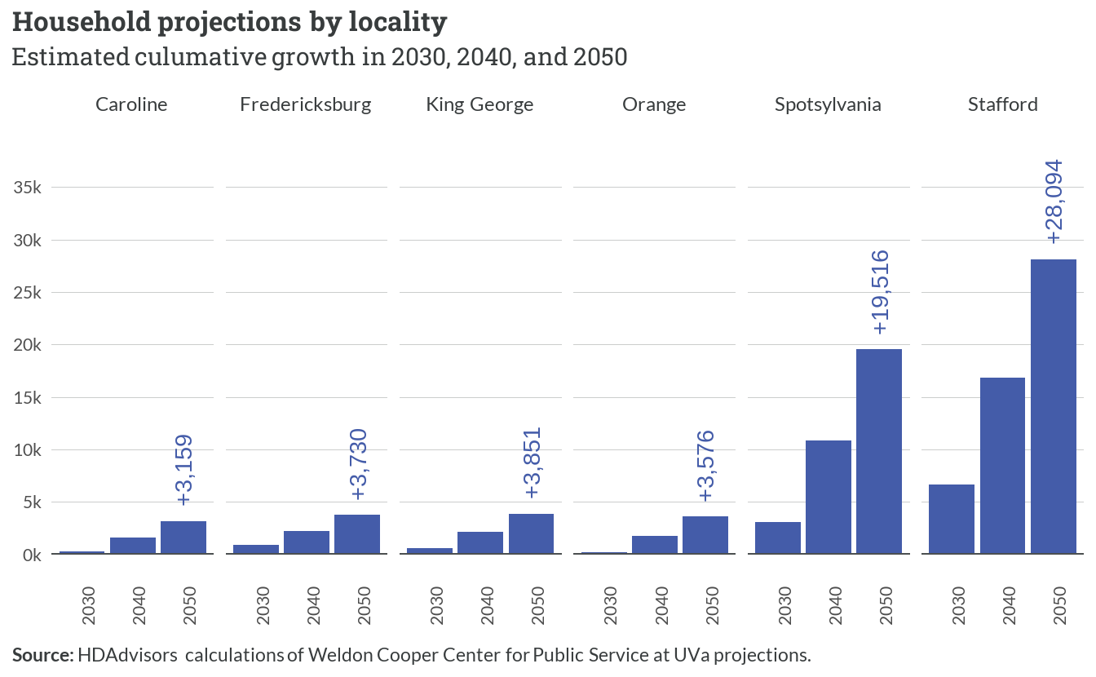

*Figure 6.3: Household projections by locality*

# Appendix A: Engagement

The first phase of this study included interviews with several local economic development officials and housing providers. These conversations provided important context to inform the methods and focus of the subsequent housing gap analysis.

## A.1 Emerging Themes

### Success in the Housing Market

Respondents reported that individuals finding the most success in the Fredericksburg region—for both rental and homeownership—appear to be Virginians migrating in from elsewhere in the state. Fairfax, Loudoun, and other Northern Virginia communities are common origins for these households.

Representatives in Caroline and Stafford also reported that many households seem to be migrating from Richmond or Henrico (for Caroline), and Fredericksburg (for Stafford). Fredericksburg also seems to attract work-from-home households from Northern Virginia.

Households unchallenged by the housing market—regardless of their origin—also very often have high education levels, according to respondents. The greater incomes for these households usually mean they seek homeownership as their first choice.

Those lacking success in the housing markets in the region appear to be larger family households (including intergenerational households), and individuals that are working as teachers, social workers, or EMTs. These households struggle to find both rental and homeownership opportunities without being cost-burdened.

Respondents indicated that starter homes or rental options seem to be limited in today’s market, even for those with the ability to afford such housing. A severe supply shortage prevents these households with more modest incomes from securing housing that meets their needs and preferences.

### Affordable Housing

The lack of rental housing affordable to lower-income workers is felt throughout the region, with the area especially lacking multifamily and senior-focused housing opportunities. Respondents outlined that the housing cost burden for workforce populations continues to increase, which in turn pushes households–—especially renters–—further from their home communities. This exacerbates their already high travel and transportation costs.

Pricing for homeownership options in the region are also on the higher end, inaccessible to those entering the workforce or those looking to downsize. Significant barriers for renters are felt in the landlord requirements for tenants, including large security deposits and credit checks that exclude many of the poorest residents. This has resulted in many families overcrowding units or living in temporary housing solutions like motels for long periods of time.

### Regional Housing Focus

Based on the three respondents, it is clear that each community in the region is unique and holds different goals related to housing and workforce development. Loisann’s Hope House serves the whole planning district and finds households that are at risk of homelessness and need support in both rural and urban areas.

Just as other populations are being pushed farther from home, they report that finding housing to serve their clients (the majority being 30-50% AMI) becomes more challenging and requires casting a wider net. The population and housing market dynamics among localities varies, but so do the goals of each locality as they relate to housing and economic development.

Nonetheless, each locality plays a significant role in serving the housing spectrum of the entire region. While localities may act alone, their local decisions have far reaching impacts outside their local boundaries and will always have consequences for their neighboring communities.

## A.2 Gap Analysis Implications

### Diverse Stakeholder Recruitment

Due to the limited scope of engagement conducted thus far, we recommended that any ongoing or future stakeholder recruitment—–in the rollout of this work and beyond–—include diverse professional expertise and experiences. This comprises real estate professionals, employers, and those that work within traditional workforce occupations.

It may be valuable to review housing outcomes with stakeholders that live and work in the communities FAAR serves. Additionally, including a diversity of geography to broaden feedback from urban, suburban, and rural communities will be important to more effectively understand the variety of needs across the region and determine how housing challenges cascade across landscapes.

### Educational Awareness

Using data and findings from the housing gap analysis, FAAR could help orchestrate an educational campaign about the opportunities for workforce and economic development to collaborate in the housing field. One example to potentially emulate is [Workforce Housing Now](https://workforcehousingnow.org/), an initiative led by the Community Foundation of Loudoun and Northern Fauquier Counties. They describe it as

*“…a public awareness campaign amplifying Loudoun’s voice for workforce housing as the missing ingredient to our community’s prosperity.”*

Respondents reported that the forthcoming housing gap analysis resources could serve as a way to “empower and equip” their communities with greater knowledge. Regionalism could also be a focus of such a campaign to expand awareness and partnerships across fields, like those who are tied to homelessness and economic development. Often these fields work independently of each other and have limited understandings of the challenges facing their respective target populations.

### Approaches to Regionalism

The housing gap analysis will not only need to account for the unique needs and gaps in each locality but also account for the interjurisdictional nature of populations housed in the FAAR region. For example, Loisann’s Hope House serves unhoused and working populations across the region and both economic development authorities interviewed recruit workforce from outside of their home counties.

While many localities aspire to have residents that live and work within their bounds, the reality is that many households will continue to commute or migrate in search of affordable options. The housing gap analysis could be leveraged to call attention to the reality of these differences and to help illuminate missing markets.

# Appendix B: Data notes

This chapter includes important context about certain data sources and methods used throughout the report.

The first two sections explain how Area Median Incomes are customized to build the regional housing spectrums found in Chapter 1 and Chapter 2.

## B.1 Area Median Income

The U.S. Department of Housing and Urban Development (HUD) calculates the *Area Median Income* (AMI) for every part of the country each year using income estimates from the Census Bureau. Many housing programs managed by HUD, other public agencies, and nonprofit providers use AMIs to limit eligibility to households with low or moderate incomes. Because wages and living costs vary by market, AMIs help ensure housing assistance reaches those with the most needs.

### How AMIs are calculated

To calculate AMI, all households[5] in a given area are arranged from lowest to highest gross income. The household exactly in the middle has the *median* income for that given area. We can then refer to any other income value relative to that AMI. For example, if the AMI is $80,000, a household with an income of $40,000 is at 50% AMI.

HUD’s process to calculate AMIs for each area across the nation has two major parts:

1. Estimate the current *Median Family Income* (MFI)
2. Use MFI to generate Very Low-Income, Extremely Low-Income, and Low-Income limits

**“Family” versus “Household”**

HUD bases its AMIs on the median incomes of families rather than households. The Census Bureau definition for a family refers to a householder living with at least one other person related by birth, marriage, or adoption. Single persons living alone and households with no related individuals are excluded from MFI calculations.

### Median Family Income

MFIs are calculated as follows:

1. **Data source:** HUD uses median family income data from the most recent version of the American Community Survey (ACS), an annual Census Bureau survey completed by 1% of the population. For FY 2024, the latest ACS estimates were from 2022.
2. **Reliability:** Because the ACS is based on a sample, HUD tests each area's income estimate to determine whether the margin of error is within an acceptable range.
3. **Inflation adjustment:** To account for the two-year lag from the ACS sample, HUD adjusts each value according to an inflation factor based on Consumer Price Index (CPI) projections published by the Congressional Budget Office (CBO).
4. **Round final value:** HUD rounds the adjusted median income value to the nearest $100. This result is the official MFI for a given area.

### Income limit categories

To translate the MFI into income values that can be used to determine program eligibility, HUD follows a standard methodology to create new limits for three different income levels:

* **Extremely Low-Income:** Households whose incomes are not above 30% of the MFI
* **Very Low-Income:** Households whose incomes are not above 50% of the MFI
* **Low Income:** Households whose incomes are not above 80% of the MFI

For each of these, HUD generates specific values for household sizes between 1-person and 8-persons.

### Very Low-Income Limits

1. Set 50% of the MFI as the preliminary 4-person Very Low-Income Limit (VLIL)
2. Adjustment VLIL up if:
   * Area has unusually high housing costs (35% of VLIL is no greater than 85% of annualized 2-bedroom FMR)
   * Area has unusually low incomes (VLIL is less than 50% of state’s MFI for non-metro areas)
3. Adjust VLIL down if:
   * Area has unusually high incomes (VLIL is greater than 80% of U.S. MFI, and the annualized 2-bedroom FMR is no greater than 30% of VLIL)
4. Compare change with previous year and apply “ceiling or floor” rules:
   * Maximum annual increase: 10%
   * Minimum annual decrease: 5%
5. Adjust final VLIL by family size and round up to nearest $50

*Table B.1: Family size adjustments for number of persons in family*

|  |  |  |  |  |  |  |  |
| --- | --- | --- | --- | --- | --- | --- | --- |
| **1** | **2** | **3** | **4** | **5** | **6** | **7** | **8** |
| 70% | 80% | 90% | — | 108% | 116% | 124% | 132% |

### Low-Income Limits

1. Multiply the VLIL by 1.6 (80% divided by 50%) to get preliminary 4-person Low-Income Limit
2. Round to the nearest $50
3. Adjust down if preliminary value is greater than U.S. MFI (“capped”)
4. Adjust up if 85% of annualized 2-bedroom FMR (multiplied by 1.6) is greater than 35% of preliminary value
5. Apply same “ceiling or floor” rules and family size adjustments used for Very Low-Income Limits

### Extremely Low-Income Limits

1. Multiply the VLIL by 0.6 (30% divided by 50%) to get preliminary 4-person Extremely Low-Income Limit
2. Round to the nearest $50
3. Adjust by family size
4. Replace any values with federal poverty guidelines[6] if guideline is higher

### Income limit areas

HUD calculates AMIs for “income limit areas” that usually align with the Metropolitan Statistical Area (MSA) definitions published and occasionally revised by the U.S. Office of Management and Budget (OMB).[7] For FY 2024 AMIs, HUD based its geographies on the delineations provided in *OMB Bulletin No. 18-04* from September 2018.

However, HUD further subdivides many MSAs into “HUD Metro Fair Market Rent Areas” (HMFAs) that can sometimes be a single county.[8] HFMAs can more accurately reflect income and market trends in a community, especially when they are part of very large metro areas like the Washington, D.C. region. If a county is not located in an MSA, HUD will calculate its unique AMI if reliable estimates are available.

As of FY 2024, HUD uses four different income limit areas across the six localities included in this study. The table below shows which OMB and HUD designations correspond to each locality.

*Table B.2: OMB and HUD area designations by locality*

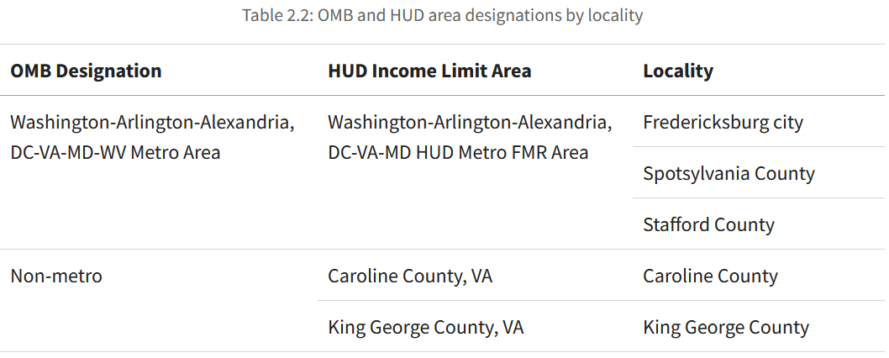

This map shows HUD income limit areas by color for localities in the Fredericksburg and Washington, D.C. regions. The Washington, D.C. MSA is outlined in black.

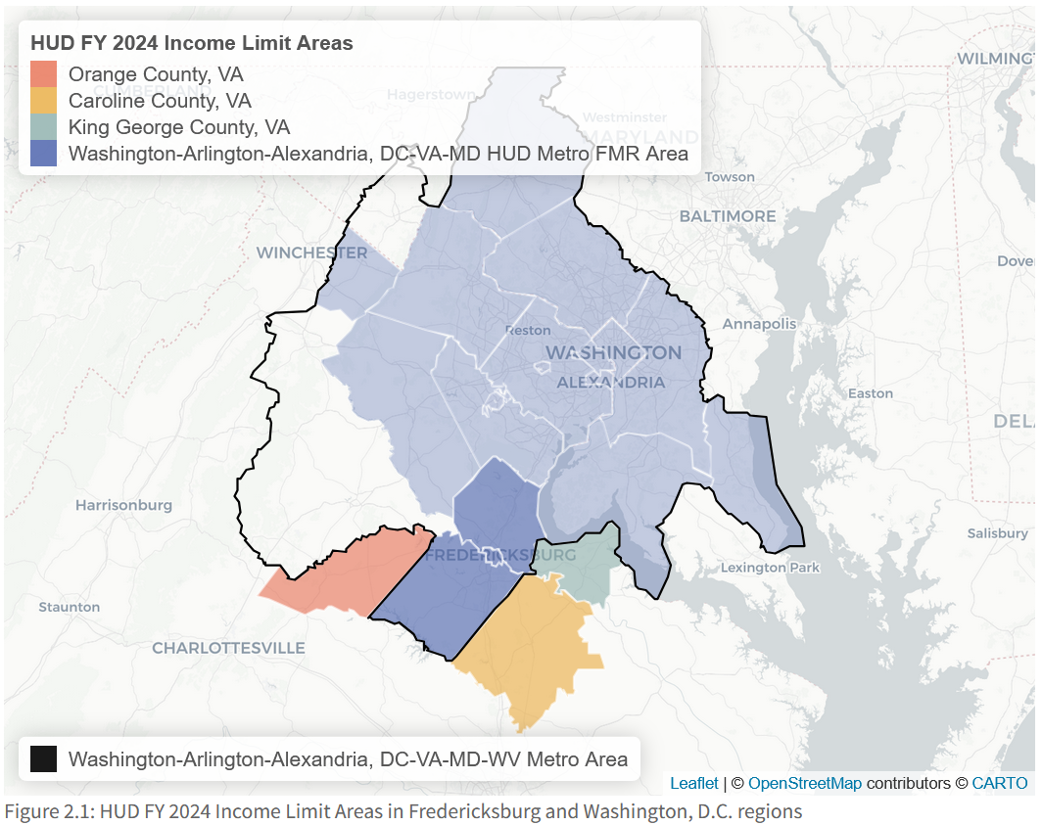

*Figure B.1: HUD FY 2024 Income Limit Areas in Fredericksburg and Washington, D.C. regions*

The *Washington-Arlington-Alexandria, DC-VA-MD-WV Metro Area* (“Washington, DC MSA”) is a large MSA encompassing the capital and localities in three other states. HUD assigns much of this region to its *Washington-Arlington-Alexandria, DC-VA-MD HUD Metro FMR Area* (“Washington, DC HMFA”) — including the City of Fredericksburg, Spotsylvania County, and Stafford County.

Although Culpeper County is part of the Washington, D.C. MSA, HUD considers it distinct enough to calculate its own AMI under the *Culpeper County, VA HUD Metro FMR Area*.

Because Caroline[9] and King George counties are not part of any MSA (i.e., non-metropolitan), HUD calculates their AMIs separately.

### AMIs in the Fredericksburg region

The official HUD FY 2024 MFIs that apply to the Fredericksburg region range from $102,000 in Caroline County to $154,700 for the three localities in the Washington, DC HMFA.

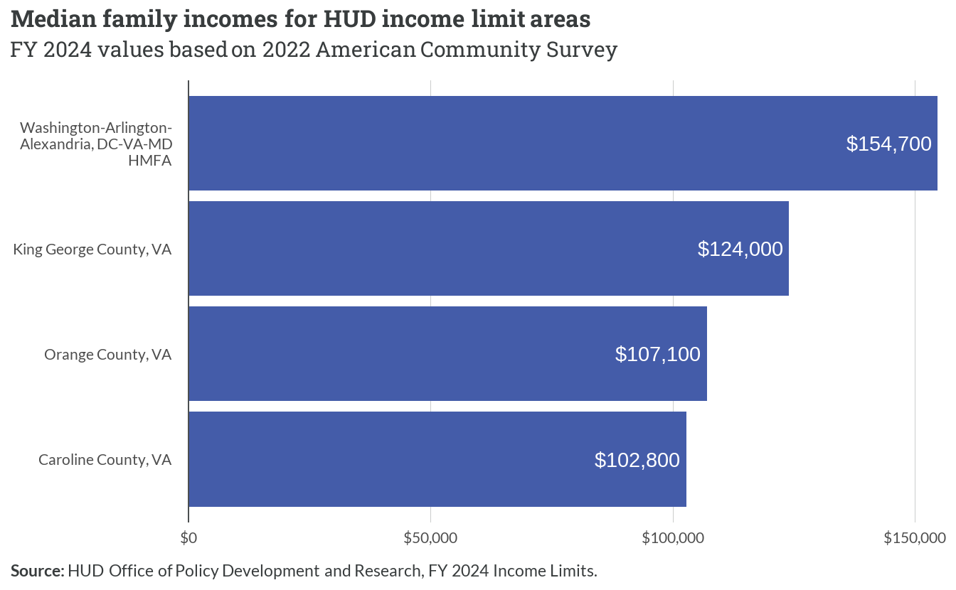

*Figure B.2: Median family incomes for HUD income limit areas*

The chart below shows the actual income limits (at 30%, 50%, and 80% AMI) for each of these four areas, broken down by number of persons in a family.

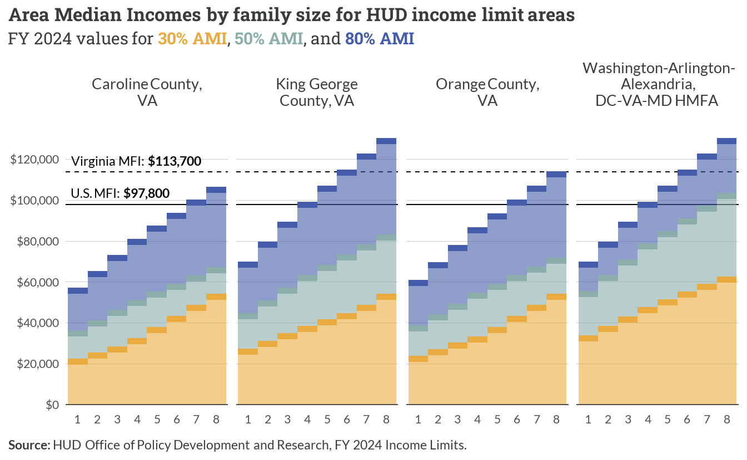

*Figure B.3: Area Median Incomes by family size for HUD income limit areas*

For King George and the Washington, DC HMFA, note that the 4-person limit at 80% AMI is “capped” at the MFI for the United States. This follows HUD’s methods described above, which adjust the preliminary 4-person Low-Income Limit down if higher than the national MFI. This adjustment ensures that federal housing resources targeted at low-income households are primarily available to those with *actual* low incomes.

*Table B.3: Capped and uncapped preliminary 4-person Low-Income Limits*

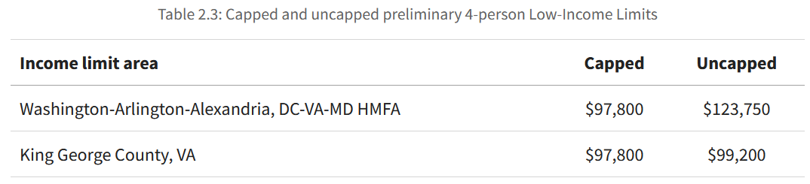

The red shaded areas in the chart below are the unofficial “uncapped” 80% AMI limits for these two areas. Uncapped values were calculated following HUD’s methodology for Low-Income Limits, but omitting the comparison and adjustment for the U.S. MFI. The uncapped limits for King George are all no greater than $2,000 of the official capped limits, since its preliminary 4-person Low-Income Limit is very close to the national MFI. That difference is much greater for the Washington, DC HMFA (nearly $26,000), which leads to uncapped limits that defines any household with two or more persons as “low-income” even if they earn six figures.

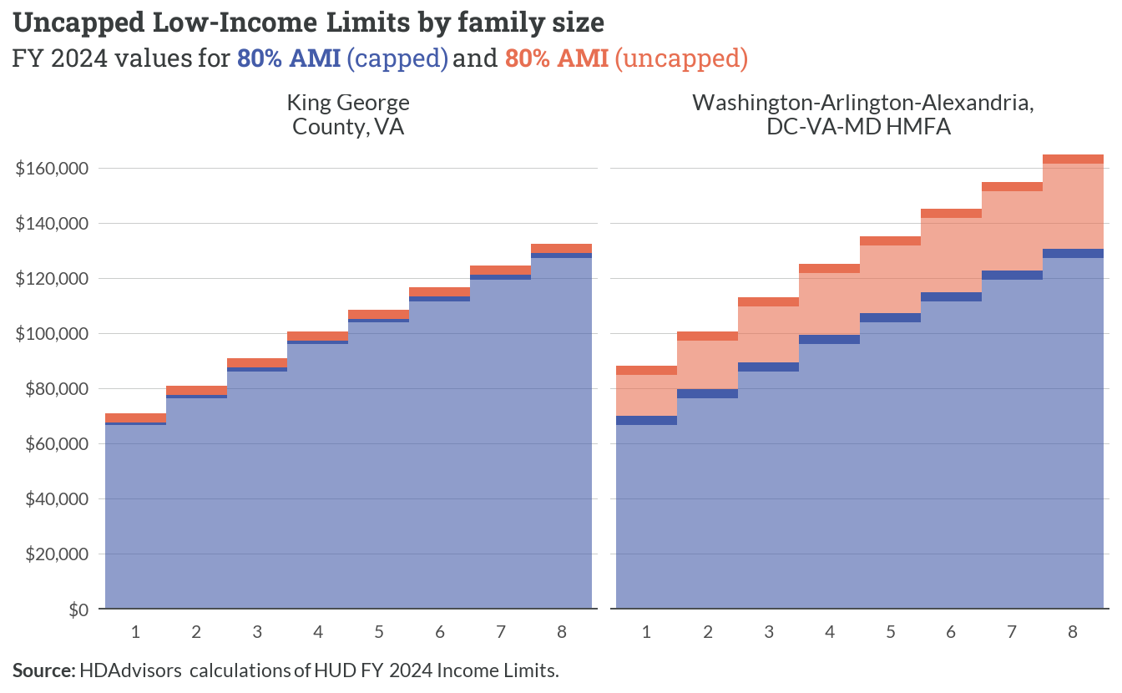

*Figure B.4: Uncapped Low-Income Limits by family size*

## B.2 Custom AMIs for GWRC region

Four different sets of income limits make it difficult to build a universal housing spectrum for the Fredericksburg region. However, we can build custom AMI values by applying HUD’s official methodology to the latest Public Use Microdata Sample (PUMS) data.

**What is PUMS?**

Along with a series of published tables with pre-calculated estimates, the Census Bureau provides data from the American Community Survey (ACS) in the Public Use Microdata Sample. PUMS records are anonymized responses at the individual and household level, and are weighted to reflect characteristics of the overall population. Researchers use PUMS to calculate custom tabulations from ACS data that are not available in the standard tables.

### PUMS and PUMAs

PUMS data are only available for specific geographies called Public Use Microdata Areas (PUMAs) that contain at least 100,000 people. Localities with large populations are split into multiple PUMAs, while localities with small populations are grouped into single PUMAs.

The George Washington Regional Commission (GWRC) officially serves Planning District 16, which includes the following localities:

* City of Fredericksburg
* Caroline County
* King George County
* Spotsylvania County
* Stafford County

Planning District 16 is composed of two contiguous PUMAs:

* George Washington Regional Commission (North) PUMA – Fredericksburg and Stafford
* George Washington Regional Commission (South) PUMA – Caroline, King George, and Spotsylvania

The map below shows these two PUMAs, along with outlines for other PUMAs in Virginia.[10]

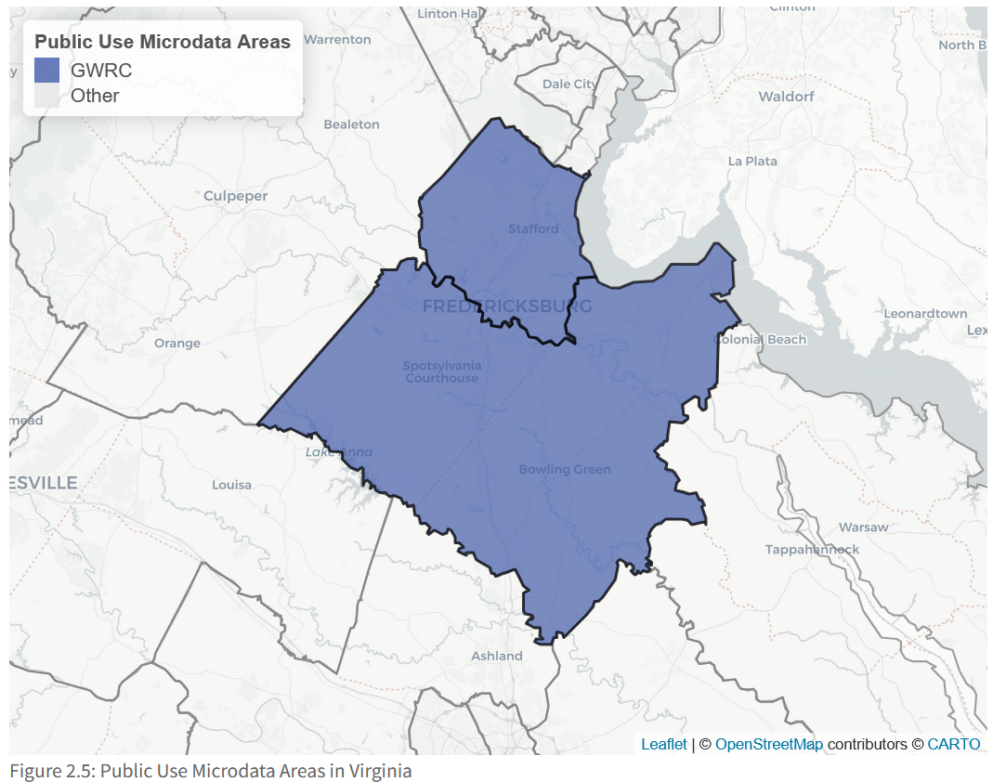

*Figure B.5: Public Use Microdata Areas in Virginia*

### Methods

Using PUMS data from these two contiguous PUMAs for the GWRC region, we can calculate new income limits and define household income categories for a regional housing spectrum.

At the time of this analysis, the latest sample available are the 2018-2022 ACS 5-year PUMS.7 The steps below outline the methods used to calculate a custom MFI and derived income limits for the GWRC region. The FY 2024 methods published by HUD are used, with the following exceptions:

PUMS data are also available for the 1-year ACS; however, the increased sample size for the 5-year dataset significantly reduces margins of error calculated from the records.

* High housing cost adjustments (which use FMR values) and previous year “ceiling or floor” rules are omitted for simplicity. None of the four HUD income limit areas already discussed used these adjustments.
* Additional income limits are generated at the 100% AMI and 120% levels to help build a complete housing spectrum.

### Median Family Income

1. Filter PUMS records to relevant entries only:
   * Household-level records; exclude persons in group quarters (SPORDER == 1)
   * Valid values for family income from past 12 months (FINCP >= 0)
2. Calculate MFI:
   * Apply housing record replicate weights
   * Calculate weighted median of FINCP variable and margin of error for 90% confidence interval (CI)
3. Apply HUD inflation adjustment to update 2022 ACS for FY 2024 (1.062)8
4. Round to nearest $100

*Table B.4: FY 2024 MFI for GWRC region derived from 2018-2022 ACS 5-year PUMS*

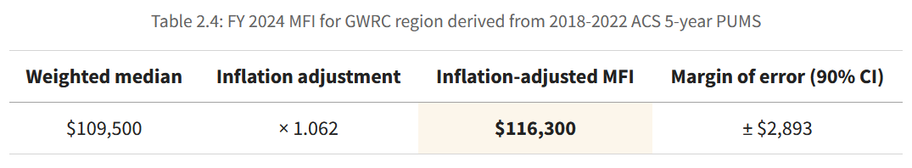

### Income Limits

1. Calculate 4-person Very Low-Income Limit (VLIL)
   * $116,300 × 0.5 = $58,150
2. Calculate 4-person Low-Income Limit and round to nearest $50
   * $58,150 × 1.6 = $93,050
   * Verify limit is below U.S. MFI ($93,040 < $97,800)
3. Calculate 4-person Extremely Low-Income Limit and round to nearest $50
   * $58,150 × 0.6 = $34,900
4. Calculate 4-person limits for 100% AMI and 120% AMI and round to nearest $50
   * 100% AMI: $58,150 × 2.0 = $116,300 (same as MFI)
   * 120% AMI: $58,150 × 2.4 = $139,550
5. Adjust 4-person limits by family size and round to nearest $50

### Results

The table below shows the final income limits by number of persons in the family.

*Table B.5: Income limits for GWRC region derived from 2018-2022 ACS 5-year PUMS*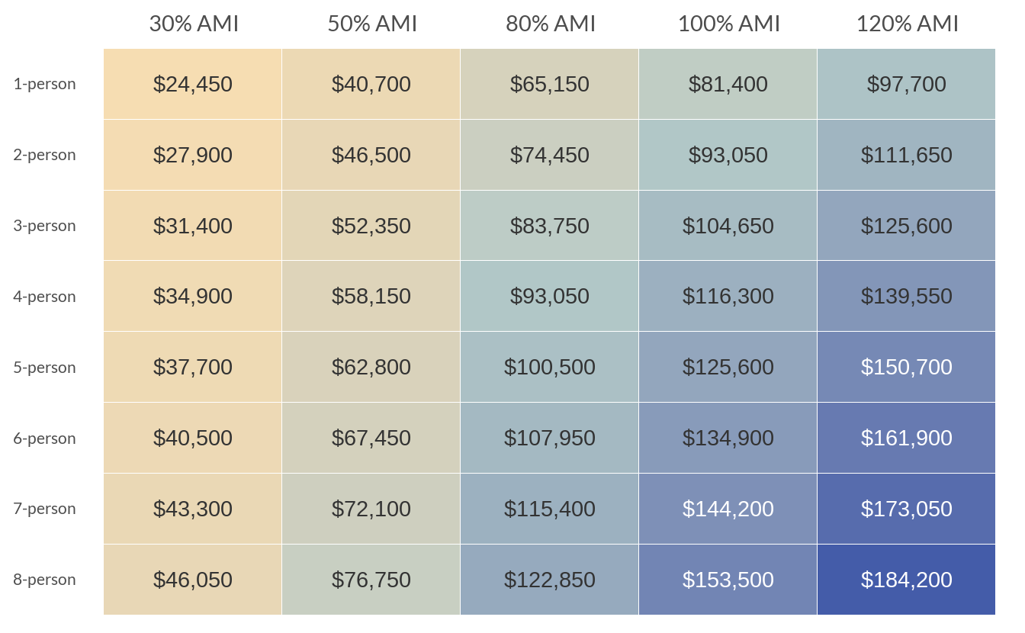

### Compared to official AMIs

The MFI for Planning District 16 falls in the middle of the official MFIs calculated by HUD for the region’s respective income limit areas.

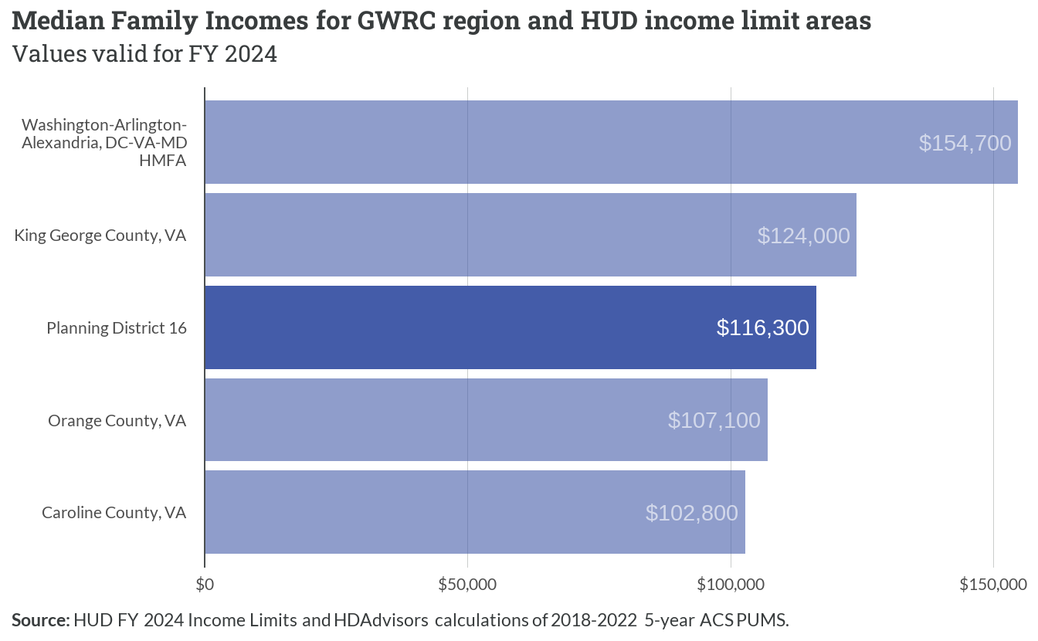

*Figure B.6: Median Family Incomes for GWRC region and HUD income limit areas*

The income limits across family sizes at 30%, 50%, and 80% AMI levels are similarly situated in the middle, even when the capped 80% AMI limits for King George and the Washington, DC HMFA are considered.

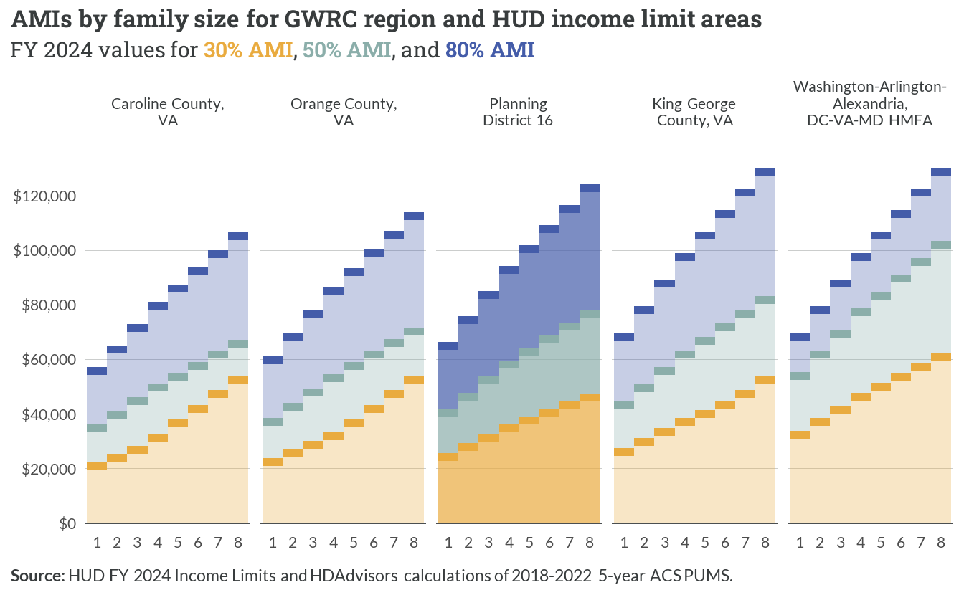

*Figure B.7: AMIs by family size for GWRC region and HUD income limit areas*

1. Persons living in *group quarters*, such as college dorms and nursing homes, are excluded from this analysis.
2. Here, typical range includes all values between the 10th and 90th percentiles. This removes outliers and reflects the middle 80% of households within each group.
3. A person is an *earner* if their total pay from wages and/or self-employment income over the last 12 months is at least $5,000.
4. This total combines the separate two ACS estimates for *Supplemental Security Income (SSI)* and for *Public assistance programs*. The latter includes Temporary Assistance to Needy Families (TANF) and other forms of cash benefits. Noncash benefits, such as Food Stamps, are excluded.
5. As described further below, HUD’s official income limits are actually derived from estimates of *family* incomes.
6. As published by the Department of Health and Human Services (HHS): [U.S. Federal Poverty Guidelines](https://aspe.hhs.gov/topics/poverty-economic-mobility/poverty-guidelines) (aspe.hhs.gov)
7. Additional details on OMB definitions can be found here: [About Metropolitan and Micropolitan Areas](https://www.census.gov/programs-surveys/metro-micro.html) (census.gov)
8. Fair Market Rents (FMRs) are also calculated by HUD at the same geographies it provides AMIs. FMRs are used to set payment standards for federal housing assistance programs. For more, see: [Fair Market Rents](https://www.huduser.gov/portal/datasets/fmr.html) (huduser.gov)
9. Caroline County was part of the Richmond, VA MSA until *OMB Bulletin No. 18-04*. HUD incorporated this change beginning with income limits published for FY 2022.
10. The Census Bureau updates PUMA geographies following each decennial census. The current boundaries, released in 2022, are based on 2020 census population data. Several PUMAs in Virginia are changed from their 2010 versions; however, the GWRC PUMAs were not altered. Therefore, ACS responses in the 2018-2022 5-year PUMS data for the GWRC region are contiguous, and no adjustments are required.